

Integrated Energy Resource Master Plan (IERMP)
23 December 2025

Submitted to the Ministry of Energy and Mineral Development (MEMD)

Draft Least cost plan report

Contributors
This report was prepared by:

Economic Consulting Associates Limited
41 Lonsdale Road, London NW6 6RA,
United Kingdom
tel: +44 20 7604 4546
fax: +44 20 7604 4547
www.eca-uk.com


Norconsult AS
Vestfjordgaten 4, 1338 Sandvika.
Norway
+ 47 67 57 10 00
www.norconsult.com

Research for Transformation and Development
Plot 8-10 Kampala Road, Uganda House, 5th Floor,
P.O. Box 25582, Kampala,
Uganda
+256-776-130913
www.rtdug.org

This report (including any enclosures and attachments) has been prepared for the exclusive use and benefit of the Ministry of Energy and Mineral Development Uganda and solely for the purpose for which it is provided. Unless we provide express prior written consent, no part of this report should be reproduced, distributed, or communicated to any third party. We do not accept any liability if this report is used for an alternative purpose from which it is intended, nor to any third party in respect of this report.

Contents
Contributors 1
Contents 2
Tables and figures 4
Abbreviations and acronyms 7
1 Introduction 9
2 Demand forecast 11
2.1 Demand forecast scenarios 11
2.2 Demand forecasting approach 12
2.3 Summary of demand forecast input assumptions 12
2.4 Demand forecast, 2024-2050 15
3 Current supply status and committed projects 18
3.1 Existing power plants 19
3.2 Existing transmission and distribution network 20
3.3 Current EE and DSM measures 23
3.4 Committed projects 24
3.5 Short-term capacity gap to be met by candidate projects 24
4 Least cost plan approach 26
4.1 Generation, storage, EE/DSM and transmission plan approach 26
4.2 Distribution plan and electrification 28
4.3 Planning criteria 28
4.4 Economic and financial parameters 30
4.5 Planning horizon 30
5 IERMP scenarios and policy targets 31
6 Candidate options 33
6.1 EE and DSM 33
6.2 Power generation and storage options 34
6.3 Transmission and distribution options 39
7 Generation, storage and EE/DSM least cost plan 47
7.1 Least cost plan results by scenario 47
7.2 Least cost plan across scenarios by technology 62
7.3 EE and DSM least cost plan 67
7.4 Emissions pathway by scenario 69
7.5 Firm capacity and reserve margin 70
7.6 Total NPV of costs across scenarios 70
8 Transmission system least cost plan 73
8.1 General approach 73
8.2 Transmission system least cost plan by scenario 74
9 Distribution system least cost plan and electrification 81
9.1 General approach 82
9.2 Costs estimates per new connection 83
9.3 Total distribution system costs 85
10 Policy considerations 86
11 5-year focus 91
Annexes 92
A1 Step-loads considered in the demand forecast 92
A2 Exports considered in the demand forecast 93
A3 Regional disaggregation of the demand forecast 94
A4 Policy targets considered in the IERMP 98
A5 Gas pipeline assumptions for the IERMP 99
A6 Capital costs of EE and DSM measures 101
A7 Least cost plan by scenario 104
A7.1 Existing and committed power plants and transmission lines 104
A7.2 Selected candidate generators by scenario 105
A7.3 Selected candidate EE/DSM measures by scenario 133
A7.4 Selected subregional transmission candidates by scenario 138
A8 Distribution system plan 143
A8.1 Distribution system costs – Base scenario 143
A8.2 Distribution system costs – Delayed transition scenario 144

Tables and figures
Tables
Table 1 Summary of input assumptions by scenario 13
Table 2 Energy demand forecast, 2024-2050 15
Table 3 Electricity demand forecast, 2024-2050 16
Table 4 Existing large (>20 MW) hydro power plants 19
Table 5 Existing small (<20 MW) hydro power plants 19
Table 6 Existing thermal power plants 20
Table 7 Existing solar PV power plants 20
Table 8 Committed power plants 24
Table 9 Voltage limits under normal and contingency operation (kV) 29
Table 10 Scenarios and sensitivities for the IERMP 31
Table 11 Candidate EE and DSM measures for the IERMP 33
Table 12 Resource assessment summary for the IERMP 35
Table 13 Uganda least cost plan by technology across scenarios 62
Table 14 EE and DSM least cost investment plan by scenario 67
Table 15 Uganda NPV of least cost plan costs by scenario 71
Table 16 Transmission lines least cost plan – Base case scenario 74
Table 17 400 kV backbone grid development – Base case transmission investment plan 74
Table 18 132 kV and 220 kV backbone grid development – Base case investment plan 77
Table 19 Transmission lines least cost plan – Unconstrained scenario 78
Table 20 Transmission lines least cost plan – Delayed transition scenario 79
Table 21 Transmission lines least cost plan – Ten-fold growth scenario 79
Table 22 Transmission lines least cost plan – Policy targets scenario 80
Table 23 Distribution plan – Investment costs (million USD) 85
Table 24 Probability-adjusted step-loads by scenario (capacity requirement in MW) 92
Table 25 Electricity exports considered in the demand forecast by scenario 93
Table 26 Load forecast by sub-region 95
Table 27 Load forecast by sub-region 97
Table 28 Policy targets incorporated IERMP scenarios and sensitivities 98
Table 29 Gas pipeline xcost assumptions assumptions 99
Table 30 Capital costs for the implementation of EE and DSM measure 101

Figures
Figure 1 Overall approach for the development of the IERMP for Uganda 9
Figure 2 Installed generation capacity mix, 2023/24 18
Figure 3 Installed capacity and peak demand 2018/19-2023/24 18
Figure 4 Short-term capacity gap to be met by candidate projects 25
Figure 5 Generation and transmission least cost plan modelling process 27
Figure 6 Fuel prices used in the IERMP 37
Figure 7 LCOEs of Uganda candidate generation options 38
Figure 8 Summary of Uganda candidate power plants 39
Figure 9 Main grid and location of PV plant candidates 40
Figure 10 Illustration of growth in peak demand by area 41
Figure 11 Main 400 kV corridors considered as part of the IERMP 45
Figure 12 Capacity least cost plan – Base case scenario 47
Figure 13 Base case scenario – Investment costs by year and technology 48
Figure 14 Capacity least cost plan – Unconstrained scenario 48
Figure 15 Unconstrained scenario – Investment costs by year and technology 49
Figure 16 Capacity least cost plan – Delayed transition scenario 49
Figure 17 Delayed transition scenario – Investment costs by year and technology 50
Figure 18 Capacity least cost plan – Ten-fold growth scenario 50
Figure 19 Ten-fold growth scenario – Investment costs by year and technology 51
Figure 20 Capacity least cost plan – Policy targets scenario 52
Figure 21 Policy targets scenario – Investment costs by year and technology 52
Figure 22 Capacity least cost plan – Dry hydro scenario 53
Figure 23 Dry Hydro scenario – Investment costs by year and technology 53
Figure 24 Capacity least cost plan – Nuclear pathway scenario 54
Figure 25 Nuclear pathway scenario – Investment costs by year and technology 54
Figure 26 Capacity least cost plan – Forced gas scenario 55
Figure 27 Forced gas scenario – Investment costs by year and technology 55
Figure 28 Capacity least cost plan – Forced gas and nuclear scenario 56
Figure 29 Forced gas and nuclear scenario – Investment costs by year and technology 56
Figure 30 Capacity least cost plan – Delayed nuclear scenario 57
Figure 31 Delayed nuclear scenario – Investment costs by year and technology 57
Figure 32 Capacity least cost plan – Regional integration scenario 58
Figure 33 Regional integration scenario – Investment costs by year and technology 58
Figure 34 Capacity least cost plan – Rapid technology cost reduction scenario 59
Figure 35 Rapid technology cost reduction – Investment costs by year and technology 59
Figure 36 Capacity least cost plan – Discount rate +3% scenario 60
Figure 37 Discount rate +3% scenario – Investment costs by year and technology 60
Figure 38 Capacity least cost plan – Discount rate -3% scenario 61
Figure 39 Discount rate -3% scenario – Investment costs by year and technology 61
Figure 40 Impact of least cost EE and DSM measures on peak demand – Base case 68
Figure 41 Impact of least cost EE and DSM measures on energy demand – Base case 68
Figure 42 Annual emissions by scenario 69
Figure 43 Firm capacity vs. peak demand, base transition scenario 70
Figure 44 Main 400 kV corridors - Base case transmission development plan 76
Figure 45 National electrification strategy – Number and type of connections 81
Figure 46 Share of population with electricity access by technology in the ETP 82
Figure 47 LCOE of CCGTs against Nuclear incorporating gas pipeline costs 100

Abbreviations and acronyms
ADB | African Development Bank
AEL | Armour Energy Limited
AfDB | African Development Bank
BaU | Business as Usual
BT | Base transition scenario
CCGT | Combined Cycle Gas Turbine
CNOOC | Chinese National Offshore Oil Company
CUL | CNOOC Uganda Limited
DSM | Demand side management
DT | Delayed transition scenario
EACOP | East African Crude Oil Pipeline
EAPP | Eastern African Power Pool
ECA | Economic Consulting Associates
EE | Energy efficiency
ERA | Energy Regulatory Authority
ESIA | Environmental and Social Impact analysis
ETP | Energy Transition Plan
GDP | Grid Development Plans
GIIP | Gas initial in place
HFO | Heavy Fuel Oil
HIS | Householder Income and Expenditure Survey
HPP | Hydro Power Plan
ICE | Internal Combustion Engine
IEA | International Energy Agency
IRENA | International Renewable Energy Agency
IRP | Integrated Resource Plan
KFDA | King Fisher Development Area
LFO | Light Fuel Oil
LOLE | Loss of Load Expectation
LOLP | Loss of Load probability
LPG | Liquefied Petroleum Gas
MEMD | Ministry of Energy and Mineral Development
MEPS | Minimum energy performance standards
NDC | Nationally Determined Contribution
NDP | National Development Plan
NEP | National Energy Policy
OCGT | Open Cycle Gas Turbine
OPL | Oranto Petroleum Limited
PPP | Public-private partnerships
PS | Permanent Secretary
PSA | Production sharing agreement
PT | Policy targets senario
PV | Photovoltaic
REFiT | Renewable Energy Feed-in tariff
REP | Renewable Energy Policy
RES | Renewable energy source
RTDU | Research for Transformation and Development Uganda
SC | Steering Committee
SG&A | Sales, General, and Administrative
SOW | Statement of Work
STOIIP | Stock tank oil-initially-in-place
TGC | Tenfold growth startegy
ToR | Terms of reference
TPDC | Tanzania Petroleum Development Corporation
TWG | Technical Working Group
UBOS | Uganda Bureau of Statistics
UEDCL | Uganda Electricity Distribution Company Limited
UEGCL | Uganda Electricity Generation Company Limited
UETCL | Uganda Electricity Transmission Company Limited
UNOC | Uganda National Oil Company
WACC | Weighted average cost of capital
WAPP | Western African Power Pool

Introduction
The draft Least cost plan report has been prepared by Economic Consulting Associates (ECA), Norconsult AS and RTDC for the Development of an Integrated Energy Resource Master Plan (IERMP) for Uganda.
The primary objective of the project is to develop a comprehensive IERMP for Uganda's energy sector. The aim of the IERMP is to define the necessary investments that enhance energy security through diversified energy sources, attract investment into the energy sector, provide affordable tariffs for vulnerable populations, and align the energy sector with national development goals and commitments, including the 2023 Uganda Energy Transition Plan and the Energy Policy for Uganda 2023. This plan will serve as a Roadmap to guide the country's energy development over the next years, starting from 2025.
The overall approach to develop the IERMP for Uganda is structured in three key phases as illustrated in Figure 1. Initially, preliminary studies prepared the ground for the development of the least cost plan. The preliminary studies included an assessment of the energy demand over the next 25 years, available domestic and imported energy resources to supply this demand, generation, storage and demand side options that could be developed over the next 25 years, network options to connect demand centres with supply options and an analysis of Uganda’s policy objectives (environmental, social, economic, electrification, generation, etc). The second phase was to develop the least cost plan under a range of scenarios, including an assment of the financial impact of the plan on system costs. The final phase includes the long-term IERMP, the short-term five year Roadmap and the institutional arrangements to implement the IERMP. In parallel, a data collection framework was established for future updates of the IERMP.
Figure 1 Overall approach for the development of the IERMP for Uganda
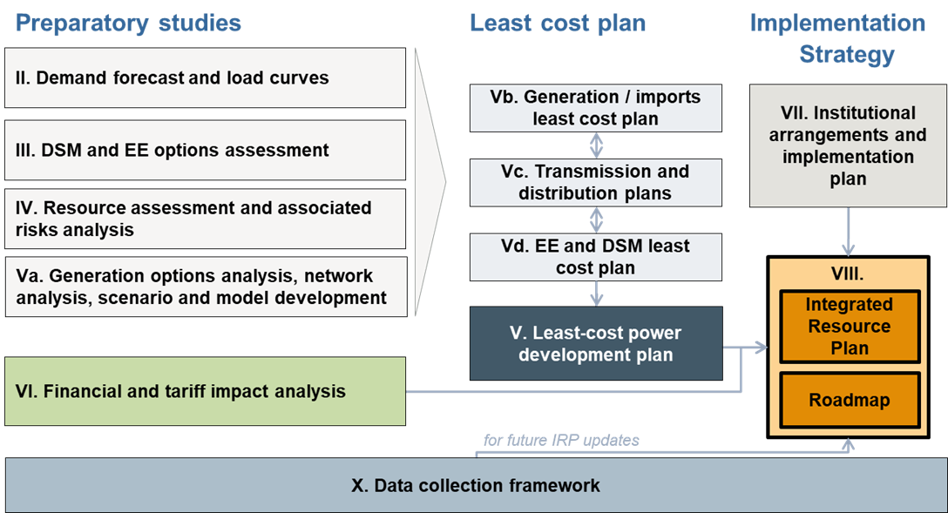
Source: ECA
The draft Least cost plan report presents the resulting least cost plan under several scenarios and is structured as follows.
Section 2: | Summarises the energy and electricity demand forecasts for the next 25 years that were used for the development of the least cost plan.
Section 3: | Summarises the current status of the energy sector in Uganda and projects that were considered certain for development over the coming years
Section 4: | Summarises the modelling approach to derive the least cost plans under each scenario.
Section 5: | Summarises policy targets considered in the IERMP and the scenarios of the IERMP.
Section 6: | Summaries candidate supply and network options that were considered as possible options to be developed in the future.
Section 7: | Presents the resulting EE, DSM, generation and storage least cost plan by scenario.
Section 8: | Present the transmission and distribution least cost plans by scenario.
Section 9: | Present the distribution and electrification least cost plan
Section 10: | Discusses key policy considerations resulting from the least cost plan.
Section 11: | Summarises the investment schedule and actions needed to implement the plan in the short run (over the next five years) for the preferred scenario.

Demand forecast
As part of the preparatory studies conducted for the development of the IERMP, a demand forecast for energy and electricity was developed capturing a range of outlooks for the energy sector in Uganda.

Demand forecast scenarios
Four demand forecast scenarios up to 2050 have been developed to capture future outlooks of the energy sector in Uganda which encompass a wide range of possible paths for energy demand due to macroeconomic and demographic changes, policy goals, and other sectorial variables:
- Base transition scenario (BT) – Assumes the implementation of current policies and plans following ongoing trends, and commitments. Economic growth is forecast to grow at an average rate of 5.4% per year. The country continues its drive to industrialisation and the adoption of electricity as the main source of energy. This continues the transition towards an industrial and services-based economy.
Industrial developments, tariff reform, electrification of transport, adoption of clean cooking, energy efficiency measures, and loss reduction measures are assumed to be implemented as planned. Nonetheless, the probability of occurrence for uncertain projects and measures is assumed to be low (50% probability) following historical trends.
- Delayed transition scenario (DT) – This scenario tries to capture impacts of unprecedented events which may result in slower economic growth and a delay in the implementation of existing plans and policy targets. Such events may include climate change impacts (cyclones, temperature changes, droughts, etc), global conflicts affecting the international market (as the wars seen recently in Ukraine and the Middle East), pandemics (as with COVID-19 pandemic) and others. In this scenario, GDP is forecasted to grow at 3.8% per year on average.
As a result, official plans and policies are implemented with a delay or not at all due to constraint finances from low economic growth. Industrial investments, electrification of transport and adoption of clean cooking solutions are not fully implemented, while other DSM and loss reduction measures are implemented with less success (10% probability).
- Tenfold growth strategy scenario (TGS) – This scenario assumes that high sustained economic growth is kept along the forecast period, allowing Uganda to meet its target of increasing its nominal GDP to 500 billion US$ by 2040. This scenario follows the evolution of the energy sector as forecasted in the 2023 IEA’s Energy Transition Plan for Uganda with average GDP growth of 7.3% each year until 2040 and then slowing to a rate of 4% by 2050 as the economy matures. These high rates of growth are accompanied with ambitious goals for the electrification of transport, adoption of clean cooking, and emissions’ reductions across all sectors of the economy.
All new industrial loads, DSM and loss reduction measures are fully implemented (100% probability) due to the high attraction of investments in the country, which results in a high increase in the use of efficient energy sources, mainly electricity.
- Policy targets scenario (PT) – This scenario reflects the power sector targets set by the National Energy Policy 2023 in addition to all other targets of the Tenfold growth strategy scenario. High economic growth increases electricity demand above all other scenarios reaching 52 GW in 2040. Thereafter, the economy has reached high maturity, which reduces its annual growth rates to ~1% reflecting levels seen in other advanced economies.

Demand forecasting approach
The energy demand forecast for Uganda was developed using a bottom-up approach where the final energy consumption for each economic sector (ie residential, services, industrial, transport, and other) has been forecasted for the 2024-2050 period. This forecast is then disaggregated based on the expected fuel sources used for each sector, with electricity being inputted from the more detailed electricity demand forecast. This approach allows for the incorporation of key trends in the sector, including the electrification of sectors, the transition towards modern cooking solutions, and the phasing-out of biofuels and waste as the main source of energy in the country.
The electricity demand forecast for Uganda was developed using a bottom-up approach where the expected energy sales of each customer category (ie domestic, commercial, industrial, streetlighting, EVs, and exports) are forecasted individually through a combination of end-use forecasting, trend analysis, and econometric analysis. Losses, both technical and non-technical, are included at the distribution and transmission levels to obtain the sent-out energy and peak demand forecasts. The resulting forecast is then disaggregated to each sub-region and transmission zone reflecting demographic changes, electrification targets, and the location of expected large industrial loads.

Summary of demand forecast input assumptions
The following table summarises the main input assumptions used for the development of the energy and electricity demand forecast for each scenario.

Table 1 Summary of input assumptions by scenario
 |  |  | Year
Parameter | Unit | Scenario (average) | 2025 | 2030 | 2035 | 2040 | 2045 | 2050
GDP growth | % | DT (3.8%) | 4.4% | 4.4% | 4.1% | 3.7% | 3.4% | 3.0%
 |  | BT (5.7%) | 5.9% | 5.9% | 6.5% | 6.5% | 4.1% | 3.5%
 |  | TGS (6.2%) | 5.9% | 8.0% | 6.8% | 6.0% | 4.4% | 4.0%
 |  | PT (8.6%) | 15.0% | 17.5% | 9.5% | 4.5% | 1.5% | 0.9%
GDP composition | % of total GDP | DT | Increase of the services’ sector from 42.5% of GDP in 2024 to 44.5% in 2050; industrial sector increasing from 25.2% to 28.1%, and agricultural sector decreasing from 24.6% to 20%.
 |  | BT | Increase of the services’ sector from 42.5% of GDP in 2024 to 44.5% in 2050; industrial sector increasing from 25.2% to 28.1%, and agricultural sector decreasing from 24.6% to 20%.
 |  | TGS | Increase of the services’ sector from 42.5% of GDP in 2024 to 44.5% in 2050; industrial sector increasing from 25.2% to 28.1%, and agricultural sector decreasing from 24.6% to 20%.
 |  | PT | Increase of the services’ sector from 42.5% of GDP in 2024 to 44.5% in 2050; industrial sector increasing from 25.2% to 28.1%, and agricultural sector decreasing from 24.6% to 20%.
Population | Million people | DT | 47.8 | 54.8 | 61.9 | 70.5 | 76.2 | 83.5
 |  | BT | 47.8 | 54.8 | 61.9 | 70.5 | 76.2 | 83.5
 |  | TGS | 47.8 | 54.8 | 61.9 | 70.5 | 76.2 | 83.5
 |  | PT | 47.8 | 54.8 | 61.9 | 70.5 | 76.2 | 83.5
Electrification targets | % of households with grid and off-grid access | DT | - | - | - | 80% | - | -
 |  | BT | - | - | - | 100% | - | -
 |  | TGS | - | - | - | 100% | - | -
 |  | PT | - | - | - | - | - | -
 | % of households with grid access | DT | - | - | - | - | - | 70%
 |  | BT | - | - | - | - | - | 80%
 |  | TGS | - | - | - | - | - | 80%
 |  | PT | - | - | - | - | - | 80%
Average tariff increases | % | All | No real-term tariff increases were assumed. Tariffs were assumed to increase only with inflation.
Step-loads | % | DT | Plans implemented with a delay. Low probability of uncertain projects to materialise (10%)
 |  | BT | Plans implemented as planned. Average probability of uncertain projects to materialise (50%)
 |  | TGS | Plans implemented as planned. High probability of uncertain projects to materialise (100%).
 |  | PT | Plans implemented as planned. High probability of uncertain projects to materialise (100%).
 |  | Details for the step loads considered in the forecast are shown in Annex A1.
Exports | MW | All | Existing export contracts were considered as firm commitments throughout the planning horizon.  New potential export contracts were considered in the demand forecast with varying degrees of probability of occurrence for each scenario as shown in Annex A2.
EVs fleet | Units by 2050 | DT | Up to 10.1 million as indicated in the Energy Transition Plan, with a low probability of occurrence (10%)
 |  | BT | Up to 10.1 million as indicated in the Energy Transition Plan, with a medium probability of occurrence (50%)
 |  | TGS | Up to 10.1 million as indicated in the Energy Transition Plan, with a high probability of occurrence (100%)
 |  | PT | Up to 10.1 million as indicated in the Energy Transition Plan, with a high probability of occurrence (100%)
Transmission system losses (electricity) | % of energy entering the grid | DT | 4.7% | 4.5% | 4.2% | 4.0% | 3.7% | 3.5%
 |  | BT | 4.7% | 4.4% | 4.1% | 3.8% | 3.5% | 3.2%
 |  | TGS | 4.7% | 4.3% | 4.0% | 3.6% | 2.9% | 2.9%
 |  | PT | 4.7% | 4.3% | 4.0% | 3.6% | 2.9% | 2.9%
Distribution system losses (electricity) | % of energy entering the grid | DT | 17.2% | 16.7% | 16.3% | 15.9% | 15.4% | 15.0%
 |  | BT | 17.0% | 16.1% | 15.2% | 14.3% | 13.4% | 12.5%
 |  | TGS | 16.8% | 15.4% | 14.1% | 12.7% | 10.0% | 10.0%
 |  | PT | 16.8% | 15.4% | 14.1% | 12.7% | 10.0% | 10.0%
System load factor (electricity) | % | DT | 69.5% | 69.5% | 69.5% | 69.5% | 69.5% | 69.5%
 |  | BT | 69.5% | 69.5% | 69.5% | 69.5% | 69.5% | 69.5%
 |  | TGS | 69.5% | 69.5% | 69.5% | 69.5% | 69.5% | 69.5%
 |  | PT | 69.5% | 69.5% | 69.5% | 69.5% | 69.5% | 69.5%
Source: ECA assumptions validated during the demand forecast Workshop

Demand forecast, 2024-2050
The results of the demand forecast for each scenario are summarised in the tables below.
Table 2 Energy demand forecast, 2024-2050
Parameter | Unit | 2023 | 2025 | 2030 | 2035 | 2040 | 2045 | 2050
 | Base transition scenario
Final energy consumption | PJ | 738 | 673 | 666 | 721 | 854 | 890 | 934
Oil products | PJ | 68 | 98 | 127 | 144 | 153 | 149 | 133
Electricity | PJ | 17 | 30 | 105 | 191 | 351 | 434 | 535
Biofuels and waste | PJ | 641 | 530 | 415 | 363 | 323 | 278 | 235
Coal | PJ | 5 | 7 | 10 | 10 | 11 | 10 | 9
Others | PJ | 8 | 8 | 11 | 13 | 17 | 20 | 23
 | Tenfold growth strategy scenario
Final energy consumption | PJ | 738 | 679 | 721 | 829 | 1,052 | 1,103 | 1,175
Oil products | PJ | 68 | 98 | 131 | 151 | 160 | 155 | 140
Electricity | PJ | 17 | 36 | 139 | 273 | 527 | 625 | 753
Biofuels and waste | PJ | 641 | 530 | 428 | 379 | 335 | 289 | 245
Coal | PJ | 5 | 7 | 11 | 11 | 12 | 11 | 10
Others | PJ | 8 | 8 | 12 | 15 | 19 | 22 | 26
 | Delayed transition scenario
Final energy consumption | PJ | 738 | 688 | 635 | 636 | 653 | 658 | 669
Oil products | PJ | 68 | 100 | 123 | 133 | 135 | 129 | 115
Electricity | PJ | 17 | 22 | 43 | 75 | 122 | 161 | 212
Biofuels and waste | PJ | 641 | 550 | 451 | 409 | 377 | 348 | 322
Coal | PJ | 5 | 8 | 9 | 9 | 8 | 7 | 6
Others | PJ | 8 | 8 | 9 | 10 | 11 | 13 | 14
 | Policy targets scenario
Final energy consumption | PJ | 738 | 712 | 971 | 1,348 | 1,770 | 1,881 | 1,866
Oil products | PJ | 68 | 102 | 175 | 233 | 254 | 236 | 193
Electricity | PJ | 17 | 40 | 203 | 491 | 939 | 1,159 | 1,287
Biofuels and waste | PJ | 641 | 552 | 553 | 565 | 507 | 414 | 319
Coal | PJ | 5 | 8 | 19 | 26 | 27 | 24 | 19
Others | PJ | 8 | 10 | 21 | 34 | 43 | 48 | 48
Source: ECA analysis

Table 3 Electricity demand forecast, 2024-2050
Parameter | Unit | 2023 | 2025 | 2030 | 2035 | 2040 | 2045 | 2050
 | Base transition scenario
Sent-out energy demand | GWh | 6,012 | 9,971 | 32,971 | 59,604 | 107,940 | 133,444 | 163,996
Sent-out peak demand | MW | 988 | 1,757 | 5,061 | 8,998 | 16,020 | 20,410 | 25,672
Load factor | % | 69.5% | 64.8% | 74.4% | 75.6% | 76.9% | 74.6% | 72.9%
Energy sales | GWh | 4,815 | 8,412 | 29,043 | 53,093 | 97,454 | 120,428 | 148,475
Domestic | GWh | 966 | 1,755 | 7,838 | 15,684 | 27,794 | 39,953 | 54,175
Commercial | GWh | 507 | 630 | 1,264 | 2,307 | 4,212 | 6,528 | 9,293
Industrial* | GWh | 2,854 | 4,521 | 18,153 | 32,851 | 62,525 | 70,132 | 80,082
Streetlighting | GWh | 3 | 3 | 7 | 11 | 15 | 18 | 22
Electric Vehicles | GWh | - | 71 | 351 | 809 | 1,477 | 2,366 | 3,472
Exports | GWh | 485 | 1,430 | 1,430 | 1,430 | 1,430 | 1,430 | 1,430
 | Tenfold growth strategy scenario
Sent-out energy demand | GWh | 6,012 | 11,532 | 42,368 | 81,473 | 153,702 | 182,870 | 220,987
Sent-out peak demand | MW | 988 | 2,058 | 6,407 | 11,998 | 22,120 | 27,260 | 33,956
Load factor | % | 69.5% | 64.0% | 75.5% | 77.5% | 79.3% | 76.6% | 74.3%
Energy sales | GWh | 4,815 | 10,007 | 38,606 | 75,926 | 146,388 | 173,655 | 209,178
Domestic | GWh | 966 | 1,755 | 8,478 | 17,379 | 30,501 | 44,512 | 62,136
Commercial | GWh | 507 | 630 | 1,497 | 2,871 | 5,042 | 7,928 | 11,748
Industrial* | GWh | 2,854 | 5,324 | 25,771 | 51,896 | 105,725 | 114,313 | 126,175
Streetlighting | GWh | 3 | 3 | 7 | 11 | 15 | 18 | 22
Electric Vehicles | GWh | - | 143 | 702 | 1,619 | 2,954 | 4,732 | 6,944
Exports | GWh | 485 | 2,151 | 2,151 | 2,151 | 2,151 | 2,151 | 2,151
 | Delayed transition scenario
Sent-out energy demand | GWh | 6,012 | 7,490 | 14,451 | 24,736 | 39,678 | 52,621 | 69,131
Sent-out peak demand | MW | 988 | 1,312 | 2,403 | 3,985 | 6,252 | 8,418 | 11,178
Load factor | % | 69.5% | 65.2% | 68.7% | 70.9% | 72.4% | 71.4% | 70.6%
Energy sales | GWh | 4,815 | 6,038 | 11,890 | 20,741 | 33,837 | 44,756 | 58,807
Domestic | GWh | 966 | 1,509 | 4,163 | 7,600 | 12,086 | 17,803 | 24,931
Commercial | GWh | 507 | 614 | 931 | 1,384 | 1,996 | 2,787 | 3,772
Industrial* | GWh | 2,854 | 3,413 | 6,237 | 11,102 | 18,965 | 23,194 | 28,907
Streetlighting | GWh | 3 | 3 | 5 | 7 | 10 | 13 | 17
Electric Vehicles | GWh | - | 14 | 70 | 162 | 295 | 473 | 694
Exports | GWh | 485 | 485 | 485 | 485 | 485 | 485 | 485
 | Policy targets scenario
Sent-out energy demand | GWh | 6,012 | 12,916 | 63,940 | 152,796 | 284,573 | 352,689 | 390,774
Sent-out peak demand | MW | 988 | 2,286 | 9,952 | 23,717 | 43,624 | 55,164 | 61,855
Load factor | % | 69.5% | 64.5% | 73.3% | 73.5% | 74.5% | 73.0% | 72.1%
Energy sales | GWh | 4,815 | 11,107 | 56,306 | 136,273 | 260,755 | 322,060 | 357,555
Domestic | GWh | 966 | 2,172 | 17,819 | 53,640 | 103,085 | 138,148 | 153,330
Commercial | GWh | 507 | 813 | 4,553 | 13,171 | 24,022 | 32,815 | 36,748
Industrial* | GWh | 2,854 | 5,826 | 31,073 | 65,681 | 128,527 | 144,196 | 158,360
Streetlighting | GWh | 3 | 3 | 7 | 11 | 15 | 18 | 22
Electric Vehicles | GWh | - | 143 | 702 | 1,619 | 2,954 | 4,732 | 6,944
Exports | GWh | 485 | 2,151 | 2,151 | 2,151 | 2,151 | 2,151 | 2,151
Source: ECA analysis. Note: * Includes medium, large, and extra-large industrial customers
The national demand forecast of each scenario was disaggregated by area to inform the transmission and the distribution least cost plans. UETCL uses 7 transmission zones for planning purposes: Central, Eastern, GKM, Jinja Metro, Northern, West Nile and Western. The same definition of zones was adopted to disaggregate the national demand forecast by zone. For the distribution development plan, the national demand forecast was disaggregated by subregion following the definition of subregions shown in the 2024 Census. The subregions include Kampala city, Buganda, Busoga, Bukedi, Bugisu, Sebei, Teso, Karamoja, Lango, Acholi, West Nile, Madi, Bunyoro, Tooro, Rwenzori, Ankole and Kigezi. The regional disaggregation of the demand forecast is shown in Annex A3.

Current supply status and committed projects
The current generation capacity mix in Uganda is dominated by hydro power, making up 83% of installed capacity. The split between large hydro (>20 MW) and small hydro (<20 MW) is 69% and 14% of total installed capacity, respectively. This is followed by 8% from co-generation/bagasse/biomass, 5% thermal generation (fuel oil), and 4% solar. The capacity mix in 2023/24 is illustrated in Figure 2 below.
Figure 2 Installed generation capacity mix, 2023/24
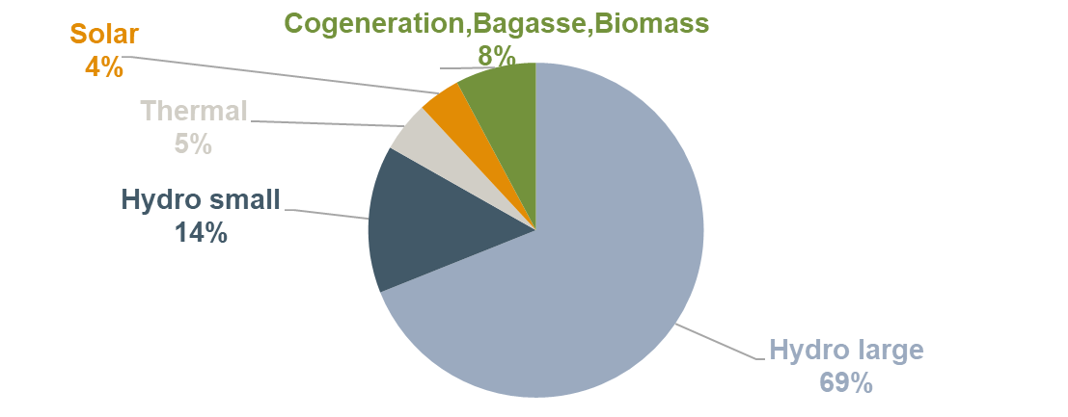
Source: An analysis of Grid Development Plan 2023-40, UETCL
Figure 3 shows the evolution of installed capacity against peak demand from 2018/19 to 2023/24. The addition of Karuma HPP at 600 MW in 2022/23 increased the installed capacity significantly to around 2,050 MW. The installed capacity was adequate to cover peak demand in the past six years with the reserves margin ranging from 65% to 138% (assuming hydro availability).
Figure 3 Installed capacity and peak demand 2018/19-2023/24
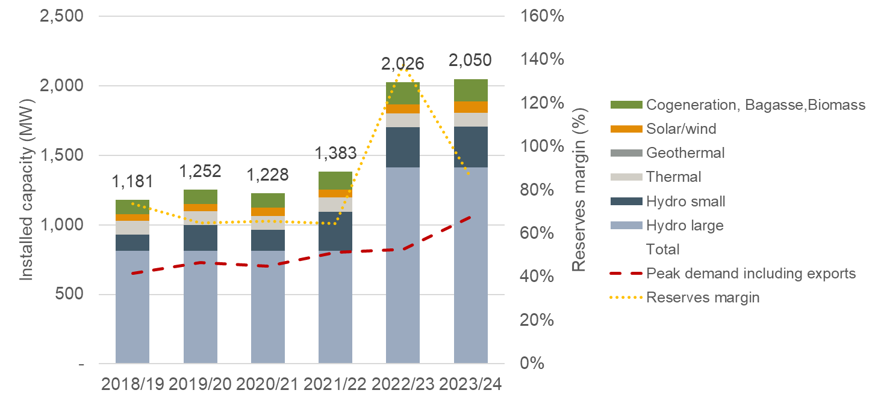
Source: ECA analysis of Grid Development Plan 2023-40, UETCL. Note: Electromaxx thermal power plant with 50 MW installed capacity has been included in graph above although appears to be unavailable for years 2019/20 – 2022/23 (inclusive), 2022/23 and 2023/24 include Karuma HPP at 600 MW.

Existing power plants
The set of existing power plants (and their technoeconomic characteristics) that were considered for the development of the IERMP are shown below.

Existing hydro power plants
As of December 2024, Uganda had seven large hydro power plants (>20 MW). A large number of small hydropower plants (< 20 MW) also exist throughout Uganda. These are all run of river plants typically connected to the distribution grid. The existing hydro power plants and the technoeconomic characteristics of each power plant that were considered for the IERMP are shown in the tables below.
Table 4 Existing large (>20 MW) hydro power plants
Source: Installed capacities, available capacities and commissioning dates were sourced from ERA in 2024 (GenerationStatistics2024.xlsx); Average historical capacity factors were calculated using actual generation data from 2009 sourced from ERA (GenerationStatistics2024.xlsx); Costs and dry year available energy were sourced from Master plan study on hydropower development in Uganda, 2011.
Table 5 Existing small (<20 MW) hydro power plants
Source: Installed capacities, available capacities and commissioning dates were sourced from ERA in 2024 (GenerationStatistics2024.xlsx); Average historical capacity factors were calculated using actual generation data from 2009 sourced from ERA (GenerationStatistics2024.xlsx); Costs and dry year available energy were sourced from Master plan study on hydropower development in Uganda, 2011.

Existing thermal power plants
Seven thermal power plants are currently installed and connected to the grid in Uganda. Two Internal Combustion Engines (ICE) operating with Heavy Fuel Oil (HFO) and five co-generation power plants operating with bagasse. The technoeconomic characteristics of the existing thermal power plants that were considered for the IERMP are detailed below.
Table 6 Existing thermal power plants
Source: MEMD and ERA, 2024. Note: 8 MW of the Electromaxx ICE were transferred to supply off-grid in 2021. The co-generation units are owned by sugar companies and most of their capacity is used for their own use – the effective available capacity for the grid is much lower than the installed capacity of the power plants as detailed in the table above.

Existing solar PV power plants
Seven utility scale solar PV power plants are currently connected to the grid. The first one (Access Solar) was developed in 2016 and the newest power plant (Xsabo Nkonge Solar) was connected in 2024. The total installed capacity of existing solar PV power plants is 84 MW. The technoeconomic characteristics of the existing solar PV power plants that will be considered for the IERMP are detailed in the table below.
Table 7 Existing solar PV power plants
Source: MEMD and ERA, 2024. Note: *The actual historical capacity factor of Busitema Solar and Xsabo Nkonge Solar is unknown and was considered to be equal to the average of the other existing solar PVs.

Existing transmission and distribution network
The existing transmission network, depicted in the figure below, comprise mainly of 132 kV, 220 kV and 400 kV lines plus a short 66 kV line. This includes 606 km of 400 kV, 1002 km of 220 kV, 2875 km of 132 kV, 35.2 km of 66 kV high voltage, 0.9 km of 132 kV Underground cable transmission lines and 35 substations.
Figure 3 Overview of the transmission grid
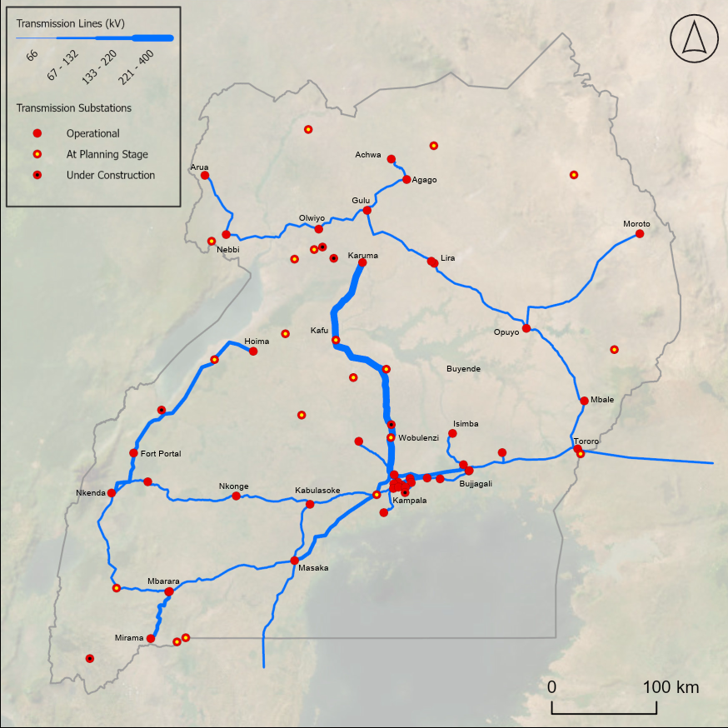
Source: A map of the existing transmission grid in Uganda, Norconsult
In general, the 132 kV network consists of single circuit lines with a single Tiger, Lynx or Goat conductor per phase on the old lines with Starling or All Aluminium Alloy Conductors (AAAC) conductors on newer lines, many of which are double circuit lines. Thermal capacity is relatively low on the older lines and voltage constraints may apply to the longer lines. Notably, many of the lines are relatively old.
The 220 kV system has been developed over recent years and consist of double circuit lines with duplex conductors – mainly running from east to west in the southern part of the country – thereby providing a transmission corridor with relatively high transfer capacity. Some of the 220 kV lines are operated at 132 kV.
Initial development of the 400 kV system consists of a double circuit line from Kawanda substation close to Kampala to Karuma and Olwiyo in the northern part of the country. Our understanding is that the section between Karuma and Olwiyo is operated at 132 kV (pending further extension of the 400 kV system towards the north).

Interconnections to neighbouring countries
Uganda has 5 neighbouring countries and with each is either export, import or energy exchange agreement through both interconnectors and as cross boundary transactions.
- Uganda – Kenya: The network in Uganda has been interconnected with the grid in Kenya via a 132 kV line from Tororo to Lessos for several years. The maximum capacity of the existing line is 40 MW.
- Uganda – Tanzania: Uganda is connected to Tanzania via a 132 kV transmission line. The existing line is currently used only for electricity exports and no imports according to the UETCL system operation data.
- Uganda – Rwanda: A 220 kV connection between Shango in Rwanda and Mbarara in Uganda was completed in June 2023. In the remainder of the year 91.25 GWh of electricity was exported from Uganda to Rwanda with imports of 7.58 GWh.

Distribution network
The distribution network consists of an extended 33 kV and 11 kV system throughout the country. The map in the following figure depicts the main distribution lines (2024).
Figure 3 Map of Uganda’s distribution network
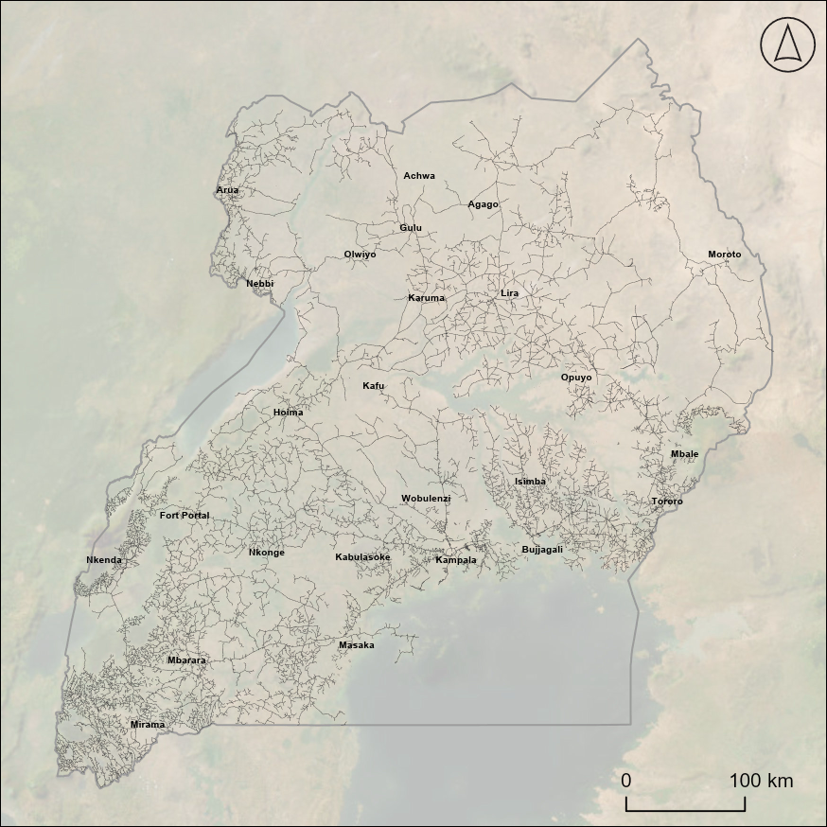
Source: A map of the existing transmission grid in Uganda, Norconsult
A recent report (the National Electrification Survey Report-2018, published by the MEMD, January 2020) states that 51 % of households have access to at least one source of electricity. 24 % of households are connected to the national grid or mini-grids while 27 % depends on off-grid solutions including rechargeable batteries and solar devices.
In urban areas, grid supply is the main source for two of three households while in urban areas one of three use off-grid solutions as their primary source of electricity (mainly solar systems).

Current EE and DSM measures
Several EE and DSM measures had been implemented in the past and were completed with success including:
- distribution of compact fluorescent lamps to households in 2007, resulting to a reduction of demand by 32 MW;
- installation of energy efficient equipment in public institutions during 2007-2012, resulting to savings of 10 GWh;
- financial support (coverage of 50% of the capital cost) for power factor correction during 2011-2014, leading to a demand reduction of 8.6 MW;
- financial support (coverage of 50% of the capital cost) for the installation of solar water heaters, during 2011-1014, resulting to peak shaving by 3.9 MW; and
- energy management training workshops carried out in 2015.
As of 2017, EE and DSM measures that were under implementation (still on-going) included:
- Industrial energy audits – energy audits in more than 50 high-energy-consuming industries and commercial facilities had been carried out under various projects, reducing energy consumption by about 10 GWh.
- Efficiency standards and labelling – such standards were developed and issued in 2012 for lighting, refrigerators, freezers, motors, and air conditioners, but the relevant regulations for enforcement had not been issued, hence the standards had not been implemented. This is included in the draft Energy Efficiency and Conservation Bill which is now approved by the Government and expected to be introduced to the Parliament for discussion.
- Awareness – mainly the annual Energy Week, a platform for large public announcements, such as LED distribution, and for exhibiting and demonstrating technologies.
- City leadership – according to the Roadmap, the Kampala Capital City Authority (KCCA) conducted energy audits for selected municipal buildings and introduced pilot Energy Efficiency measures including occupancy sensors, lighting timers for corridors, and sensor-controlled outdoor lights.
As of 2024, no other new measures are under implementation.

Committed projects
A committed project is one for which a contract has been signed or some other commitment has been made that makes it costly in financial or political terms to retract from that commitment. Committed projects were considered certain for development in the IERMP.
Three hydro power plants which are under construction and one Solar PV project were considered as committed power plants for the IERMP. These are shown in the table below. No other power plants have reached financial closure to be considered as committed power plants for the IERMP.
Table 8 Committed power plants
Source: UTCL grid development plan (2023-2024); Deep Earth International 2024, "Testing of Kigwabya hydro to start soon"; Synatra Energy - Kiraboha hydro specification; UEGCL, 2023, "Nyagak III nears completion"; AMEA Power announces groundbreaking of 24 MWp Solar PV Project in Uganda and MEMD.
The following 400 kV transmission projects are understood to be at an advance stage of development.
Table 3 Main 400 kV transmission lines being considered
Projects | Status | Expected commissioning year
Masaka – Mbarara: 135 km 400 kV transmission line and associated substation | Procurement process is ongoing | 2028
Tororo – Karuma: 345 km 400 kV transmission line | Procurement of EPC Contractor | 2030
Masaka – Wobulenzi: 151 km 400 kV transmission line and associated substations | Feasibility stage | 2028
Source: UTCL grid development plan (2023-2024)

Short-term capacity gap to be met by candidate projects
The following figure shows the amount of firm capacity that will be needed from new projects over the coming years. By 2030, 3,165 MW of new firm capacity will be needed to meet peak demand and prevent unserved load in the base transition scenario.
Figure 4 Short-term capacity gap to be met by candidate projects
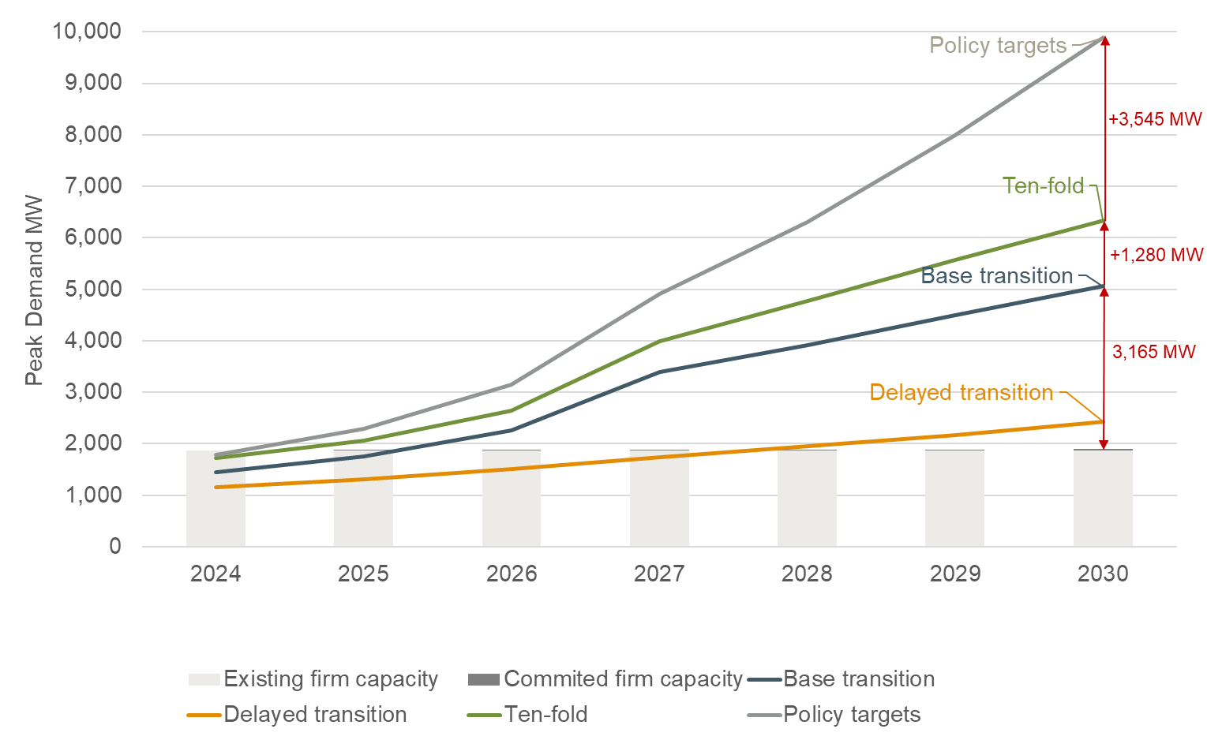
Source: ECA analysis

Least cost plan approach
Least-cost generation development plans for any power system are prepared by identifying a set of candidate plants and supply options and assessing the present-valued economic costs (capital, fuel and operating costs) of alternative sequences and combinations of investments that satisfy demand over the planning horizon (26-year projection starting from 2024) at a given level of reliability.
The least cost planning analysis is conducted in economic terms using appropriate shadow pricing and external costs where appropriate. In an economic analysis, historical costs are treated as sunk, taxes and subsidies are excluded and an appropriate economic/social discount rate is used. Climate change, electrification, environmental, social and other policy targets were also taken into consideration in choosing the optimal plan. This was done by placing an explicit value reflecting the targets that have to be met by specific dates.
The output of the least cost plan is an optimised generation, transmission, and demand side management (DSM) development plan covering a 25-year period with associated costs for each scenario. The plan determines the optimal mix of imported and domestically produced electricity (including renewables) for different scenarios. The generation proposals are complemented by a transmission plan incorporating essential grid services for system stability and reliability, also addressing the current bottleneck situation. A risk analysis was also conducted to assess demand risks, supply risks, security of supply risks, environmental and social risks, and policy implications risks for the optimised portfolios.

Generation, storage, EE/DSM and transmission plan approach
The generation least cost plan was produced by assessing all possible combinations of supply and demand side management options and selecting the combination of options that meets the demand at lowest cost subject to technical constraints and policy targets. This involved the simulation of the dispatch of the system in Uganda at hourly intervals for the planning horizon to capture variations of supply and demand at hourly intervals. The software that was used for the IERMP is PLEXOS.
The analysis was carried out through a fully iterative process that links long-term generation expansion modelling in PLEXOS with detailed transmission system studies in PSS/E. This approach ensures that the least-cost investment pathway is economically optimal both from a generation and transmission perspective. It also ensures that the least cost plan is technically feasible, taking account of operational constraints, system security, and renewable variability.
The steps to derive the least cost plan are described below and illustrated in Figure 5:
- Initially, the least-cost generation and transmission plan were simulated in PLEXOS model considering existing, committed and candidate generator/storage and transmission lines.
- In a second step, costs to connect the selected least cost generators/storage and to evacuate the power to demand centres was assessed using PSS/E. Transmission simulations in PSS/E test the feasibility of the optimised plan under hourly load, renewable variability, and contingency conditions.
- The identified connection and network costs were then introduced into the PLEXOS model to re-run the optimisations. This second run considers network costs to connect generators and evacuate the power to demand centres and therefore optimises the generation assets considering network costs as well.
- This process was repeated until the generation and transmission plans converge on a consistent least-cost solution (feedback loop, repeating steps 1-3 until convergence between PLEXOS and PSS/E results is achieved).
Figure 5 Generation and transmission least cost plan modelling process
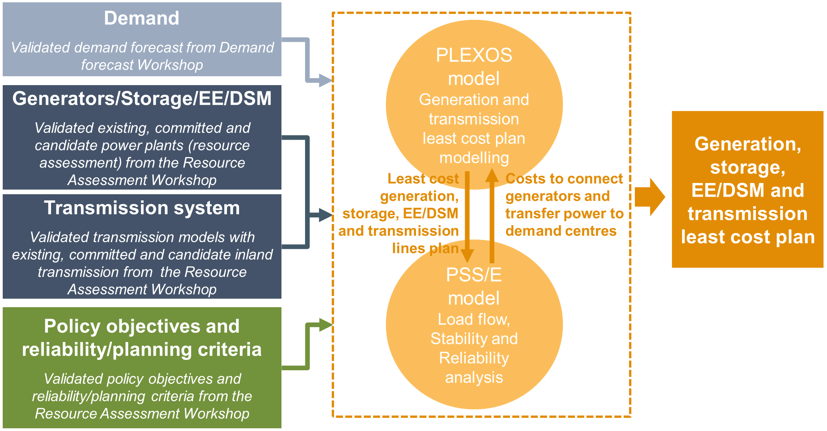
Source: ECA
As indicated above, dispatch modelling was carried out at hourly resolution over the planning horizon to capture the variability of demand and the intermittency of renewable generation (solar, wind, hydropower). This allows the assessment of system adequacy, reserve requirements, and the ability to integrate variable renewable energy at scale.
The simulations generate a wide range of outputs including:
- total and annual capital expenditures, operating costs, and fuel costs,
- emissions trajectories,
- capacity factors,
- average and marginal generation costs, and
- reserve margins and adequacy indicators.
The generation planning model incorporates the subregional zones for which demand is broken into as discussed in section 2.4. The transfer limits between zones are informed based on analysis of the existing transmission network. Candidates to enable expansion in the transfer capacities between subregions are included.
The work on the transmission expansion plan builds on the load forecast and the generation expansion planning process described above. The power system studies also take account of import/export options and work on the identification of suitable RES power plants locations. On the latter, the analysis of the power system also supported the identification of grid capacity for connection of intermittent renewable plants – both from the point of grid capacity in the local area and the system’s ability to integrate highly variable output from wind and solar PV power plants.
The transmission expansion plan ensures that evacuation of power from plants included on the power generation plan can be facilitated while meeting the expected load growth throughout the system. Different grid options, both with respect to voltage and conductor size and configuration, were assessed to arrive at an optimum reinforcement and expansion plan. The study considered cost of investments, cost of technical losses and cost of operation and maintenance of each option. The planning criteria will ensure a minimum level of reliability, however, where higher levels of reliability may be justified, the study will also take account of cost of supply interruptions in the economic assessment of relevant projects.
Furthermore, fault levels were documented for all substations in the grid to provide background information on the rating of main equipment (ie, along with information on maximum loading as provided by the load flow studies).

Distribution plan and electrification
The work for the development of the distribution least cost plan built on the electrification plans developed under the MEMD and the World Bank, and the on-going works on demand forecast, energy efficiency, and year-to-year tariff supported customer connection programs. From these documents and the Consultant’s experience from similar electrification programs, costs of reinforcement and extension of the distribution systems to meet growth in demand and an increased electrification ratio were assessed.

Planning criteria
The primary objective of generation expansion planning is to find the least cost long-term expansion scenario that supplies the forecast demand at an acceptable or specified level of reliability.

Generation planning criterion
The grid code of Uganda requires “the operating reserves to be large enough to cover the loss of the largest generating unit in the system.” Assuming that the largest unit of the system is Karuma units (eg 100 MW) and that peak demand in 2023 was 986 MW, the required reserves margin would be 10%. UETCL’s Corporate Strategic Plan 2024-2029 published in 2024 also outlines a target reserve margin of 10%.
In line with the planning criteria set in Uganda, reliability of supply in IERMP will be ensured by targeting a reserve margin (deterministic criterion) of 10% of firm capacity above the peak demand. The same reserve margin was used throughout the study horizon.
The contribution of different generating technologies to the reserves margin is an important parameter ensure security of supply. The contribution of different generating technologies to the reserves margin was determined by the minimum available level of production at the time of peak demand. For storage options, the derating factor was set to 0% for 1h duration batteries, 25% for 2h duration batteries and 50% for 4h duration batteries.

Transmission network planning criteria
The “Grid Development Plan 2023-2040” prepared by UETCL is understood to be based on a typical N-1 planning criteria matching the criteria for the grid in the EAPP. During the Resource Assessment Workshop it was agreed to use similar criteria for the studies to be conducted as part of the preparation of the IERMP.
The N-1 reliability criterion ensures that the transmission system can sustain the outage of a single element (for instance a transmission line or power transformer) without loss of load or loss of synchronism – thereby avoiding cascading faults that may black-out part (or all) of the system. To the extent that cost of losses or cost of outages justifies further investment, such investment was considered to ensure that the system provides an overall least cost solution considering generation options and supply to load centres.
The planning criteria applied by UETCL furthermore allows for short-time overload up to 120% of the continuous thermal rating although this is “depending on the age and physical condition of the equipment”. Considering the uncertainties in future development and load growth, it was agreed to carry out the IERMP based on no short-time overload, thereby leaving room for operational margins. The thermal capacity for all components weas therefore set at 100% of the rated continuous capacity. Substation voltages were limited to +/- 5 % of normal voltages in normal operation and +/- 10 % during contingencies as shown in the table below.
Table 9 Voltage limits under normal and contingency operation (kV)
Voltage level | Normal operation |  | N-1 contingencies
 | Minimum | Maximum | Minimum | Maximum
400 kV system | 380 | 420 | 360 | 420*
220 kV system | 209 | 231 | 198 | 242
132 kV system | 125.4 | 138.6 | 118.8 | 145
66 kV system | 62.7 | 69.3 | 59.4 | 72.6
Source: Grid Development Plan 2023-2040” prepared by UETCL. Note: UETCL states 440 kV as the maximum value in this case. Maximum equipment rating is 420 kV and operation at higher voltages should be limited to ensure no damage to the equipment on the system.
It was assumed that the power factor of the loads on the system will be corrected at distribution level or by switched compensation in key substations. Main power plant generators on the system and any dynamic VAR systems (SVCs, STATCOMs) will be used to support reactive power requirements following disturbances on the system. Line shunt reactors were included when required to ensure safe energisation of long lines.

Economic and financial parameters

Discount rates
The analysis is carried out using a social discount rate (SDR) which is the rate of discount which reflects society's preference for present as opposed to future consumption, i.e. a measure of society's inter-temporal and inter-generational preferences. The SDR can also be thought of as the rate of return on capital expected by society, rather than the investment criteria that may be used by the private sector.
Because the SDR in the first interpretation is essentially a value judgment, it is not appropriate that the value be set by outside consultants. It is rather a key parameter to be set by the IRP Working Group.
Typical practice for national economic studies is to set the SDR at between 6% and 10%. This rate is then used in this study to calculate the net present value (NPV) of input and output costs, expressed in real terms. High SDRs like 10% favour short-term gains while lower SDR values make it more likely that projects will be chosen with high up-front costs and social and environmental benefits spread over the long term. Renewable energy projects have cost-benefit profiles that fit this pattern, so low discount rates support decarbonisation.
For this IERMP it was agreed to use a social discount rate of 10%.

Cost and present worth datum
All costs are expressed in constant 2023 prices. All present worth and discounting calculations will also use 2023 as the reference point.

Duties and taxes, interest during construction
Duties, taxes, and interest are not included in this economic study. Interest is a financial cost and as such is excluded from the economic evaluations. The construction period varies by technology, and this affects the cost to develop the projects in present value terms. This is considered by distributing the capital expenditure over the entire construction period.

Planning horizon
As per the requirement outlined in the TOR, the plan is to cover a development period of 25 years and it is intended to model the system from 2023 to 2050.

IERMP scenarios and policy targets
Scenarios and sensitivities were modelled to handle the uncertainty of key assumptions and provide insights to key policy questions. The scenarios and sensitivities assessed in the IERMP are outlined in Table 10. This selection was agreed following discussions with stakeholders at the Resource Assessment Workshop. In total, fourteen scenarios and sensitivities were simulated for the IERMP.
Table 10 Scenarios and sensitivities for the IERMP
Scenario name | Demand scenario | Supply scenarios and emission targets
Scenarios
Unconstrained | Base transition | - No policies, targets or constraints
This scenario is used as a Benchmark scenario to compare costs and benefits across scenarios.
Delayed  transition | Delayed transition | - Net-zero electricity sector emissions by 2050  - 18.8% GHG reduction by 2030
The delayed transition scenario reflects a slow economic growth trajectory.
Base transition | Base transition | - Net-zero electricity sector emissions by 2050  - 18.8% GHG reduction by 2030
The Base transition scenario reflects the forecasted economic growth by international institutions and the government of Uganda and the implementation of policies and plans of the Government of Uganda.
Ten-fold growth strategy | Ten-fold growth strategy | - Net-zero electricity sector emissions by 2050  - 18.8% GHG reduction by 2030
The Ten-fold growth strategy scenario reflects the Ten-fold growth strategy of the Government of Uganda.
Policy targets | Policy targets | - Net-zero electricity sector emissions by 2050  - 18.8% GHG reduction by 2030  - Vision 2040 and NEP 2023 generators capacity targets
The Policy targets scenario adopts the economic growth, policies and plans mentioned in NEP 2023.
Dry hydro conditions | Base transition | - The available generation of hydro power plants is limited due to drought.
The Dry hydro conditions scenario considers the impact of climate change on the least cost plan assuming dry hydro conditions (available generation of hydro power plants is limited to energy production levels of historical dry years) prevailing throughout the planning horizon.
Nuclear path | Base transition | - Force nuclear to the mix in 2032 as dictated by the 2023 NEP.
The Nuclear path scenario forces nuclear power plants (Buyende I 1,300 MW in 2033 and Buyende II 1,000 MW in 2035) to the capacity mix as dictated by the 2023 NEP. It assesses the impact from enforcing the nuclear policy to the capacity mix.
Forced gas | Base transition | - Enforce the development of the gas pipeline between Uganda and Tanzania in 2033
The forced gas scenario explores the least cost plan assuming that a natural gas pipeline between Uganda and Tanzania is built in 2033. Therefore, it assesses the impact from a policy decision to develop the gas pipeline.
Forced gas & nuclear | Base transition | - Enforce the development of the gas pipeline to Tanzania in 2033 and nuclear power plant in Buyende at the earliest available date
The forced gas and nuclear scenario explores the least cost plan assuming that both the natural gas pipeline to Tanzania and the nuclear site in Buyende I are built at the earliest available date. Therefore, it assesses the impact from a policy decision to develop both the gas pipeline and Buyende I nuclear plant (impact on system costs and on the investment/capacity plan).
Delayed nuclear development | Base transition | - Delay the earliest date nuclear power can be developed by 5 years (eg from 2033 to 2038)
The Delayed nuclear development scenario explores the least cost plan assuming that nuclear power cannot be implemented as planned (eg in 2033) but later.
Regional integration | Base transition | - Allow imports from EAPP (all other scenarios will not allow imports from EAPP and will be modelled to support self-sufficiency)
The Regional integration scenario allows imports from EAPP to explore the benefits and costs from regional integration.
Rapid reduction of RES/BESS capital costs | Base transition | - Rapid reduction in BESS & RES capital costs
All other scenarios assume that RES and BESS capital costs reduce over time. This sensitivity will explore the impact on the least cost plan with a more rapid decrease on RES and BESS capital costs in comparison to the other scenarios.
Discount rate +/-3% | Base transition | - Discount rate adjusted up and down 3%
This sensitivity explores the impact of lower or higher discount rates on the least cost plan.
Source: Agreed with MEMD and stakeholders during the Preliminary studies Workshop.
Note: The policy targets considered in the IERMP were analysed in detail in the Resource Assessment report and are summarised in Annex A4.
Only the Policy targets scenario includes supply side targets taken from the Vision 2040 and NEP 2023 documents. This reflects that the inferred generation from supply targets are significantly higher than the forecasted base demand. Therefore, the Policy targets scenario uses an expanded demand forecast consistent with the expansion in supply targeted by policy. The high gas scenario and delayed gas scenarios were removed and replaced with the forced gas and forced gas and nuclear scenarios after observing that gas was not selected in the least cost plan in the base transition scenario.

Candidate options
The following section summarises the candidate investment options that were agreed with key stakeholders to considered for the IERMP in Uganda. These options span demand-side and supply-side measures, including energy efficiency and demand-side management, power generation and energy storage technologies, and transmission and distribution network investments. Together, these options form the basis for assessing least-cost pathways to ensure reliable, affordable, and sustainable power system development that meets forecasted demand.

EE and DSM
The IERMP least cost plan approach included EE and DSM candidate options whereby EE investments focus in replacing inefficient technology that can reduce energy demand and DSM focus in shifting or curtailing demand. The assessment EE and DSM candidate measures was discussed in detail in the Energy Efficiency and Demand Side Management Measures report and a summary of the candidate EE and DSM measures agreed to be considered for the IERMP are reported in Table 11.
Table 11 Candidate EE and DSM measures for the IERMP
Name of measure | Earliest year available | Lifetime | Capital costs per user | Fixed O&M cost | Maximum penetration rate | Peak demand reduction | Energy demand reduction
 | (year) | (years) | (US$) | (US$/ year) | (% of sector users connected) | (% of total annual system peak demand) | (% of total annual sector energy demand)
Residential sector
Urban LED lighting (4.8/user) | 2026 | 10 | 2.98 | 3% of capex | 67% | 16% | 15%
Rural LED lighting (2.98/user) | 2026 | 10 | 2.42 | 3% of capex | 87% | 22% | 20%
Urban efficient refrigerator (1/user) | 2026 | 6 | 337.5 | 3% of capex | 6% | 2% | 12%
Rural efficient refrigerator (1/user) | 2026 | 6 | 337.5 | 3% of capex | 6% | 1% | 11%
Urban efficient fan (2/user) | 2026 | 2 | 999.0 | 3% of capex | 8% | 1% | 2%
Rural efficient fan (2/user) | 2026 | 2 | 999.0 | 3% of capex | 3% | 2% | 3%
Commercial sector
Low-flow faucet aerator | 2026 | 5 | 6.76 | 3% of capex | 23% | 0.1% | 7%
High-efficiency reach-in cooler | 2026 | 5 | 402.30 | 3% of capex | 23% | 0.4% | 1%
LED lighting | 2026 | 8 | 29.70 | 3% of capex | 23% | 1% | 20%
Heat pump water heater | 2026 | 8 | 3440.15 | 3% of capex | 100% | 1% | 8%
Variable speed drive on chiller system | 2026 | 8 | 294.08 | 3% of capex | 23% | 0.4% | 1%
Solar water heater | 2026 | 8 | 972.00 | 3% of capex | 100% | 1% | 10%
High-efficiency solid-door freezer | 2026 | 5 | 699.30 | 3% of capex | 23% | 0.4% | 3%
Source: Energy Efficiency and Demand Side Management Measures report. Note: The cost for each candidate measure has been estimated using available market data. The sources are shown in Annex A6.

Power generation and storage options
A detailed analysis of available domestic or imported energy resources was conducted in the Resource assessment report to conclude on power generation or storage options that could be considered in the IERMP to satisfy the forecast demand and policy targets at least cost. The analysis covered:
- Renewable energy resource – solar resources for inland or floating utility-scale solar PV, geothermal energy, onshore and off-shore wind resources for wind farms, bioenergy resources (waste, manure, or crop residues) for the thermal generators and hydro resources for hydro power plants.
- Nuclear resources – The MEMD of Uganda is conducting screening of possible screening sites. These could be powered by imported uranium in the short run or domestic supply in the longer run when the on-going exploration activities progress.
- Fossil fuel resources – Uganda is expected to become an oil producer in the next two years. Several production and exploration licenses have been issued and a pipeline to transport oil is under development. Domestic crude oil and crude oil distillates are expected to be available in the market in 2028. Until then, imported crude oil and crude oil distillates remains an option. Additionally, there are plans to produce LPG domestic from associated gas at the oil fields, with imported LPG remaining an option for IERMP.
A gas pipeline to import natural gas from Tanzania is also under consideration, which could potentially fire OCGTs or CCGTs. Domestic non-associated gas cannot be extracted at this stage as it is needed to maintain the pressure for the oil production and associated gas will be used to supply with power the oil activities and will be oriented for LPG production.
- Hydrogen resources – hydrogen generation for use in OCGT or CCGT.
- BESS storage options – BESS storage options of various durations.
The following table provides a summary of the analysis and the technoeconomic assumptions that were considered for each option for the IERMP. Further details can be found in Uganda IRP – Resource assessment report.
Table 12 Resource assessment summary for the IERMP
Candidate option | Resource assessment considerations | Capital cost considerations (2024 real terms)
Hydropower | - Main potential comes from 4 large (> 330 MW) candidate sites on the Nile River.  - Several other known smaller candidates are available in smaller Nile tributaries. | - Capital costs: ~$3,500 – 6,000/kW depending on site;  - CF: ~50-90% depending on site.
Geothermal | - Potential for geothermal is in the West of the country where observations suggest subsurface temperatures are high enough for electricity generation. | - Capital costs:: ~$5,583/kW;  - Earliest available in 2030
Nuclear | - Exploration for domestic uranium resources underway in Uganda.  - Import of uranium from the international market possible before a local nuclear fuel cycle is fully established. | - Capital costs:: $4,454/kW for a 1,000 MW site;  - Earliest available 2033-2035 depending on the development of necessary infrastructure, nuclear fuel cycles, legislation/regulation and licenses.
Inland Solar PV | - Strong solar potential (~1,800-2,300 kWh/m²/yr GHI).  - 14 priority zones with the highest solar irradiation potential identified based on exclusion criteria including protected areas and topography. | - Capital costs: ~$999kW (in 2024);  - CF: ~17-21% depending on zone;  - Costs expected to fall (-2.2%/yr base case; -4.6%/yr rapid case).
Floating Solar PV | - Complements land PV.  - Possible on Lake Victoria.  - 10 GW potential assumed.  - Requires anchoring, careful siting. | - Capital costs: ~$1,680/kW;  - CF: ~18%.  - Cost decline as for solar PV
Onshore Wind | - Majority of Uganda has wind speeds less than 5 m/s (100m height), not significant enough to justify onshore wind development.  - Some areas in the far northeast and southwest of the country have wind speeds > 6 m/s | - Capital costs: ~$1,788/kW (2024);  - CF: 10–23% depending on site, highest wind site limited to 1,300 MW.  - Costs projected to decline (-1.9 to -2.3%/yr).
Bioenergy (Waste-to-Energy, Biomass) | - Potential from municipal solid waste, crop residues, animal residues.  - Limited based on waste and residue potential | - Capital costs: ~$3,000–4,000/kW;
Hydrogen (for OCGT / CCGT) | - Would rely on RES-powered electrolysers to generate hydrogen.  - Hydrogen could be stored or used directly in OCGT or CCGTs. | - Electrolyser Capital costs: ~$967/kW;  - Storage Capital costs: ~$600/kg;
Battery Energy Storage Systems (BESS) | - Provides firming for solar/wind.  - Considered in 1h, 2h, 4h durations. | - Capital costs: 1h ~$626/kW; 2h ~$904/kW; 4h ~$1,468/kW (in 2024);  - Costs expected to decline sharply as still a relatively nascent technology.
Thermal:  HFO ICEs | - Domestic oil production expected by 2026, a new pipeline will give easy access for sale to the international market.  - Hoima refinery should allow the majority of domestic petroleum demand to be met domestically. | - Capital costs: ~$1,236/kW,  - Heat rate ~9.1 GJ/MWh.
Thermal:  OCGT / CCGT | - Requires Gas import via a pipeline from Tanzania.  - Domestic gas associated with oil fields to be used for self-consumption at oil wells. | - OCGT Capital costs: ~$688/kW;  - CCGT Capital costs: ~$1,137/kW;  - Gas pipeline cost determined by size of pipeline, significant economies of scale.
Source: Resource assessment report

Fuel prices and transportation costs
As system dispatch is driven by the cost of electricity production, fuel price forecasts are required to assess generation costs and determine the least-cost development pathway. Fuel price forecasts for the operating fuels of power plants considered for the Uganda IERMP were estimated and incorporated into the modelling to derive the least-cost plan. The full derivation of fuel prices, including key assumptions, is documented in the Resource Assessment report.
The resulting fuel price forecasts are summarised in Figure 6. The prices shown below are the delivered prices including transportation costs. The only exception is the natural gas price, which excludes the costs of the gas pipeline between Tanzania and Uganda. The costs of the gas pipeline were explicitly modelled within the IERMP framework as they depend on the choice of the capacity of the pipeline. The capacity of the pipeline (and the respective investment costs) was based on the least cost gas fired generation capacity selected. Therefore, the capacity of the pipeline was also optimised within the IERMP analysis to serve the selected least cost gas fired capacity. Key assumptions relating to the costs and physical capabilities of prospective gas pipelines from Tanzania to Uganda are provided in the Annex A5.
Figure 6 Fuel prices used in the IERMP
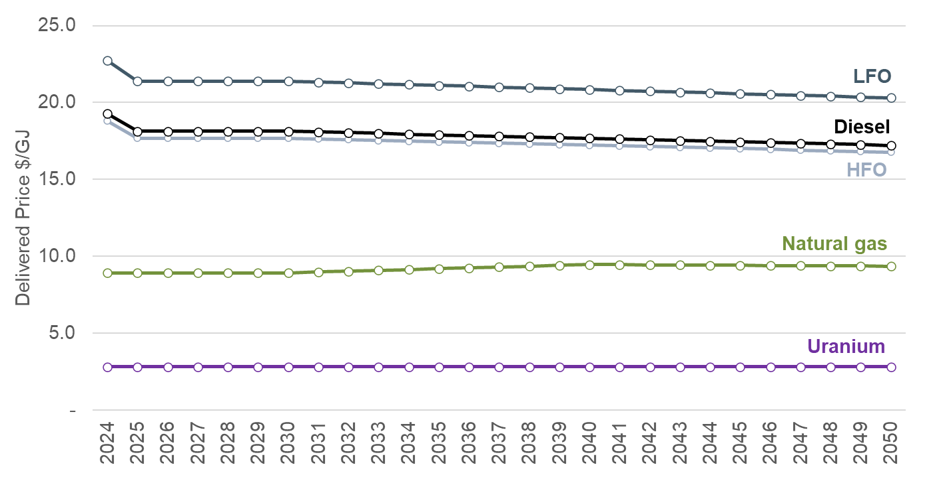
Source: Resource assessment report

Screening analysis and final generation and storage candidate options
The screening stage compared unit power plant costs to exclude candidate options that were clearly uneconomic to be developed in Uganda.
Levelised Costs of Electricity (LCOE) provide a simple, common basis for comparing generation technologies in US$/kWh but has several limitations. It does not capture the intermittent nature of renewable energy sources (RES), it cannot assess the actual operating time of power plans (and thus assumes a load factor) and cannot assess the ability of power plants to provide capacity at different times of the day. At a high level, LCOE can be used to compare power plant costs but cannot be used to formulate the least-cost plan.
Figure 7 shows the LCOEs for the candidate IERMP options using the technical and economic parameters assessed in the Resource assessment report. LCOEs were calculated using the average fuel price over the planning horizon. Non-renewable power plants were assumed to operate with load factor of 75% to provide base load power. LCOE illustrate that hydrogen as an option is clearly uneconomic to be developed in Uganda. Therefore it was excluded from the least cost planning modelling analysis.

Figure 7 LCOEs of Uganda candidate generation options
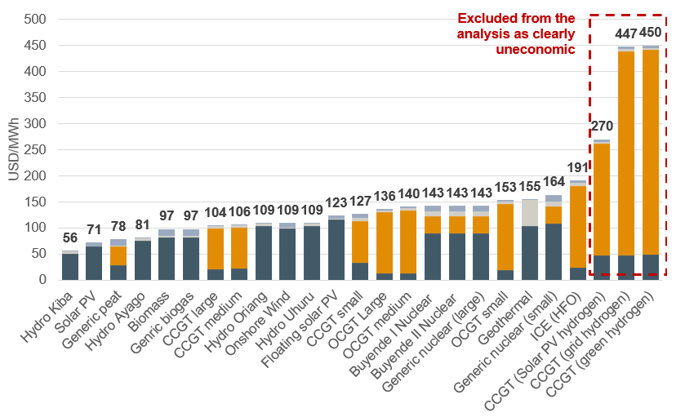
Source: Resource assessment report
Following the resource assessment and screening analysis a final set of candidate power plants and storage facilities was agreed with key stakeholders to be considered in the IERMP. The candidate options considered for the IERMP are summarised in Figure 8 together with the key parameters of each candidate option. Further details are available in the Resource assessment report.
Figure 8 Summary of Uganda candidate power plants
Source: ECA analysis

Transmission and distribution options
The existing transmission system is predominantly based on 132 kV infrastructure and some 220 kV lines, with the 400 kV network currently applied primarily for power evacuation from the Karuma hydropower plant into GKM. This approach can be applied for future transmission development, where higher-voltage transmission is used for bulk power evacuation from major generation areas. As the 400 kV system is expanded, further expansion of the 220 kV system should be considered carefully to avoid having substations with all three voltage levels i.e. 400 kV, 220 kV and 132 kV. Such development would lead to large and costly substations, and expansion of the system based on mainly 400/132 kV substations. Limited expansion of the 220 kV system would likely provide lower-cost solutions.
The transmission development plan presented in this report is therefore structured around the establishment of a 400 kV high-voltage backbone as the foundation of the future power system. The planning approach reflects the need for a robust bulk transmission system capable of accommodating the projected demand growth across the country and supporting high power transfers between generation areas and major load centres.
Given the scale of the demand forecasts and the presence of large, geographically uncertain step-loads, the transmission development strategy is based on providing supply to major load centres by establishing bulk supply points at key locations. The development of the 132 kV network (and the 220 kV system to the extent relevant) is addressed at a more generic level. Investments at this (sub-transmission) voltage level are envisaged to be implemented in coordination with the evolving spatial distribution of demand and must be further refined as part of pre-feasibility and feasibility studies as more detailed information on (actual) load development becomes available.

Key drivers
The transmission expansion plan is based on the spatial distribution of demand and the allocation of candidate generation projects discussed in the Demand forecast report. Figure 9 shows the allocation of the solar candidates presented in the Resource assessment report with the existing transmission grid.
Figure 9 Main grid and location of PV plant candidates
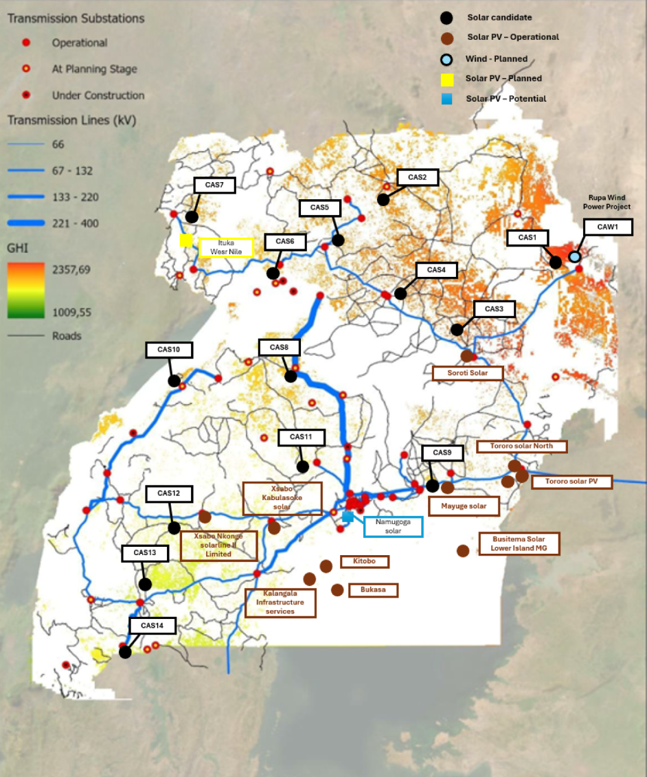
Source: A map of the existing transmission grid in Uganda, Norconsult, and solar candidates, IERMP.
Figure 10 shows the spatial distribution of demand in regions for different stages. It illustrates that the demand centre on the system at present is in the GKM region. High growth in the Western region means that the peak demand in this part of the system may exceed the demand in GKM in future. A significant share of this growth is foreseen to take part in the northern areas of the Western region.
Figure 10 Illustration of growth in peak demand by area
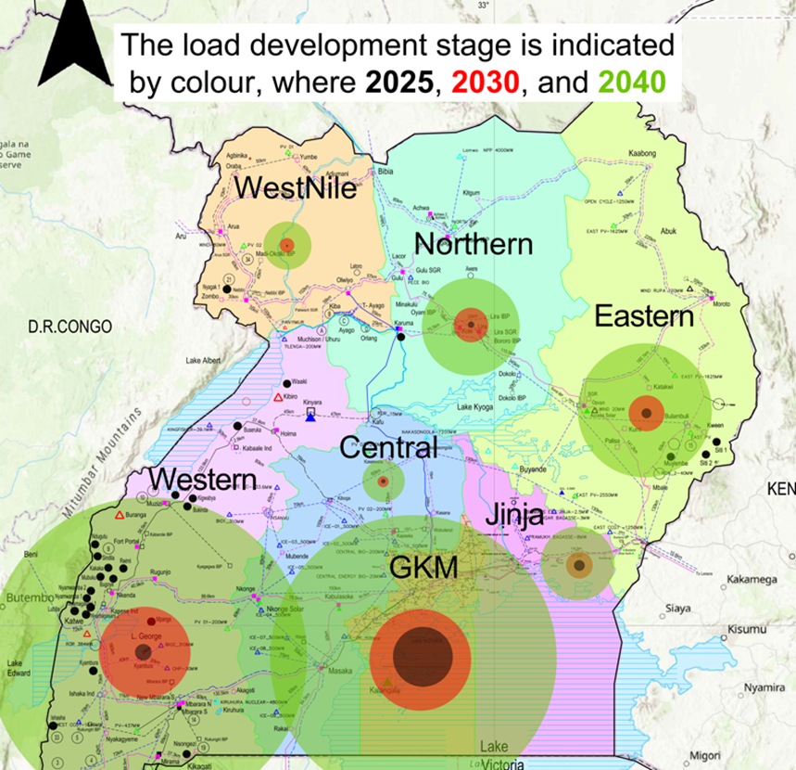
Source: Uganda grid map, UETCL, with illustrations of load increase from the Demand forecast.
The demand forecast and the generation expansion scenarios are the key drivers for the development of the transmission expansion plan.

Power evacuation
As part of the IERMP it is necessary to assess the evacuation of power from major generation hubs to the main load centres, including the capital city and designated industrial parks. The proposed transmission developments are therefore closely aligned with the location and scale of future generation projects and demand centres.

Solar Power Plants
Transmission options for solar power plants have been evaluated based on the requirement to evacuate power from large-scale solar generation sites to harness the country’s solar resource potential in a least-cost manner. Grid reinforcements and new transmission connections are required and have been assessed for the 7 regions optimised in the PLEXOS simulations.

Hydro Power Plants
Transmission development for hydropower generation, focuses on reinforcing the high-voltage transmission corridor from the major hydropower areas in the northern region to the southern part of the country. This includes investments in the main north–south transmission corridor towards the GKM region, as well as the development of additional 400 kV interconnections from the northern hydropower plants to both the eastern and western regions.

Nuclear Power Plants
Buyende, located in the Eastern region, has been identified as the leading candidate site for nuclear power development. Transmission options for power evacuation from this location primarily involve reinforcing and expanding the transmission connections to the GKM region, which represents the main load centre of the system at present and is foreseen to remain one of two regions with significantly higher demand than other regions, see Figure 10.

Regional projects
The transmission development strategy prioritises interregional projects to enable efficient power transfer across different regions of the power system. This approach considers the location of the main demand centres, as well as areas expected to experience large step-load additions driven by industrial development and economic growth.
The interregional projects include major investments in 400 kV transmission lines to strengthen the backbone of the national grid and facilitate regional power exchange. The primary transmission corridor is proposed across the GKM region, connecting the Central region with areas characterised by high economic activity, projected load growth, and major industrial demand centres.
A key interregional corridor is suggested between the Eastern region and Mbarara in the Western region, enabling high-capacity power transfer through the GKM region, which is considered one of the main load centres in the system. This corridor also facilitates the transfer of power from high-production areas in the east to large industrial demand centres in the west.
The proposed regional transmission development supports the objectives of the Eastern Africa Power Pool by increasing energy availability to citizens of its member countries through enhanced cross-border electricity interconnections between Kenya, Uganda, and Tanzania.

System expansion and grid reinforcement projects
The existing power system is predominantly based on 132 kV infrastructure. Accordingly, the transmission investment plan includes significant investments in the expansion and reinforcement of the 132 kV network, alongside higher-voltage transmission developments, to meet projected demand growth and network expansion requirements.

400 kV reinforcement around the GKM region
To meet the projected demand in the GKM region, the transmission investment plan includes the development of high-voltage bulk supply points to enable large-scale power transfer into the GKM area from remote generation sources. A preliminary set of bulk supply substations in the GKM region includes:
- Kawanda (existing)
- Wobulenzi (committed)
- Namulonge (candidate)
- Mukono (candidate)
- Bussunju (candidate)
The candidate substations are indicative and represent tentative areas for additional, new bulk supply points. The underlying concept is to establish a ring of bulk supply substations around the Kampala metropolitan area and along the wider GKM region, comprising north-eastern, north-western, eastern, and western bulk supply points. Wobulenzi is foreseen to be a likely bulk supply point feeding into the outskirts of GKM and covering growth in demand in surrounding areas noting that GKM may grow beyond its current limits.
This 400 kV reinforcement is to be implemented in conjunction with reinforcement of the 132 kV network and to some extent the 220 kV system to ensure adequate capacity and to provide a reliable power supply within the high-demand GKM region.

Bulk point overview
The demand forecast for other regions indicate load growth at a scale that requires consideration of 400 kV bulk supply points to establish a strong and resilient transmission backbone. The transmission investment plan therefore includes the assessment of bulk supply substations in selected regions outside the GKM area.
The development of 400 kV bulk supply points is planned in combination with continued reinforcement and expansion of the 132 kV network. However, given the uncertainty related to the precise location, timing, and magnitude of future loads, the indicative location of new bulk supply points are intended to provide a flexible interface between the 400 kV backbone and the underlying sub-transmission system which is mainly foreseen to rely on a 132 kV system.
Based on maps and demand reports, a set of candidate bulk supply points has been identified in regions outside the GKM area as presented in the table below. These candidate locations represent preliminary bulk supply points for future 400/132 kV transformation and form part of the planned high-voltage transmission backbone. The locations must be refined as actual load development becomes clearer as part of feasibility studies of the expansion of the sub-transmission systems in the different regions.
Table 6 Candidate bulk points for the Base Case scenario
Region | 2030 | 2040 | 2050
GKM | Wobulenzi  Kawanda | Wobulenzi  Kawanda  GKM northeast  GKM east  GKM northwest | Wobulenzi  Kawanda  GKM northeast  GKM east  GKM northwest  GKM west
Jinja Metro |  | Bujjagali | Bujjagali
Central | Kafu | Kafu  Masaka | Kafu  Masaka  Kiboga
Western | Hoima  Mbarara | Hoima  Mbarara  Ishaka  Kasese | Hoima  Mbarara  Ishaka  Kasese
Eastern | Tororo  Opuyo | Tororo  Opuyo  Moroto | Tororo  Opuyo  Moroto
Northern | Karuma | Karuma  Gulu  Lira | Karuma  Gulu  Lira  (Bibia)
West Nile | Olwiyo | Olwiyo | Olwiyo
Source: Norconsult analysis

400 kV network candidates
On the background provided above, the transmission system development plan is structured around 400 kV corridors connecting major generation areas to the main demand centres, with extensions to support regional power exchange. The table below provides a set of candidates for 400 kV interconnections between regions, including candidates for multiple units of the same interconnection. The candidate interconnections aim to indicate the build out of the 400 kV transmission corridors illustrated in Figure 11.
Table 6 Candidate 400 kV between regions – Investment costs
(from) Region | (to) Region |  | CAPEX (kUSD)
16 Eastern | 11 GKM | Opuyo - Namulonge | $135,000
16 Eastern | 12 Jinja Metro | Tororo - Jinja Metro | $105,000
12 Jinja Metro | 11 GKM | Jinja Metro - Mukono | $75,000
11 GKM | 15 Central | Kawanda - Masaka | $107,000
15 Central | 18 Western | Masaka - Mbarara | $110,000
16 Eastern | 14 Northern | Opuyo – Lira | $105,000
14 Northern | 11 GKM | Karuma - Kawanda | $141,000
19 West Nile | 14 Northern | 400 kV operation Karuma - Olwiyo | $41,000
14 Northern | 18 Western | Kafu – Hoima | $87,000
15 Central | 18 Western | Nkonge – Kasese | $95,000
11 GKM | 15 Central | Kawanda – Masaka, multiple units | $81,000
19 West Nile | 14 Northern | Karuma – Ayago, multiple units | $27,000
16 Eastern | 11 GKM | Opuyo – Namulonge, multiple units | $108,000
15 Central | 18 Western | Hoima – Kiboga | $83,000
15 Central | 18 Western | Masaka – Mbarara, multiple units | $60,000
Source: Norconsult analysis
Figure 11 Main 400 kV corridors considered as part of the IERMP
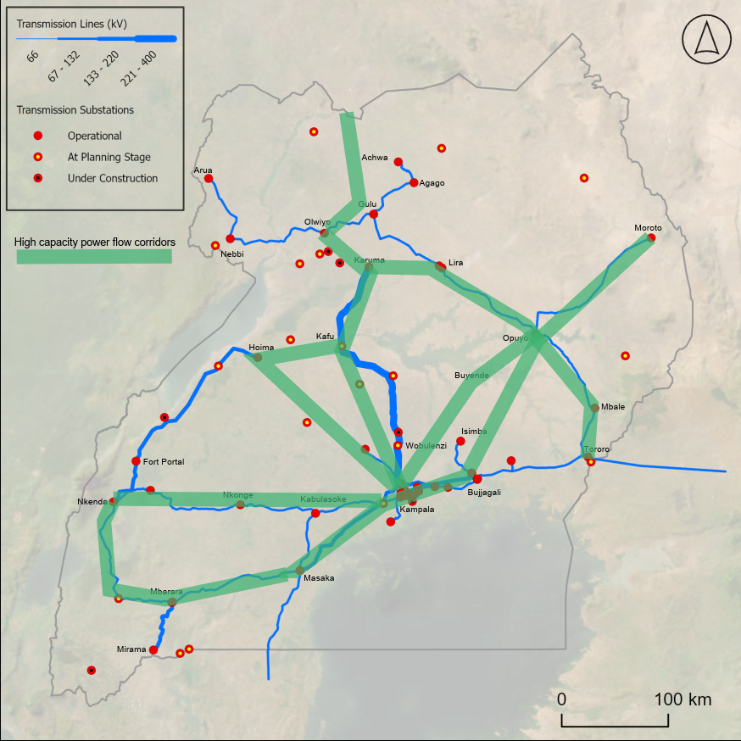
Source: Norconsult analysis

132 kV and 220 kV network
The planning of the 132 kV and 220 kV network is subject to a higher degree of uncertainty compared to the higher-voltage transmission system, primarily due to limited visibility on the precise spatial distribution and timing of future load growth. At this voltage level, load development may materialise in different forms, including reinforcement of existing corridors, redistribution of power flows through alternative paths, or increased reliance on local resources such as distributed generation, and storage.
In addition to the specific 132 kV and 220 kV project candidates, the transmission development plan includes generic reinforcement measures across different parts of the system. It is assumed that these reinforcements will be further refined at a later stage as part of pre-feasibility and feasibility studies as system conditions and load development become clearer.
Generic 132 kV candidate projects include:
- Development of a 132 kV double-circuit transmission line in the Northeastern region, north of Moroto.
- Jinja Metro: reinforcement of several existing lines with relatively low thermal capacity and voltage constraints (including Bujjagali – Nalubaale)
- GKM: reinforcement of several existing 132 kV lines with relatively low thermal capacity and existing voltage constraints, together with expansion of the 132 kV network within and around the GKM region.
- West Nile: development of 132 kV network north of Arua.

Generation, storage and EE/DSM least cost plan
The scenarios modelled in the IERMP are detailed in Section 5. For each scenario a generation least cost plan has been derived based in the modelling approach described in Section 4 (optimising EE and DSM, Generation, Storage and Transmission).
The key outcomes of the least cost plan by scenario are summarised in the sub-sections below. The focus of the summary is:
- Capacity plan – capacities and technologies selected as least cost at five year intervals, accompanied by key indicators including the reserve margin, RES capacity, unserved energy and total carbon emissions.
- Investment plan – investment requirements per technology per year.
Detailed tables with the least cost capacity plan, dispatch, variable costs, fixed O&M costs and other information for the least cost plan are provided in Annex A7.

Least cost plan results by scenario

Base case scenario
In the base scenario, where the system is constrained to meet a zero emissions target, the least cost solution relies on solar and nuclear to supply the zero emitting power generation required in 2050. A substantial BESS build out, mainly consisting of longer duration four-hour batteries, provides firming for the large solar fleet by shifting daytime solar production into nighttime hours.
The least cost solution also includes significant investment in geothermal and biomass and biogas generation, and both technologies are developed only to the extent allowed by the availability of suitable geothermal resources biomass/biogas resources.
Figure 12 Capacity least cost plan – Base case scenario
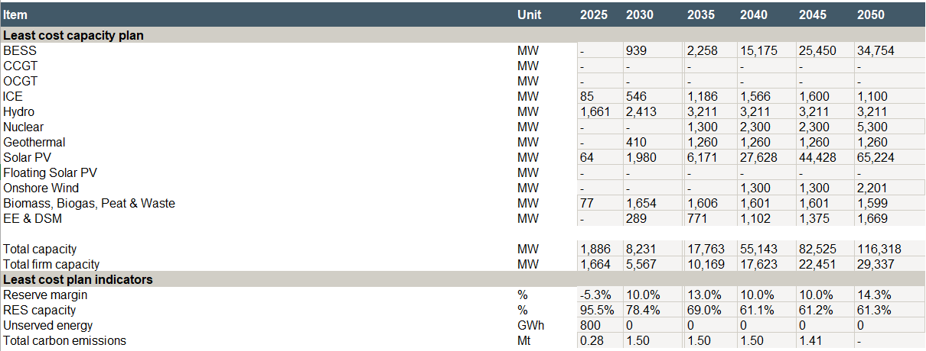
Source: ECA Analysis
The investment plan for the Base case scenario is shown in Figure 13.
Figure 13 Base case scenario – Investment costs by year and technology
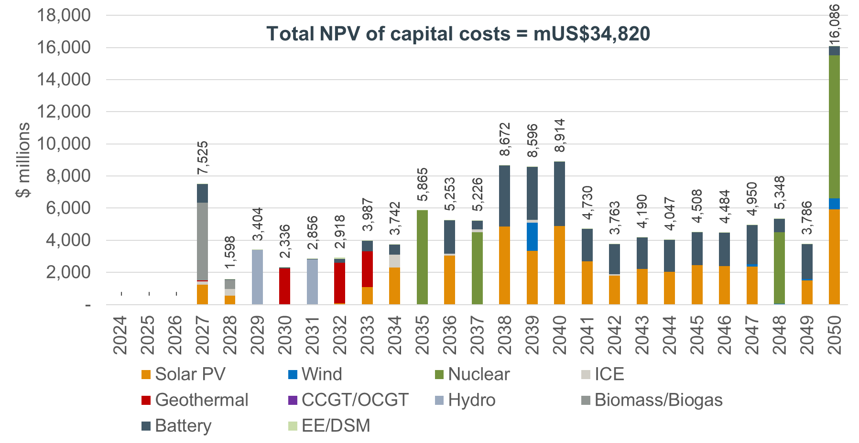
Source: ECA Analysis

Unconstrained scenario
Unlike the base scenario the unconstrained scenario is not restricted by any policy targets and the least cost pathway is defined solely by the economic cost of available options and the forecast demand.
Without any net zero targets by 2050, gas fired power plants become a least cost option for the system, displacing nuclear power which was selected as least cost in the Base case. At high load factors gas investment is more economic than nuclear and there is no policy incentive to avoid carbon emissions. This also results in less solar, and wind build out than the Base case. Nearly 6 GW of CCGT capacity is developed by 2037 when the gas pipeline is selected as least cost to be developed.
Figure 14 Capacity least cost plan – Unconstrained scenario
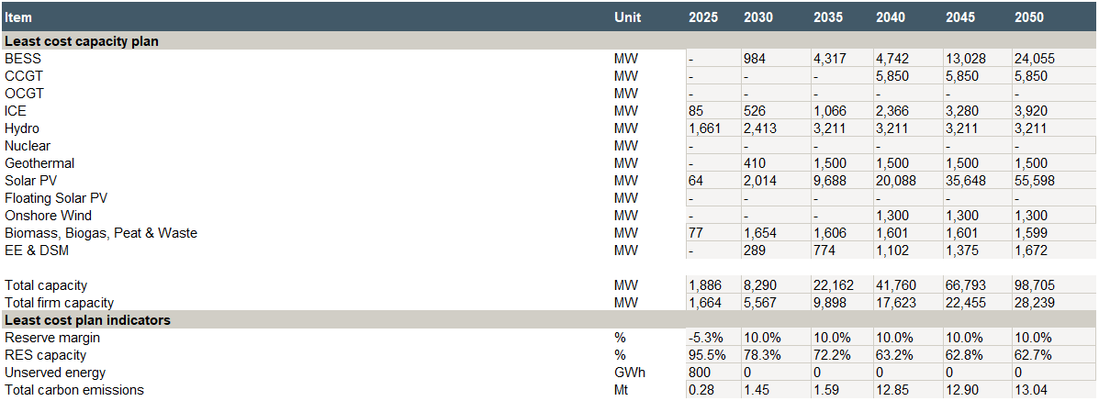
Source: ECA Analysis
The sequencing of the investment requirements in the Unconstrained scenario are shown in the figure below.
Figure 15 Unconstrained scenario – Investment costs by year and technology
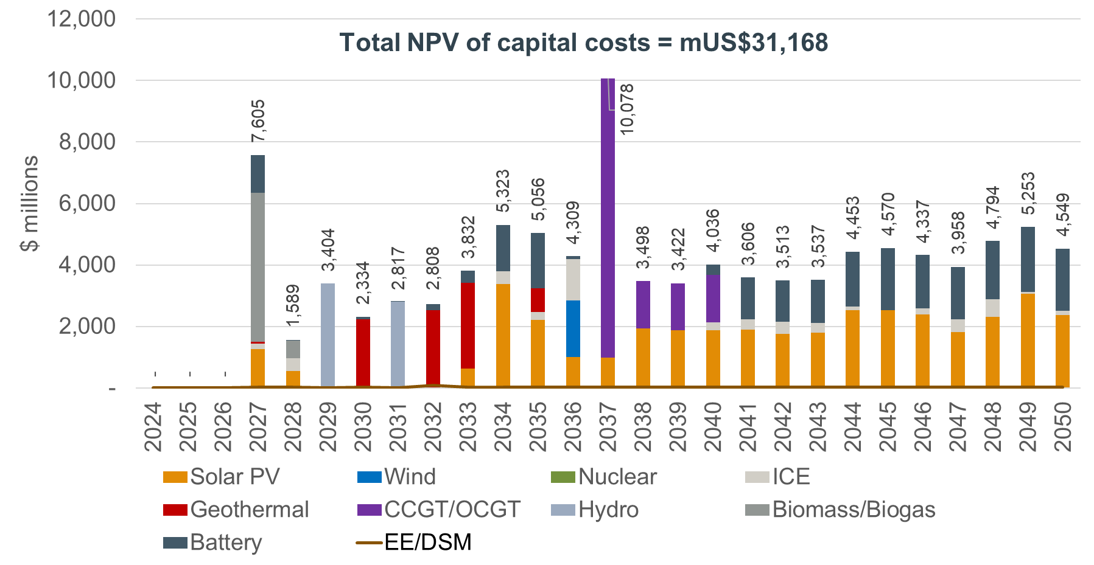
Source: ECA analysis

Delayed transition scenario
The Delayed transition scenario sees a much-reduced acceleration in power demand across the time horizon relative to the other scenarios. A key results difference in the least cost pathway relative to the base and unconstrained scenarios is no investment in nuclear generation capacity, due to the reduced demand. The lower capacity factor a nuclear power plant would operate under this scenario, constitute an investment to nuclear power uneconomic. A system dominated by hydro, solar and geothermal can deliver zero emission electricity in 2050.
Without nuclear or gas generation the reserve margin of 10% is delivered via over 3 GW of ICEs, hydropower plants, biomass and biogas plants and long duration batteries as shown in Figure 16.
Figure 16 Capacity least cost plan – Delayed transition scenario
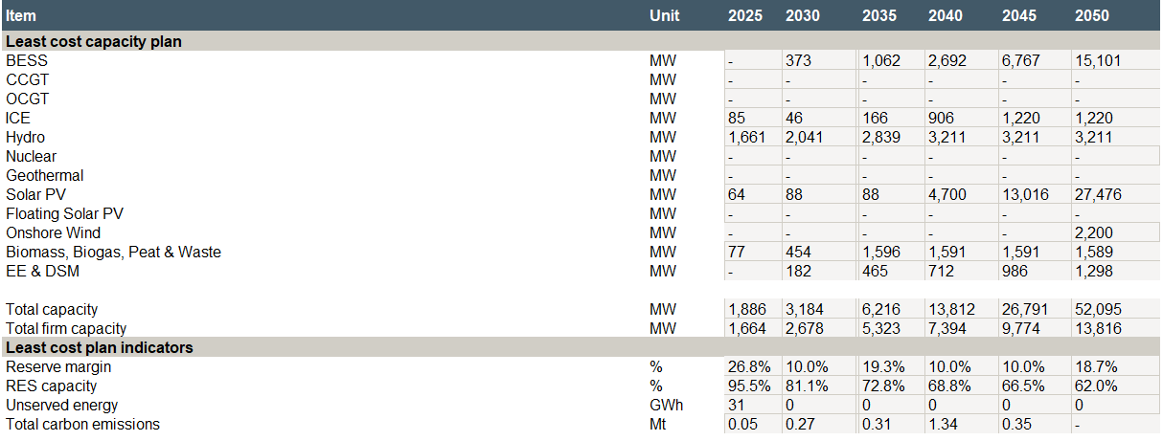
Source: ECA analysis
The lower capacity requirements due to the lower demand forecast of this scenario, also dictate the lowest investment requirements among all scenarios (see Figure 17).
Figure 17 Delayed transition scenario – Investment costs by year and technology
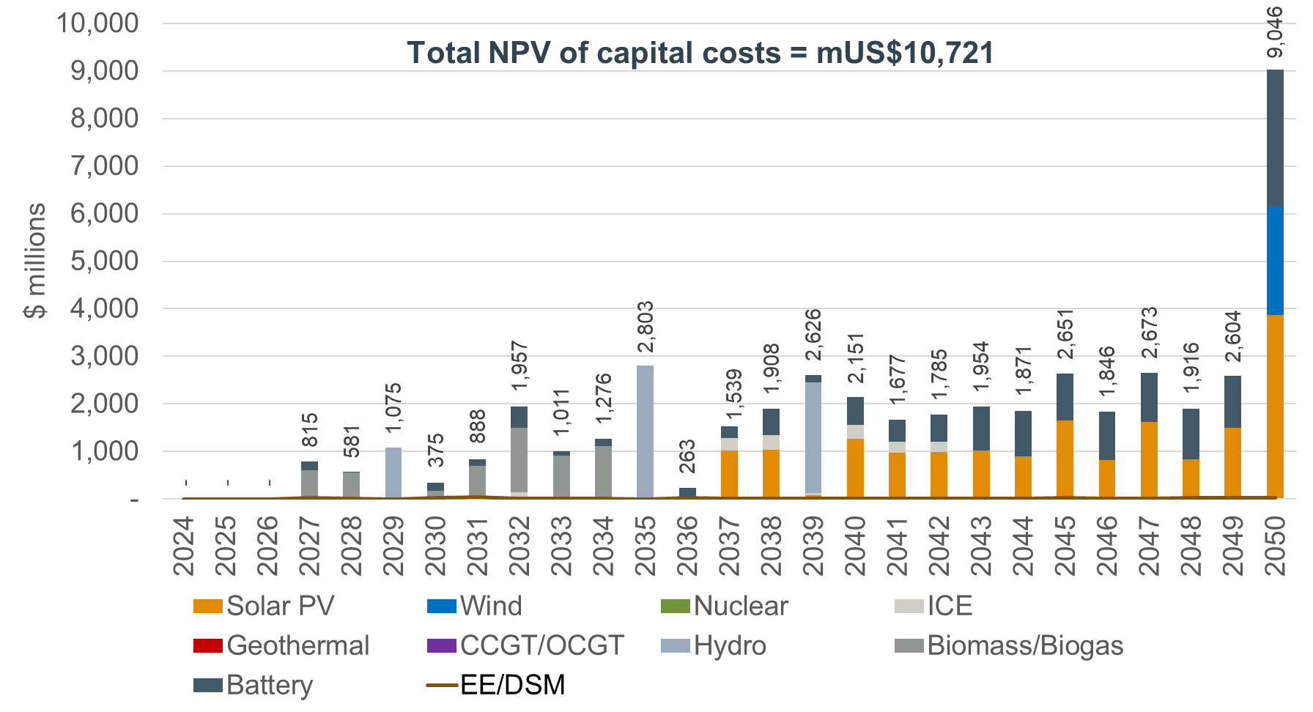
Source: ECA Analysis

Ten-fold growth scenario
The ten-fold growth scenario includes a faster rate of electricity demand growth relative to the Base case. Total electricity demand in 2050 is 30% higher than the Base case scenario. The result is more generating capacity required, however, given that the available capacity of solar, geothermal, biomass and hydropower is exploited in full, the main viable options for further capacity is nuclear power and floating solar PV.
The Ten-fold growth scenario sees a faster and higher level of nuclear development than the Base case. Floating solar PV, a more expensive option than typical land based solar PV, is also required to meet the higher demand at the end of the horizon.
Figure 18 Capacity least cost plan – Ten-fold growth scenario
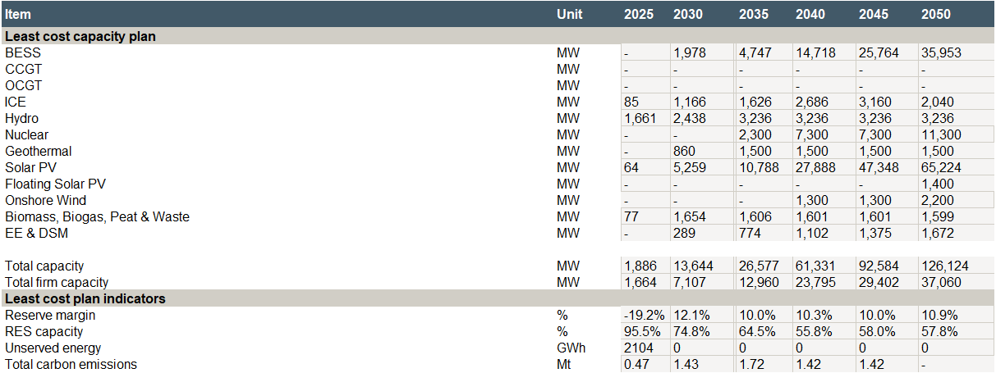
Source: ECA Analysis
The investment requirements of the Ten-fold growth scenario are approximately 35% higher than the base case, driven by higher capacity needs to meet the higher demand.

Figure 19 Ten-fold growth scenario – Investment costs by year and technology
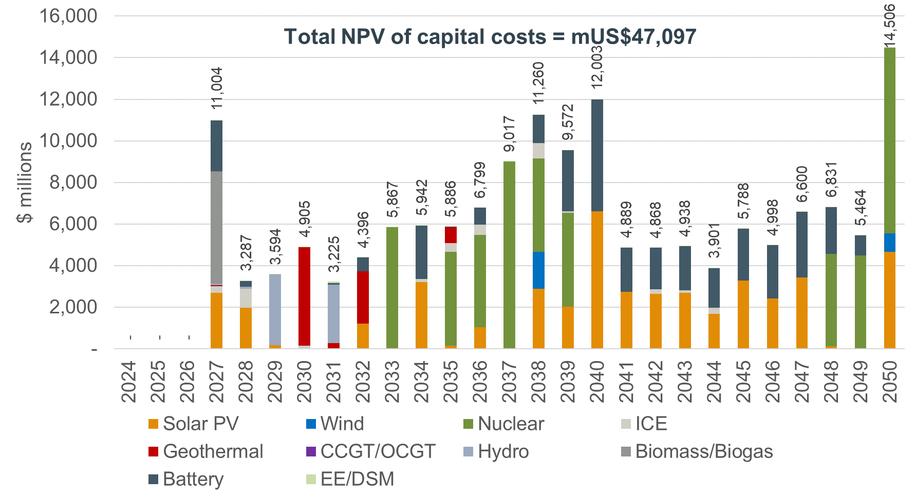
Source: ECA Analysis

Policy targets scenario
The Policy targets scenario imposes more aggressive requirements for renewable electricity and assumes significantly higher power demand than the Base scenario. The Policy targets scenarios exploits in full the available renewable energy resources in Uganda, including solar, hydro, geothermal and biomass, and the system is unable to achieve the target of 95 percent renewable generation by 2040. As a result, the model is specified to allow nuclear generation as a last resort. However, even with nearly 24 GW of nuclear capacity added to the system, total demand still cannot be fully met, and a substantial share of demand remains unserved by 2050.
Potential options to avoid unserved load include identifying additional geothermal potential, permitting solar PV development in conservation areas or increasing electricity imports from neighbouring countries.
Figure 20 Capacity least cost plan – Policy targets scenario
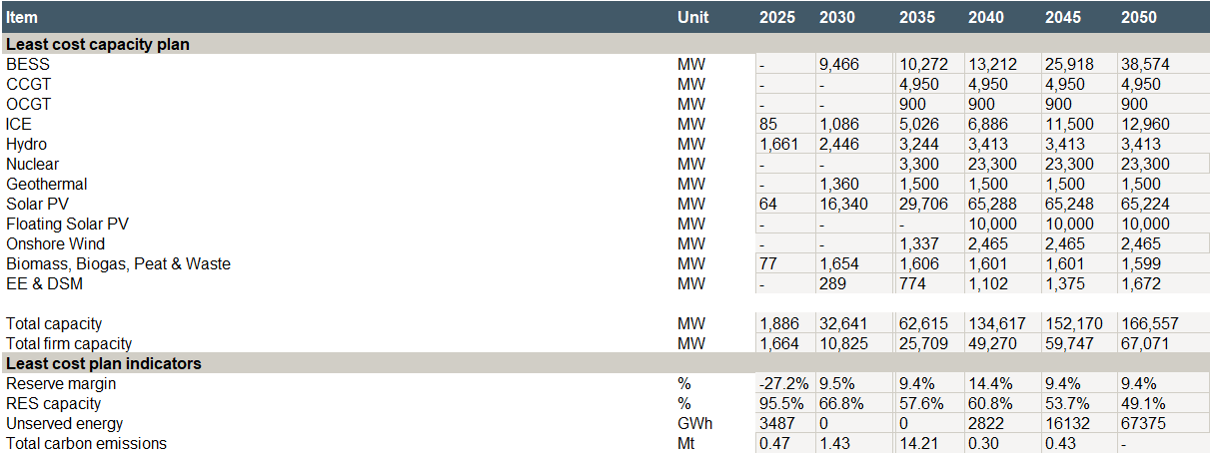
Source: ECA Analysis
Investment cost requirements are the highest among all scenarios as shown in the figure below.

Figure 21 Policy targets scenario – Investment costs by year and technology
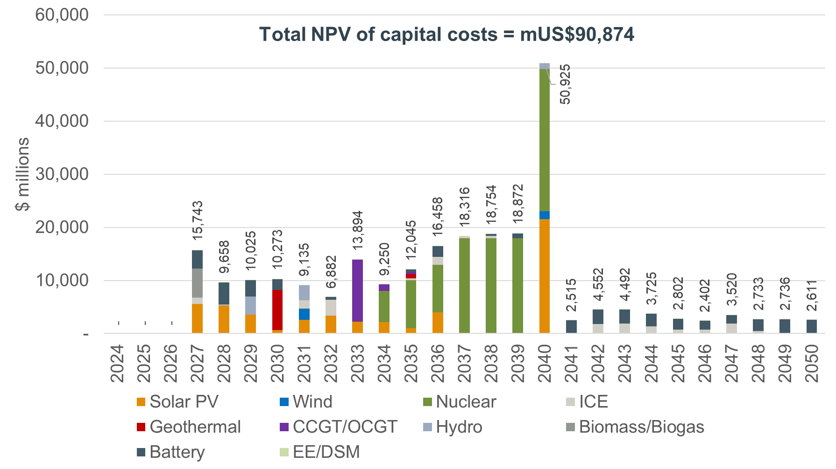
Source: ECA Analysis

Dry hydro scenario
In the Dry hydro scenario, the potential generation capability of all hydro options is constrained to be that of a dry weather year where limited rainfall reduces the downstream movement of water and therefore the capacity factors of hydropower plants. It aims to identify the impact of climate change on the least cost plan and identify the least cost pathway under such conditions.
At the end of the modelling horizon the differences to the Base scenario are relatively small, 0.6 GW of solar PV is added to the mix to partly replace the shortfall of hydro production and there is increased BESS build out to shift solar production to non-sunshine hours when hydro would typically be producing at a high-capacity factor in a normal year.
The most notable impact is at the start of the pathway, when solar PV capacity is selected at a higher levels, 3.5 GW of solar PV in 2030 compared with 1.9 GW in the base case, reflecting the necessity to build additional capacity to make up for reduced capacity factors of hydropower plants.
The least cost capacity plan of the Dry hydro scenario is shown in Figure 22.
Figure 22 Capacity least cost plan – Dry hydro scenario
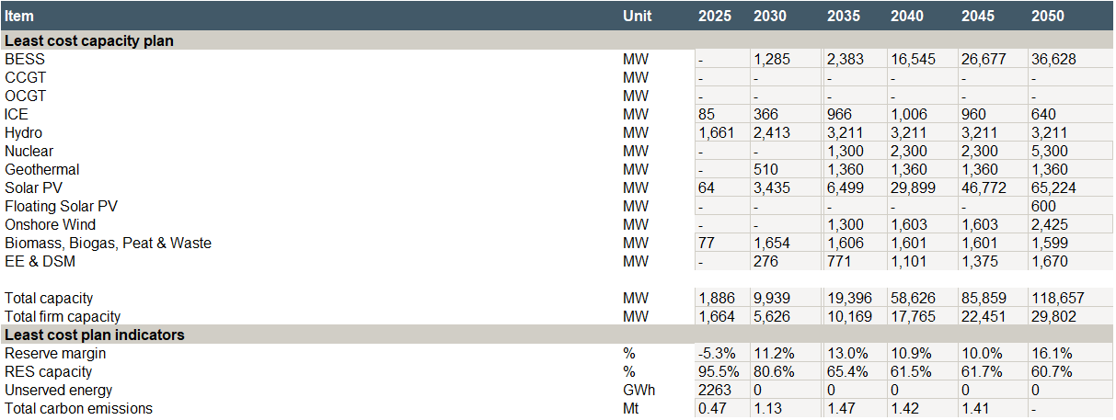
Source: ECA Analysis
Investment costs increase by approximately 6% in comparison to the Base case scenario to mitigate the energy gap from hydropower generation.
Figure 23 Dry Hydro scenario – Investment costs by year and technology
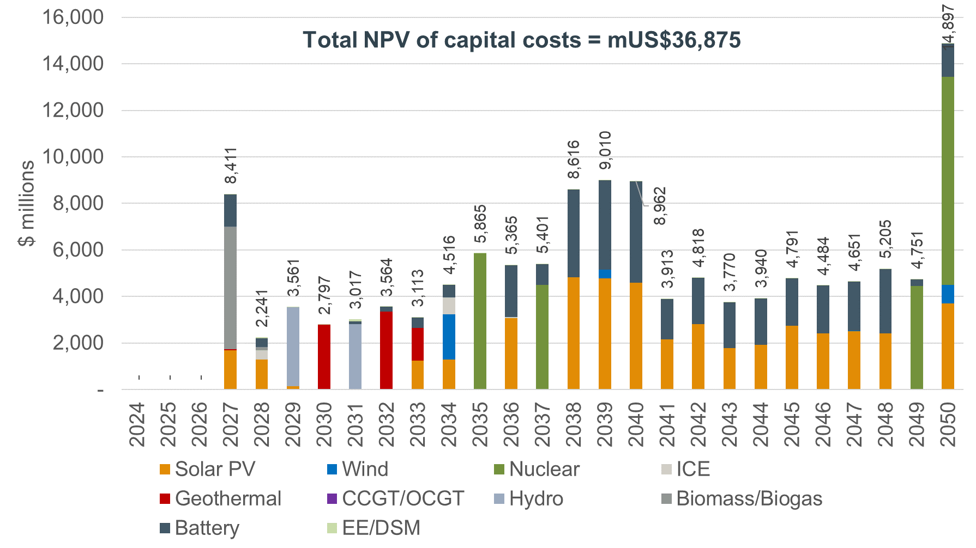
Source: ECA Analysis

Nuclear pathway scenario
The nuclear pathway scenario assumes that nuclear will be developed independent of the economic case at the earliest available date. It explores the impact from a policy decision to develop nuclear power as early as possible irrespective of the least cost plan.
Given that the Base case scenario also selects nuclear close to the earliest available date, the differences to the Base case are negligible with nuclear development only accelerated by two years. Such a policy decision does not pose a significant impact on the least cost plan.
Figure 24 Capacity least cost plan – Nuclear pathway scenario
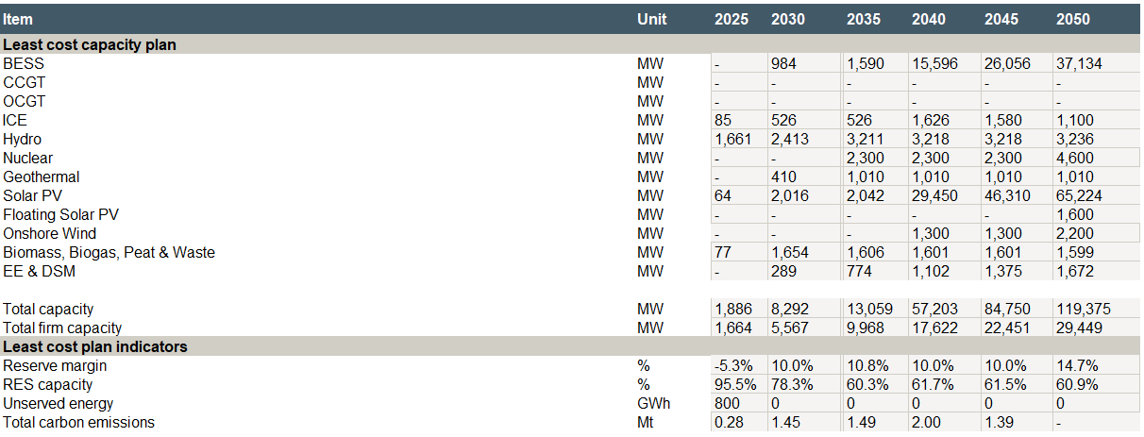
Source: ECA Analysis
Despite the lower NPV of capital costs in comparison to the Base case, the Nuclear pathway results in approximately 1% higher total NPV of costs. This justifies that the impact of a Nuclear pathway decision would have minor impact on costs compared to the costs of the Base case.
Figure 25 Nuclear pathway scenario – Investment costs by year and technology
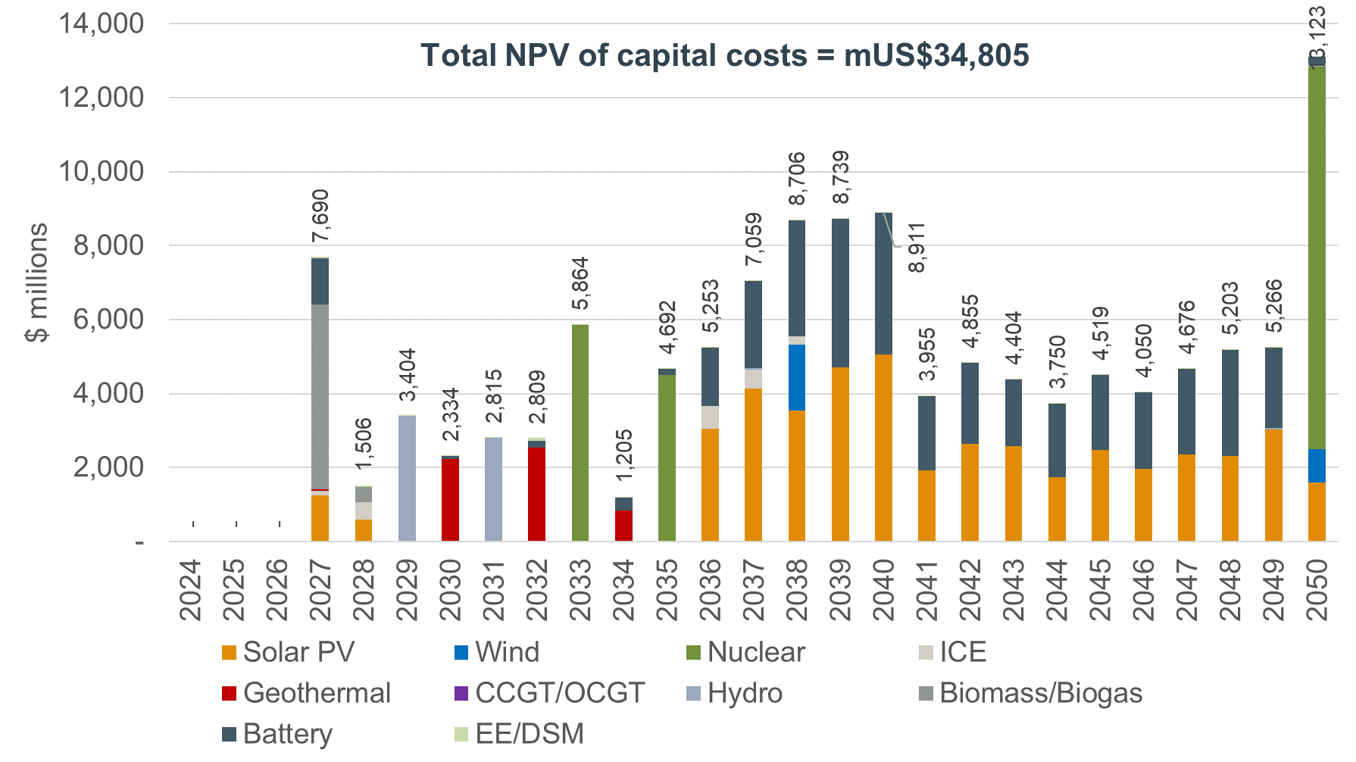
Source: ECA Analysis

Forced gas scenario
The Forced gas scenario investigates the impact of selecting to develop a gas pipeline between Tanzania and Uganda independent of the economic cost. The development of the pipeline makes CCGT power plants economic to build in the least cost pathway.
The key result is that nuclear power plants are not required, with CCGTs able to deliver baseload power until 2050 when the zero emissions constraint means CCGTs are no longer able to deliver power to the system and results in significant investment in nuclear generation capacity at the end of the horizon. The least cost capacity plan under a policy decision to develop the gas pipeline between Tanzania and Uganda is shown in Figure 26.
Figure 26 Capacity least cost plan – Forced gas scenario
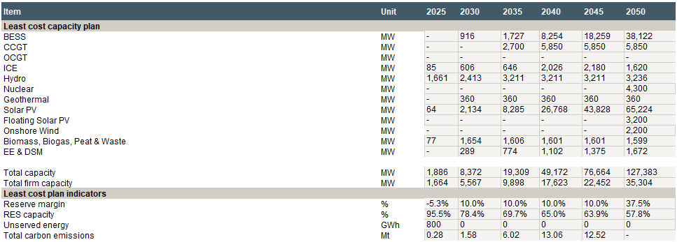
Source: ECA Analysis
Despite the reduction in the NPV of capital cost requirements compared to the Base case, the total NPV of costs in the Forced gas scenario increase by approximately 2%. The impact on costs of such a policy decision seems to be low compared to the Base case.
Figure 27 Forced gas scenario – Investment costs by year and technology
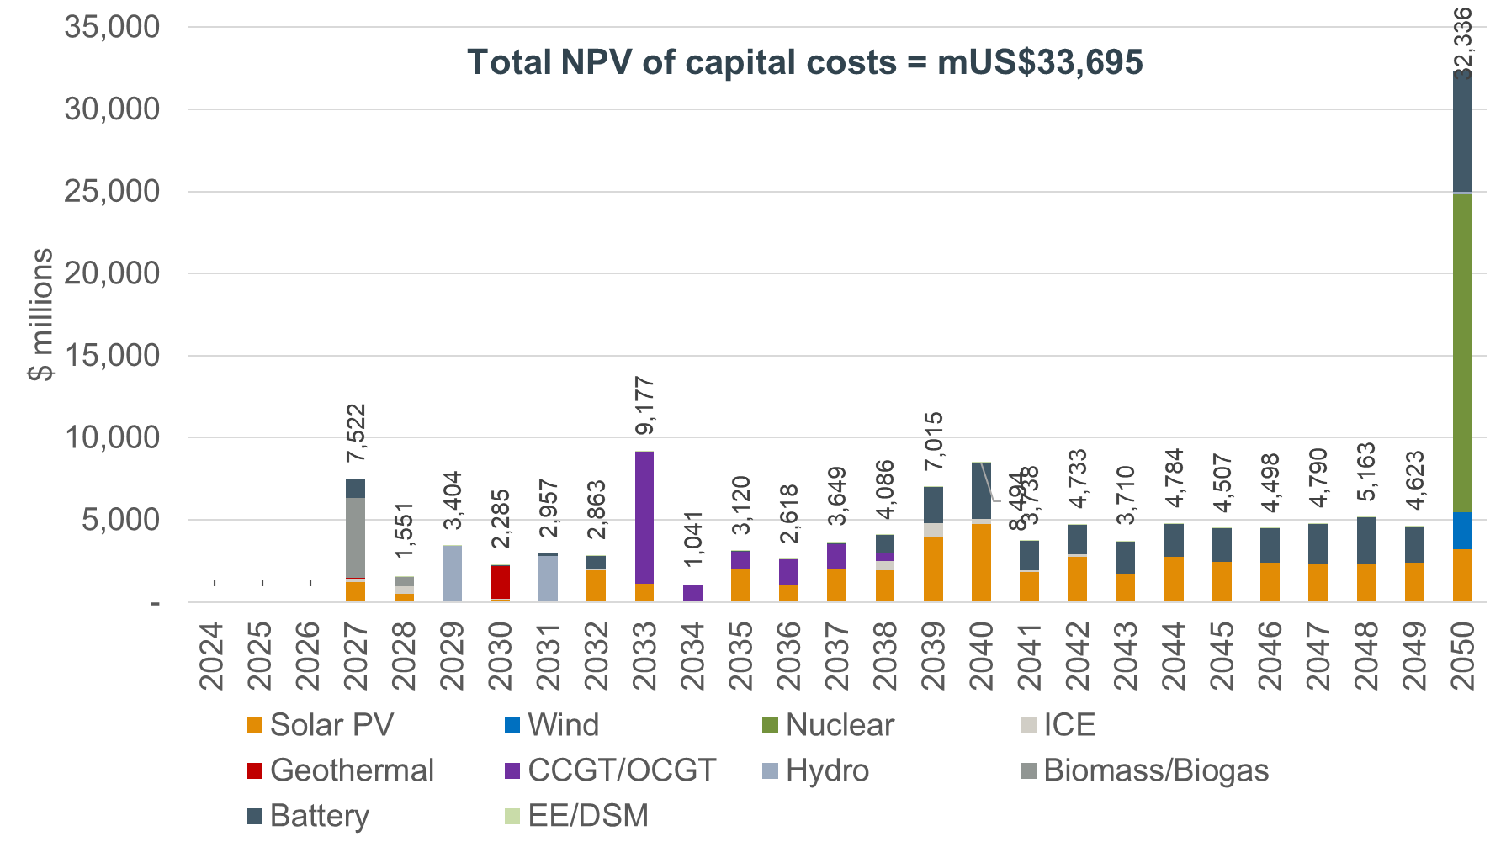
Source: ECA Analysis

Forced gas and nuclear scenario
The Forced gas and nuclear scenario explore the impact of forcing gas and nuclear capacity at the earliest point they become available. This forces a system where both key baseload technologies are selected. It aims to explore the impact from a policy decision to develop both nuclear and natural gas fired capacity to gain a diversification of resources even if not least cost. Such a decision would slow down the build out of solar and wind, however, given the 2050 zero emissions target prevents gas production in the final year of the horizon, the final selection of capacities is similar to that of the Base case as shown in Figure 28.
Figure 28 Capacity least cost plan – Forced gas and nuclear scenario
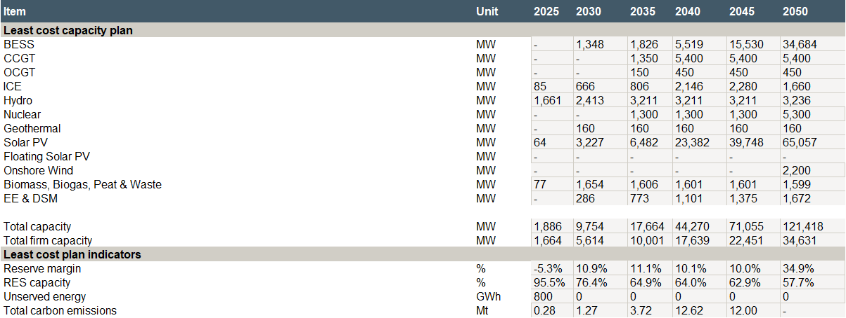
Source: ECA Analysis
The investment requirements of the Forced gas and nuclear scenario are shown in Figure 29. Again, the impact on capital costs is a reduction compared to the Base case, but the total NPV of costs increases by approximately 3% in comparison to the base case. The low impact on the total NPV of costs of the Forced gas and nuclear scenario constitutes such a policy decision attractive to gain the benefits of a diversified mix of resources.
Figure 29 Forced gas and nuclear scenario – Investment costs by year and technology
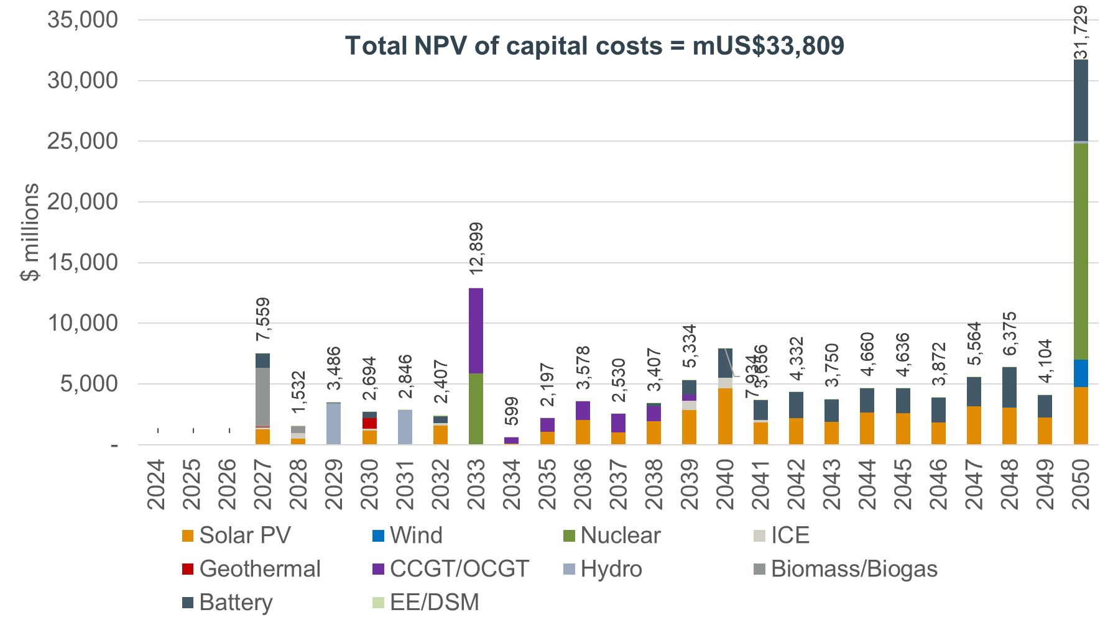
Source: ECA analysis

Delayed nuclear scenario
The delayed nuclear scenario models a world where the commissioning of nuclear power plants is delayed until 2038. It aims to explore the least cost plan under a case where nuclear will not be developed as planned.
Given the base scenario sees commissioning of nuclear in 2035 there is a necessity for development of alternatives to ensure demand can be met prior to 2038. The result is an accelerated build out of solar PV and batteries in the early and mid-2030s to supply the demand covered by nuclear and gas-fired power plants in the other scenarios.
Figure 30 Capacity least cost plan – Delayed nuclear scenario
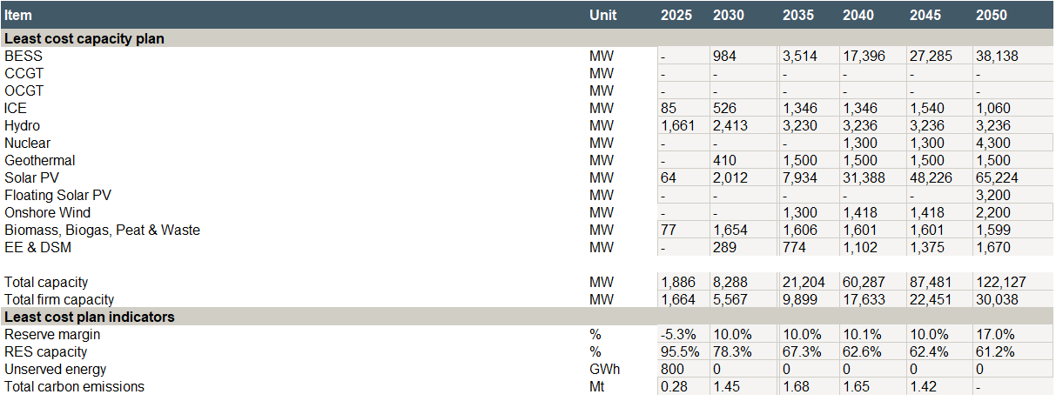
Source: ECA Analysis
This has a minor impact on the NPV of capital costs which increase by approximately 1% in comparison to the Base case as shown in the figure below.
Figure 31 Delayed nuclear scenario – Investment costs by year and technology
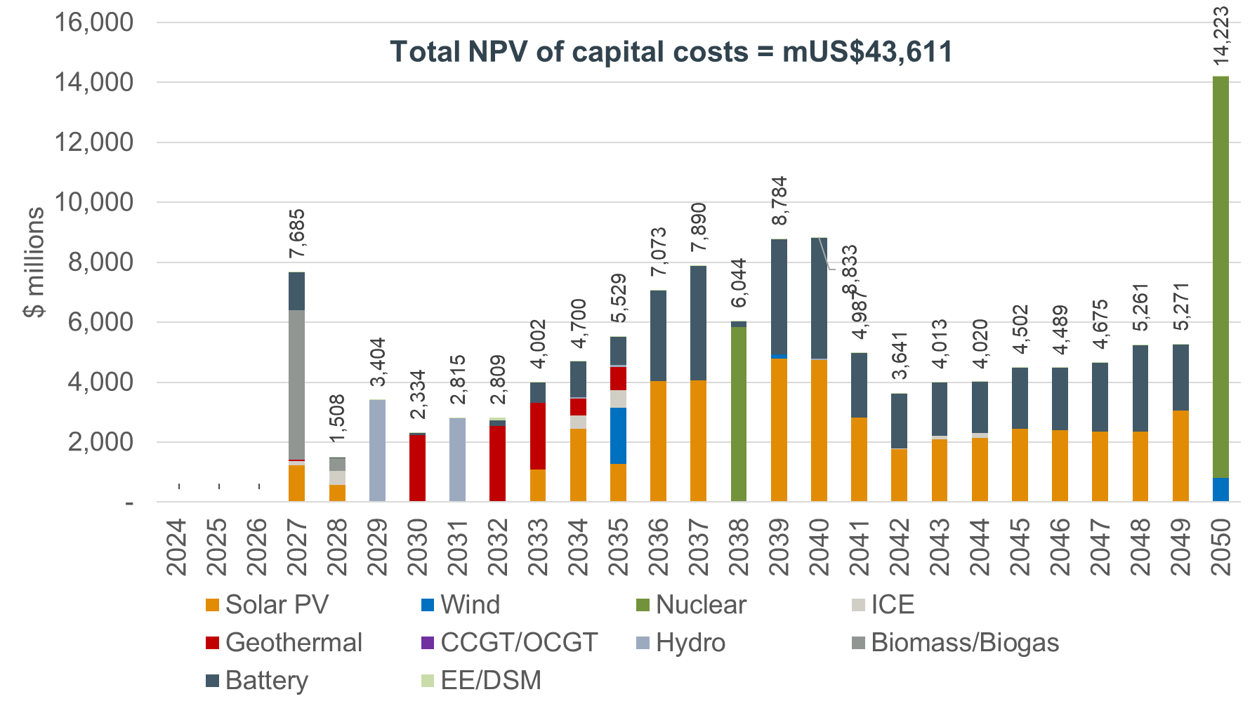
Source: ECA Analysis

Regional integration scenario
The regional integration scenario allows imports from Rwanda, Kenya and Ethiopia to compete with domestic generation options to satisfy the demand and policy targets in Uganda. Despite the relatively high cost of imports these are cost competitive given the transmission infrastructure is assumed to be increasingly available through the 2020s to 2030.
The main impact relative to the Base case is the delayed development of nuclear power plants in 2040. Imports can supply baseload power at a cost less than the LCOE for nuclear. Domestic nuclear and other baseload technologies such as geothermal and biomass are selected as least cost in later years.
Figure 32 Capacity least cost plan – Regional integration scenario
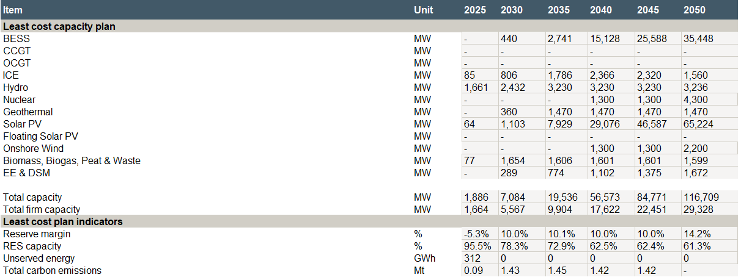
Source: ECA Analysis
The Regional integration scenario reduces the capital costs of the least cost plan by approximately 3% compared to the Base case as shown in the figure below.
Figure 33 Regional integration scenario – Investment costs by year and technology
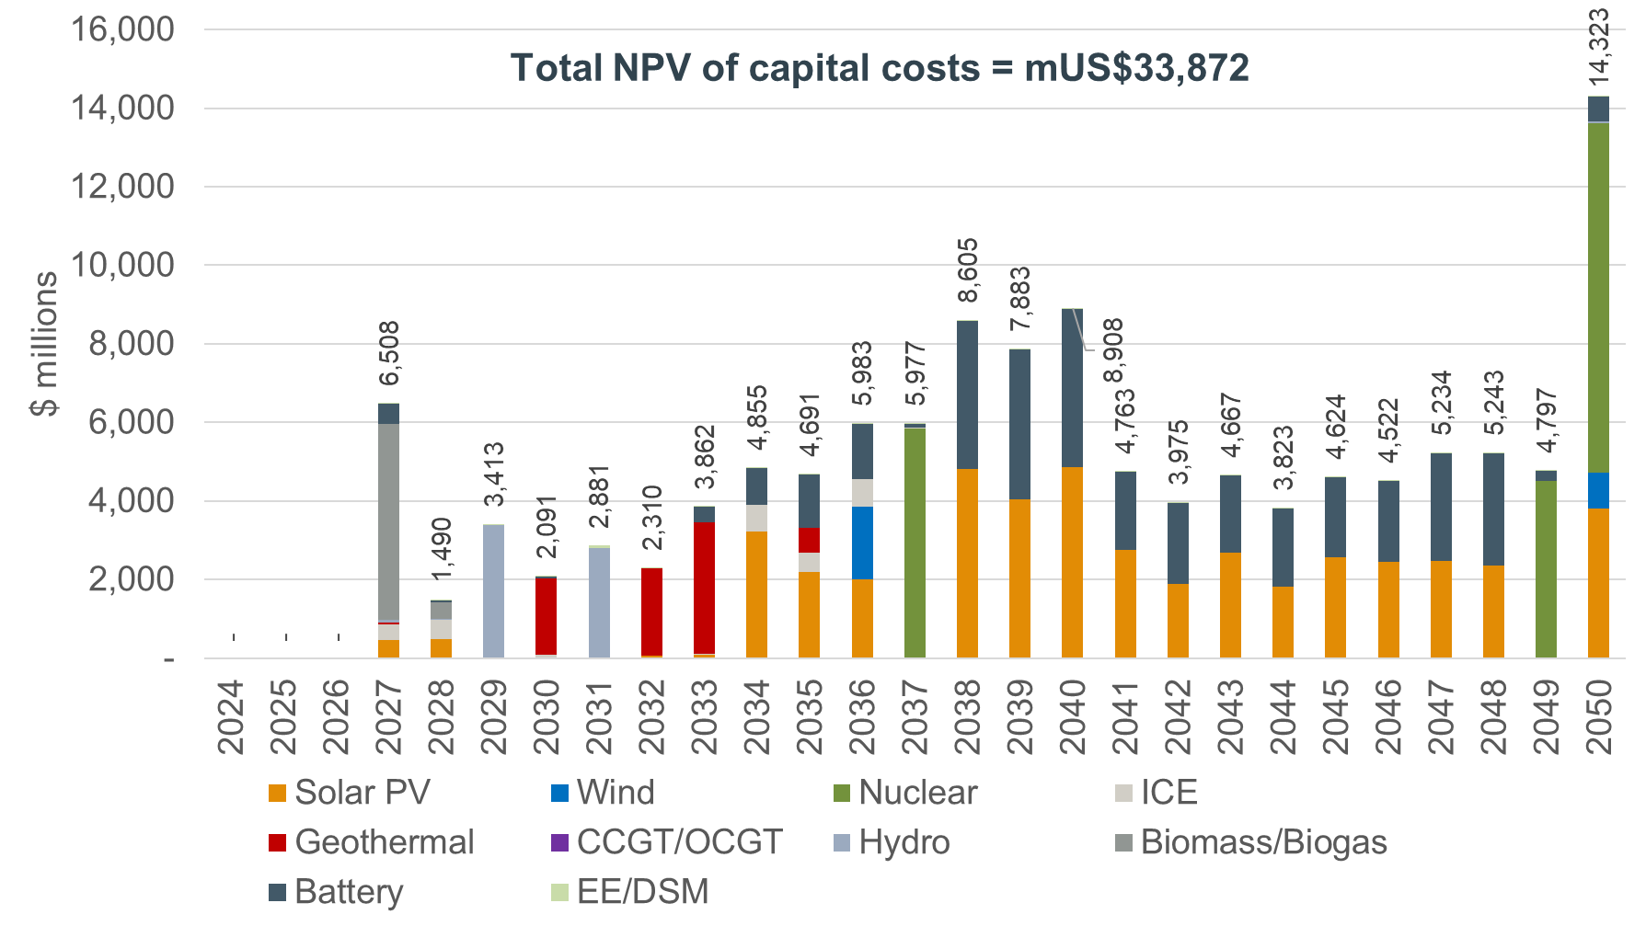
Source: ECA analysis

Rapid technology cost reduction scenario
This scenario tests the sensitivity of the least cost plan to faster-than-expected reductions in capital costs for solar PV, wind, and battery storage. While all scenarios already assume baseline cost improvements, this case reflects a more optimistic technology learning trajectory, especially for BESS, which is expected to see larger cost declines than solar and wind due to its lower maturity stage.
The main impact is nuclear development is delayed until 2050 and at a lower capacity level relative to the base case 3.3 GW compared with 5.3 GW in the Base case. Solar, batteries and wind, now with reduced cost are more economic to build in the 2030s when nuclear first becomes available. The NPV of investment costs reduces by approximately 5% compared to the Base case (see Figure 35).
Figure 34 Capacity least cost plan – Rapid technology cost reduction scenario
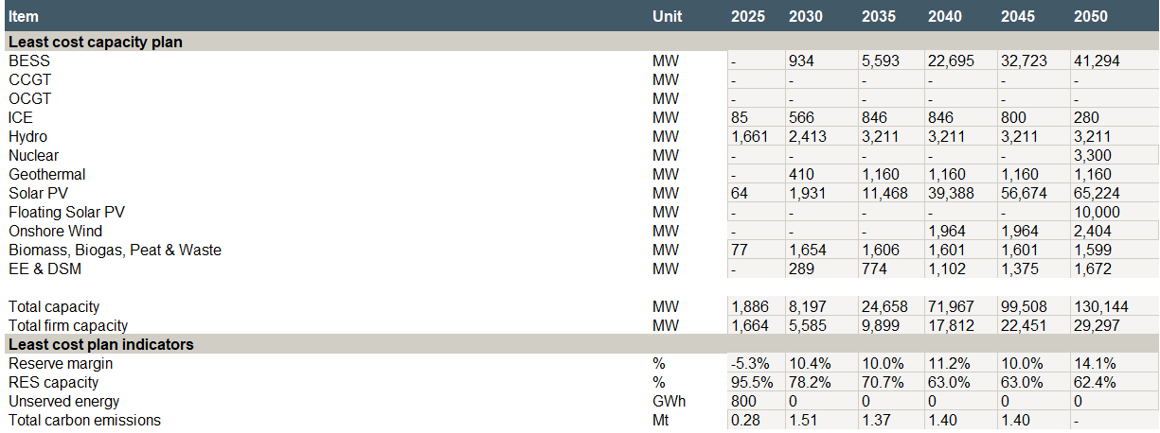
Source: ECA Analysis
Figure 35 Rapid technology cost reduction – Investment costs by year and technology
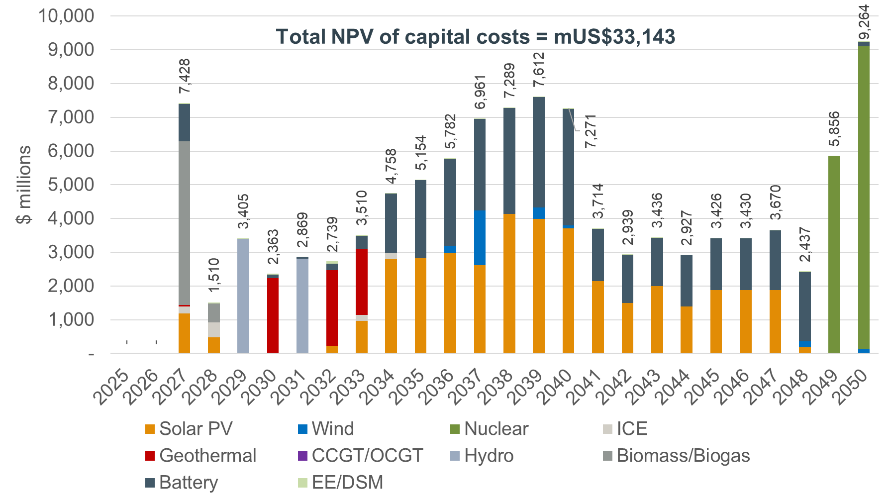
Source: ECA analysis

Discount rate +3% scenario
This scenario increases the cost of capital relative to the base case by 3% (from 10% to 13%). The cost of capital is particularly important for generating assets that have a large proportion of their costs allocated towards capital expenses. In the base scenario almost all generation capacity has low marginal costs and significant capital costs.
The increased capital costs result makes development of gas burning capacity relatively cheaper than nuclear and other low marginal cost candidates like solar and wind. The result is 5 GW of CCGT is developed. This results in a delay of nuclear investment, which is still required given the zero emissions constraint on the system (see Figure 36 and Figure 37).
Figure 36 Capacity least cost plan – Discount rate +3% scenario
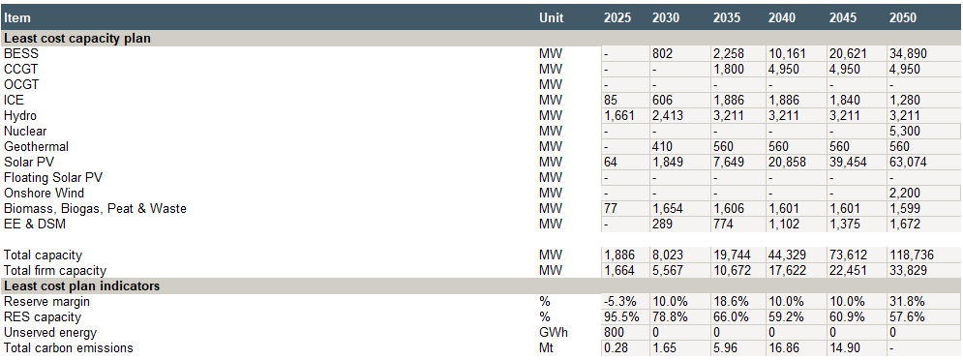
Source: ECA Analysis
Figure 37 Discount rate +3% scenario – Investment costs by year and technology
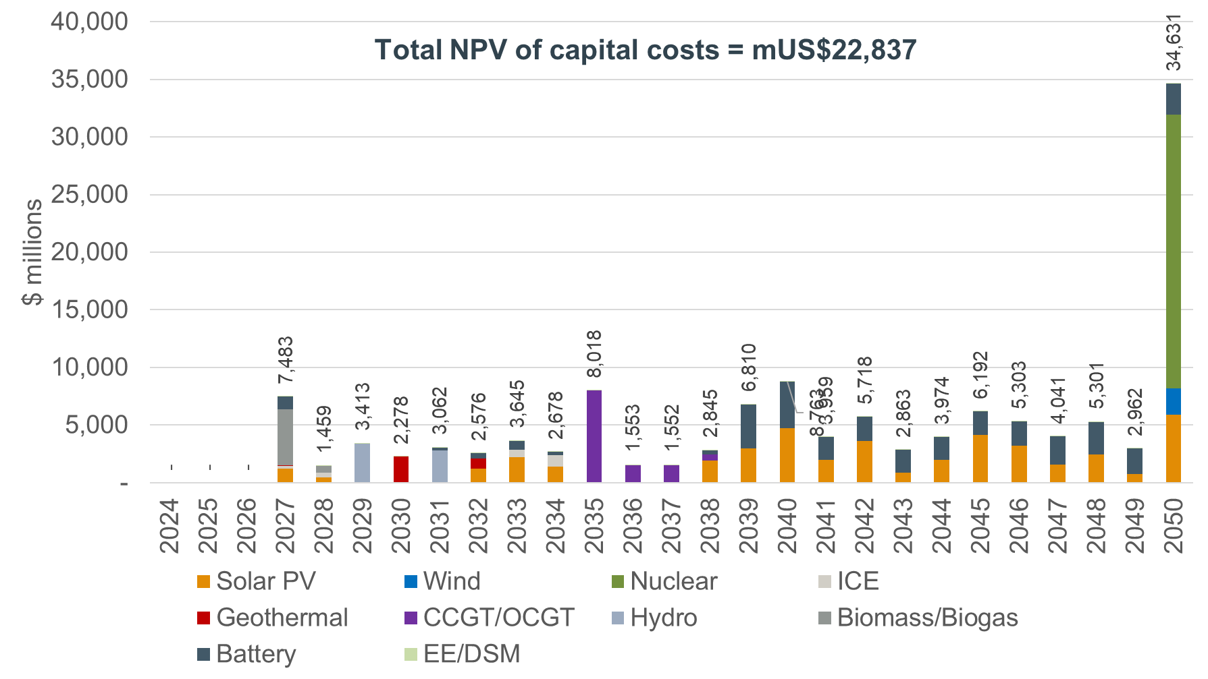
Source: ECA Analysis

Discount rate -3% scenario
In this scenario, the cost of capital is adjusted downwards, unlike the high discount rate case, the key technologies in the least cost pathway remain the same as in the base scenario. The lower cost of capital leads to more accelerated development of solar PV, wind and batteries, since these technologies have effectively zero marginal cost, and the cost of capital therefore has a significant influence on their overall business case (see Figure 38 and Figure 39).
Figure 38 Capacity least cost plan – Discount rate -3% scenario
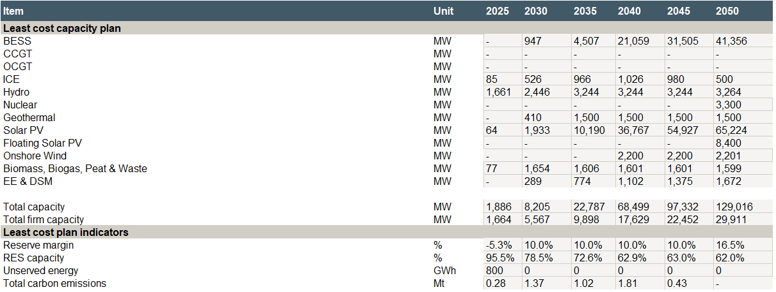
Source: ECA Analysis
Figure 39 Discount rate -3% scenario – Investment costs by year and technology
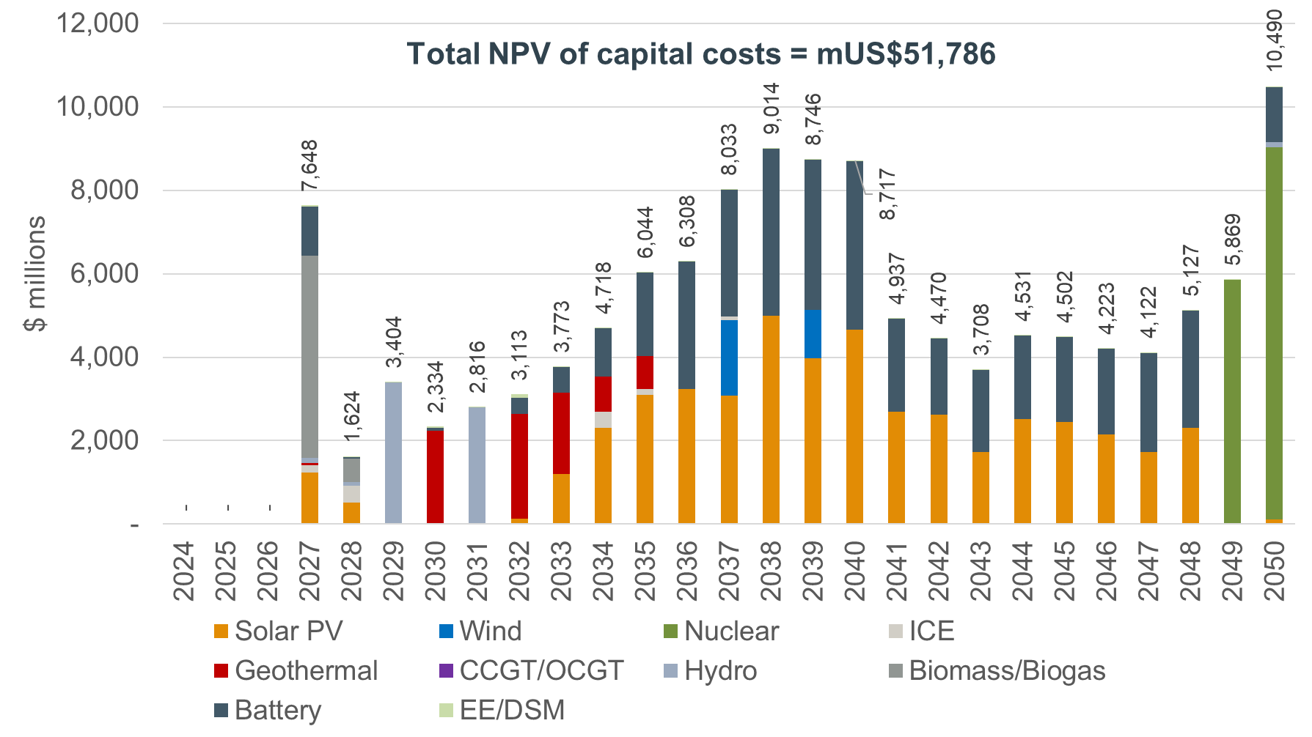
Source: ECA Analysis

Least cost plan across scenarios by technology
The following tables discuss which technologies were selected as least cost options across scenarios, what volume of capacity was selected and when. They also comment on which technologies were not proven to be economically competitive to be developed in Uganda.
Table 13 Uganda least cost plan by technology across scenarios
Technology | Conclusion from all scenarios
  Hydro   | - Large hydropower sites on the Victoria Nile are selected as least-cost options across all scenarios. The primary variation between scenarios is the timing and pace of development, driven by demand growth. Under the delayed growth scenario, only the Kiba site is developed by 2030.  - Large hydro power plants are selected as least cost option in all scenarios and action should be taken a-priory to enable its timely development when needed.  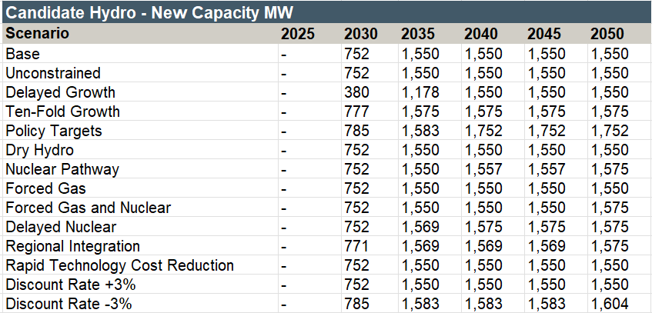
  Geothermal   | - Geothermal capacity has relatively high investment costs but provides zero emitting and low variable cost baseload power and therefore is selected in all but the delayed growth scenario.  - Although there is still uncertainty about the exact potential and costs of geothermal in Uganda the technology should still prioritised to be an important part of the future for the development of the energy system in Uganda.  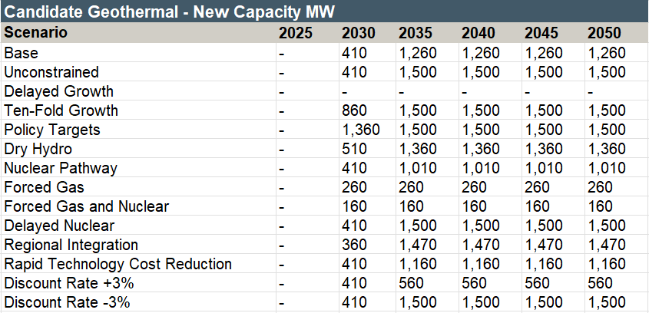
  Solar PV  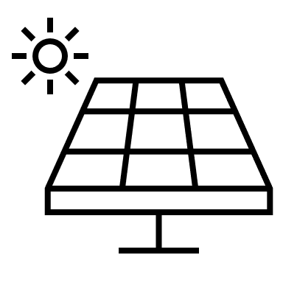 | - Uganda’s geographic location and consistently high solar irradiance make solar PV well suited to supporting a zero-carbon electricity target by 2050. However, limited generation outside daylight hours and the distance between optimal solar sites and load centres mean that solar deployment must be complemented by investment in the transmission network and storage or firm baseload technologies such as hydro or nuclear.  - By 2030, at least 1 GW of new solar PV will be needed and by 2050 at least 27 GW. Action should be taken for land banking and transmission system development to enable the construction of new Solar PV on time.  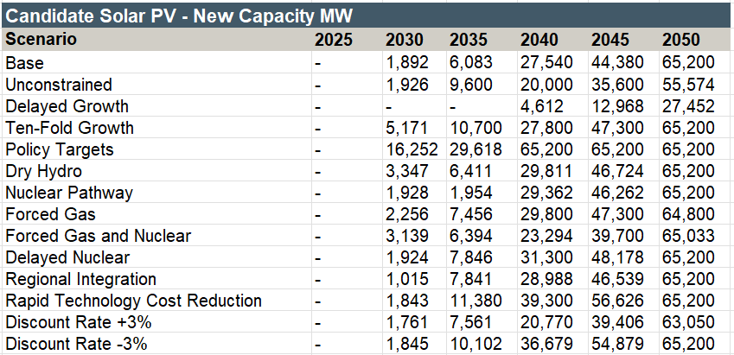
  Floating solar PV   | - Floating solar is not selected as a least cost option in most scenarios due to the higher costs for development. It is selected only in high demand scenarios when all other resources are fully utilised.  - Floating solar PV development should not be a priority investment for the power sector in Uganda.  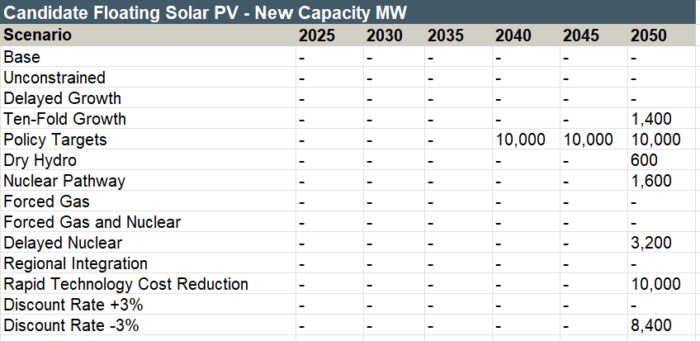
  Onshore wind  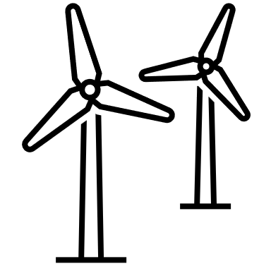 | - Wind potential is relatively scarce in Uganda, sites with high enough wind speeds are in rural areas and therefore require significant transmission expenditure on top of the capital cost of the wind turbines themselves.  - The result is wind is not selected in all scenarios and the capacity magnitude is low. Although wind could play an important part in delivering policy targets such as achieving 95% of generation from renewables there are other technologies which better complement the resources available in Uganda.  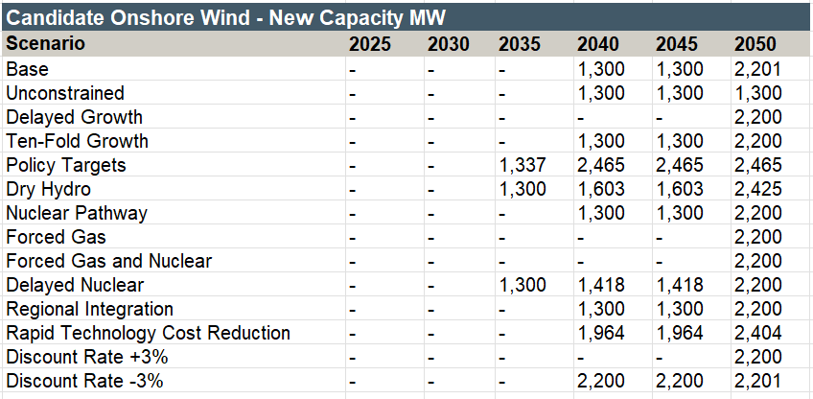
  BESS  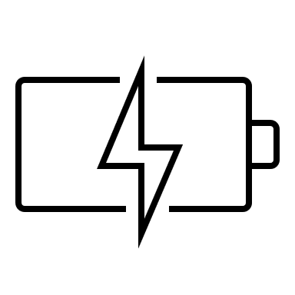 | - BESS capacity is selected in all scenarios, with deployment often closely linked to solar PV expansion. Long-duration (four-hour) storage assets help mitigate solar PV’s limited availability during evening and nighttime hours.  - BESS with higher duration (4h and 2h) are selected over BESS with lower duration (1h) as they are needed to firm solar PV capacity over nighttime when the sun is not signing.  - BESS are selected to also contribute firm capacity to the system, supporting reserve margin requirements and reducing the need for peaking thermal generation such as ICE units.  - BESS forms a critical component of all system development pathways with significant new capacity selected as least cost.  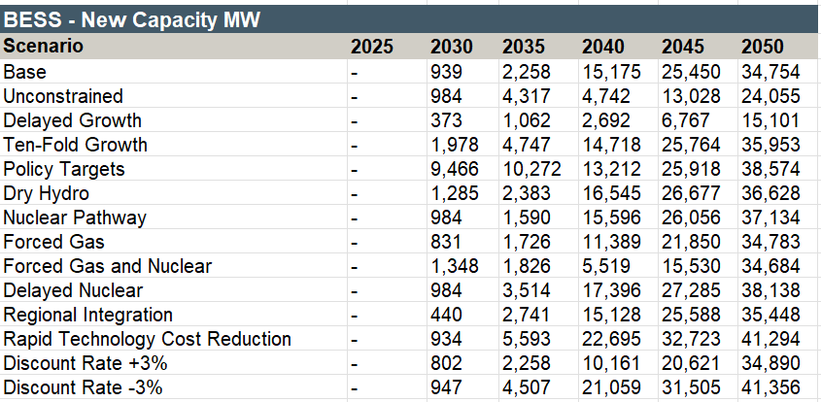
  Nuclear   | - In scenarios without net-zero targets, nuclear is not selected as least cost option. Gas fired power plants prove to be the least cost option over nuclear generators.  - In all scenarios where a 2050 emissions limit applies, nuclear is selected as a least cost. This reflects nuclear power’s ability to provide large-scale baseload generation with minimal carbon emissions, in the absence of sufficient alternative non-emitting baseload technologies.  - Given Uganda’s projected demand growth, developing national capability in nuclear power represents a credible long-term option, as there are currently no other non-carbon-emitting technologies able to supply baseload power at the scale required.  - In the Base case, nuclear will be needed from 2035 with 5.3 GW required by 2025.  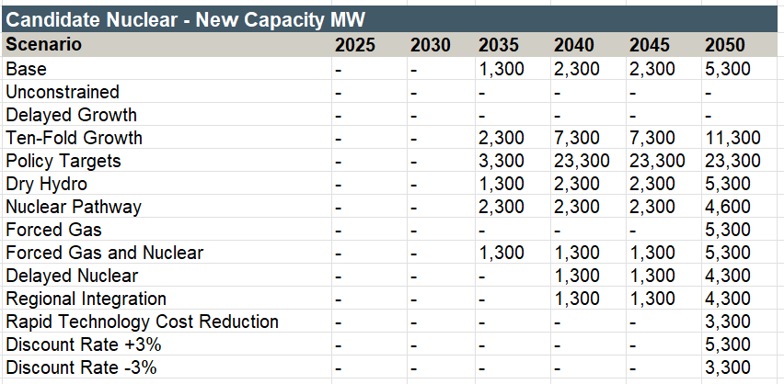
  Gas turbines  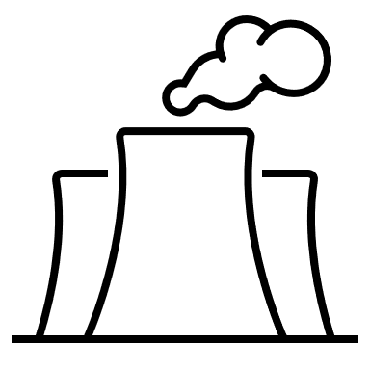 | - Without net-zero targets, gas fired power plants are selected as least cost options to provide base load and peaking power over nuclear generators. Pipeline-supplied gas-fired CCGTs are a cheaper baseload option than nuclear power.  - The inclusion of net-zero targets, constitutes gas-fired power plants a non-economic option and is not selected in the capacity plan.  - The NPV of cost of the forced gas scenario is less than 5% higher than the base scenario, indicating that development of a gas pipeline and associated CCGT/OCGT capacity represents a viable option for diversifying Uganda’s generation mix to meet rapidly growing demand.  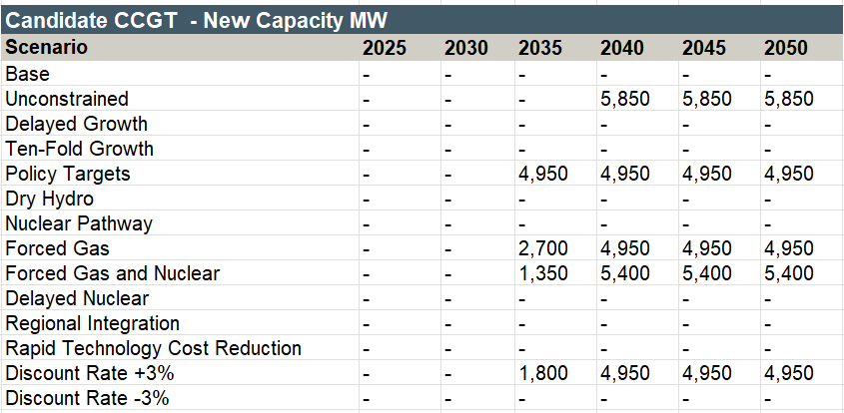  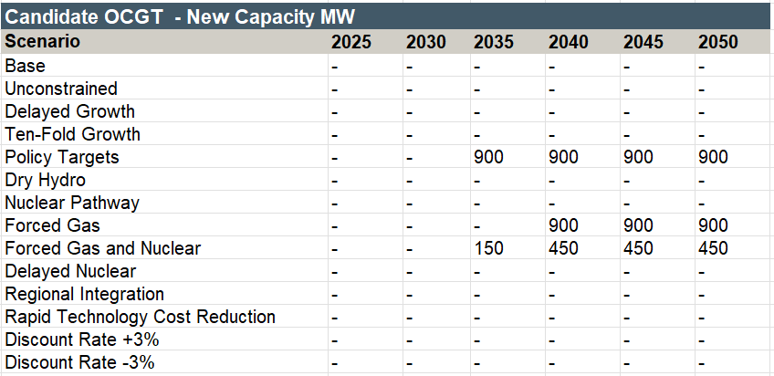
  Biomass, biogas, waste and peat   | - Biomass and biogas power plants are chosen in all scenarios, and always up to the maximum the physical feedstock in the country allows.  - Costs for the infrastructure to develop the necessary infrastructure to process and deliver feedstock to power plants can be highly variable and this should be taken account when taking decisions to prioritise investment in such generating assets.  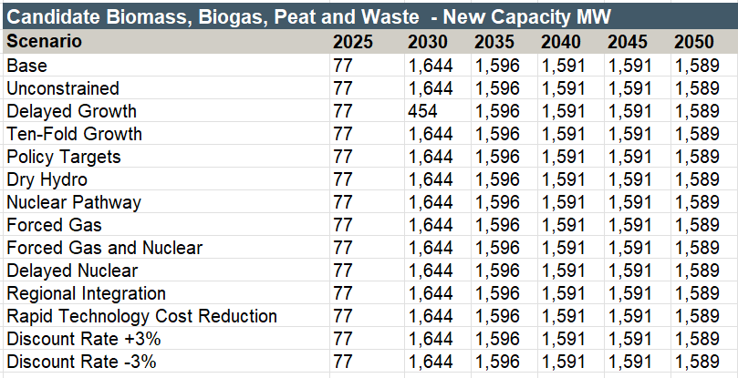
  Internal combustion engines  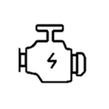 | - ICE generators utilising domestic HFO supply play an important role at the start of the planning horizon in most scenarios. ICEs are mainly selected as least cost to provide back-up capacity and contribute to the reserves margin. The high level of solar PV penetration selected as least cost and the inability of Solar PV to provide firm capacity at nighttime requires additional firm capacity to be installed to the grid. ICE operate with low capacity factors and are maintained in the system to provide back-up capacity.  - ICE generators provide important backup capacity, supporting system resilience as renewable generation capacity expands. In the Base case 0.5 GW will be needed by 2030 and 1.1GW by 2050.  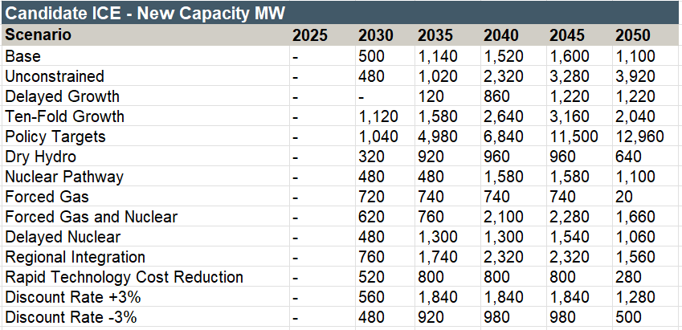
  EE and DSM   | - EE measures are selected as least cost in all scenarios to be implemented. From the candidate options, the measures selected as least cost include the replacement of inefficient bulbs with LED lightbulbs, the utilisation of low flow water aerators and replacement of electric boilers with solar water heaters.
Source: ECA Analysis

EE and DSM least cost plan
Of the candidate EE/DSM options (described in section 6.1) assessed in the least cost planning model only a small selection was chosen as least cost in the least cost plan for Uganda. Across all scenarios the following measures were selected as least cost:
- LED lightbulbs – The replacement of old inefficient bulbs with LED lightbulbs in both the residential and commercial sector.
- Low flow water aerators – The utilisation of low flow water aerators, thereby reducing consumption of heated water was also selected, this reflects the very small capital cost for these technologies.
- Solar water heaters – Replacement of electric boilers with solar water heaters was selected, Uganda as evidenced in the resource assessment has high irradiance making the country well suited to the utilisation of this technology.
On-grid efficient refrigerators, on-grid efficient fans, high-efficiency reach-in cooler, heat pump water heaters and high-efficiency solid-door freezers candidate measures were not selected under any scenario. This reflects their relatively high investment costs and the limited reduction in electricity demand they deliver compared to the baseline alternative. The costs of implementation outweigh the associated benefits in terms of reduced power consumption.
The investment costs to implement the above measures by scenario is shown in the table below. Detailed tables with the volumes required for each measure by scenario is shown in Annex A7.3.
Table 14 EE and DSM least cost investment plan by scenario
Source: ECA Analysis

Impact of the selected EE and DSM measures on demand
The impact of the selected measures on the demand is shown in Figure 40 for peak demand and Figure 41 for total energy demand for the Base case scenario. The replacement of inefficient bulbs with LED lights could reduce the demand up to 703 MW (and 1,026 GWh) in a residential setting and 61 MW (and 161 GWh) in a commercial setting. The replacement of water heaters with solar water heaters could reduce the demand up to 61 MW (and 647 GWh) while implementation of low flow water aerators could reduce demand by up to 300 MW (and 321 GWh). The relatively large impact on peak demand from replacement of residential lightbulbs reflects the correlation between the timings of residential lighting utilisation and peak demand.
Figure 40 Impact of least cost EE and DSM measures on peak demand – Base case
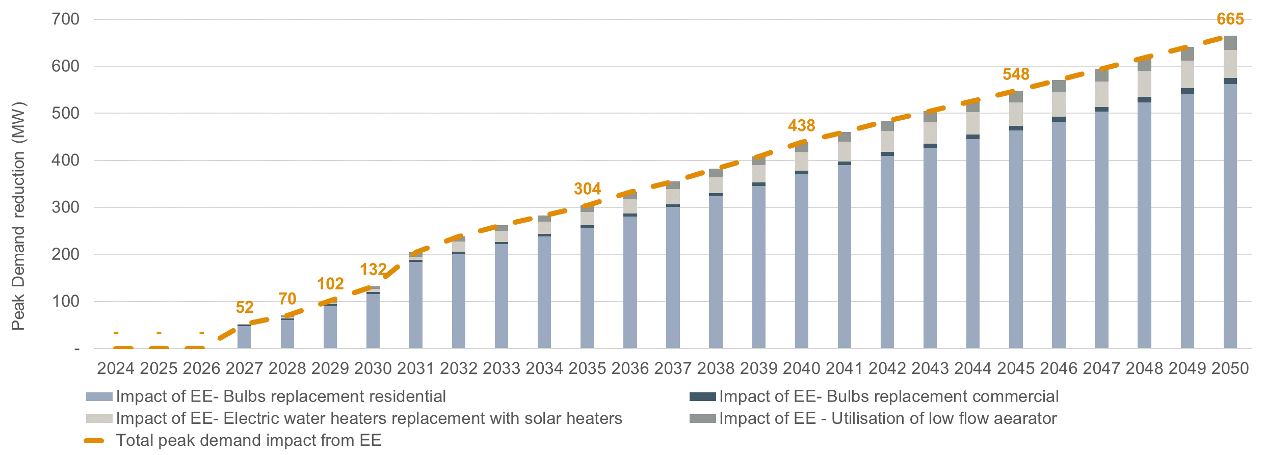
Source: ECA analysis
Figure 41 Impact of least cost EE and DSM measures on energy demand – Base case
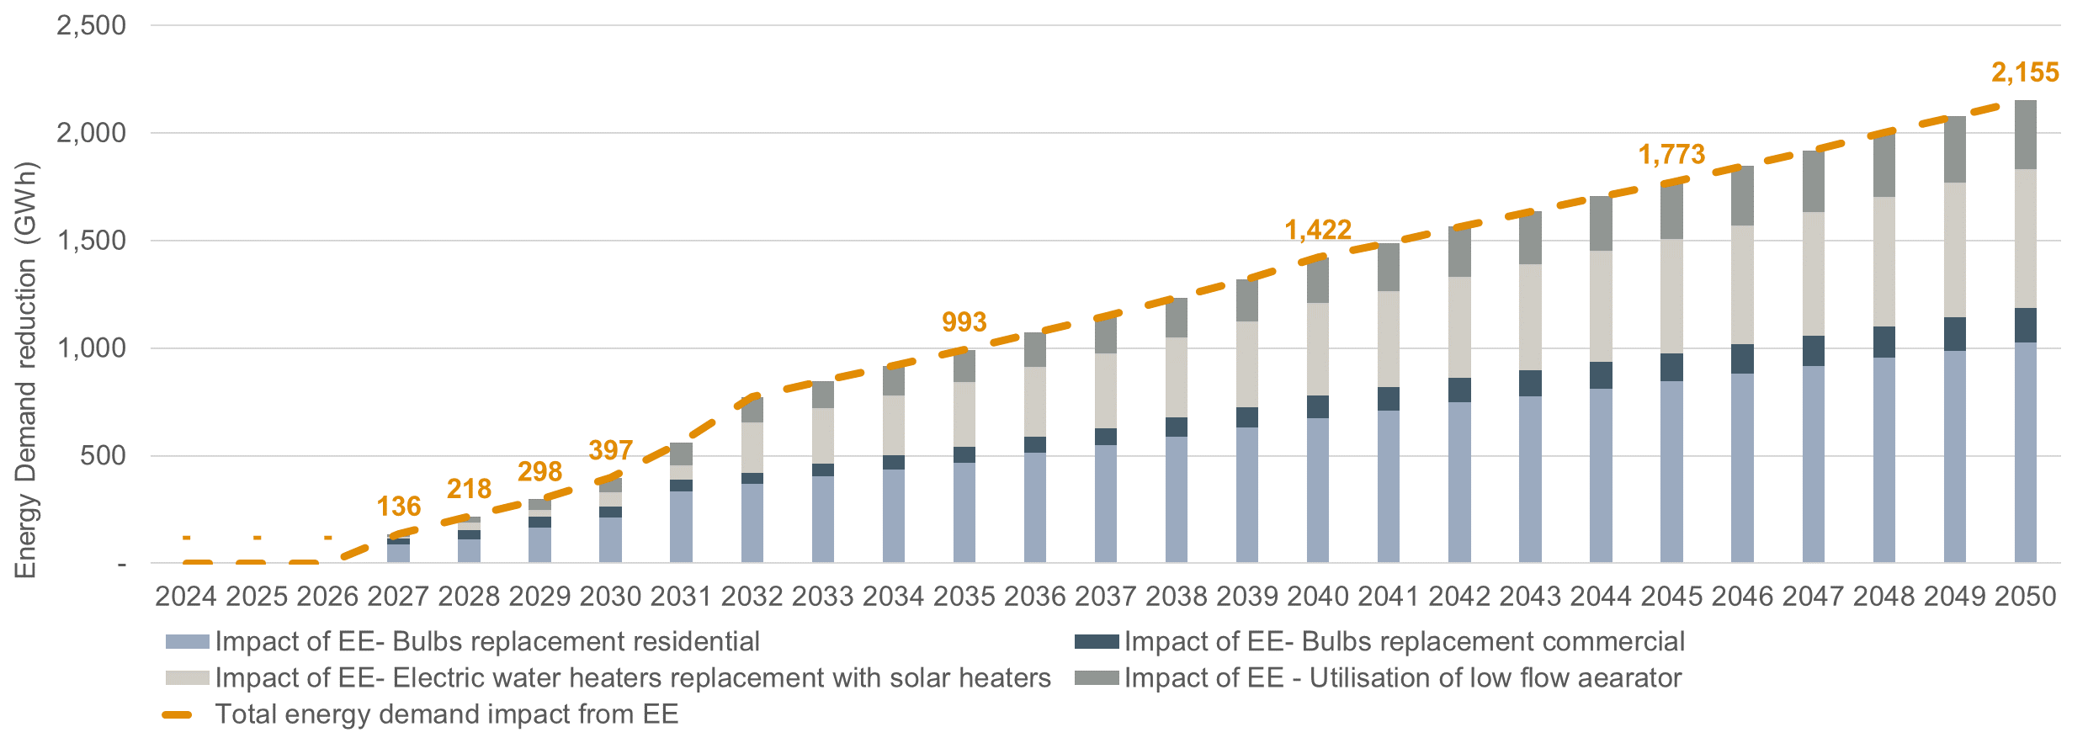
Source: ECA analysis

Emissions pathway by scenario
The Uganda ETP (2023) targets net-zero economy-wide emissions by 2065. Within this, the electricity sector is expected to achieve zero emissions by 2050. As described in Section 5.8, this emissions target applies to all scenarios except the unconstrained scenario.
Because a fixed emissions target of zero is imposed for 2050 in the model, all scenarios, other than the unconstrained one, successfully meet this requirement. They do so largely through additional build-out of nuclear generation capacity later in the modelling horizon. In contrast, the unconstrained scenario develops less nuclear capacity, as it is not limited by the same emissions targets and instead gas-fired power plants are selected as least cost.
Across most scenarios, emissions rise through 2030, plateau until around 2045, and then decline to reach the 2050 target. Four notable exceptions are the policy-target scenario, the two forced-gas scenarios and high WACC scenario.
- In the policy targets scenario, rapidly increasing demand in the 2030s drives emissions upward until about 2035. After that, the policy objective of achieving 95% renewable generation by 2040 results in a sharp emissions decline.
- In the forced gas and forced gas and nuclear scenario – scenarios involving the construction of a new gas pipeline - emissions remain substantially higher due to the continued use of gas in CCGT power plants until 2050. After 2050, emissions fall sharply as gas assets are decommissioned and replaced with nuclear capacity.
- In the high WACC scenario the gas pipeline and associated CCGTs are also developed while nuclear capacity is delayed, this results in significant emissions prior to the 2050 zero emissions target.
Figure 42 Annual emissions by scenario
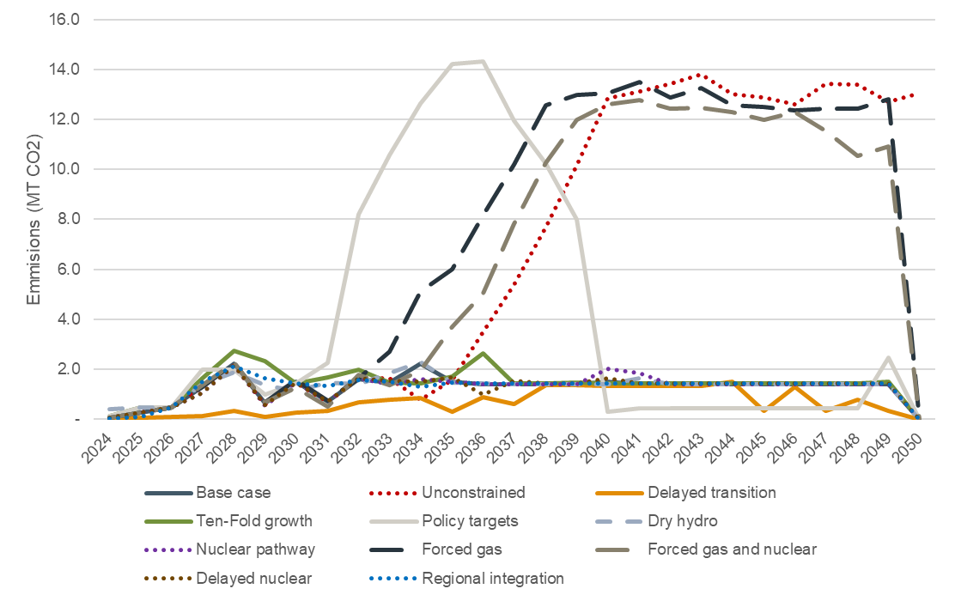
Source: Outputs from Uganda least cost planning scenario. Emission factors are defined in the resource assessment and result in emissions from Gas, HFO ICE and biomass/biogas power plants.

Firm capacity and reserve margin
Firm capacity from reliable generation sources is required to maintain a 10 percent reserve margin across all forecast scenarios. In the Base scenario, and consistently across all scenarios, this firm capacity is provided by a combination of hydropower, internal combustion engines, batteries, geothermal generation, and either nuclear or gas fired power plants.
The contribution of firm capacity relative to peak demand is illustrated in Figure 43. This highlights the importance of maintaining a diversified portfolio of firm and flexible generation technologies to ensure system reliability as electricity demand grows.
Figure 43 Firm capacity vs. peak demand, base transition scenario
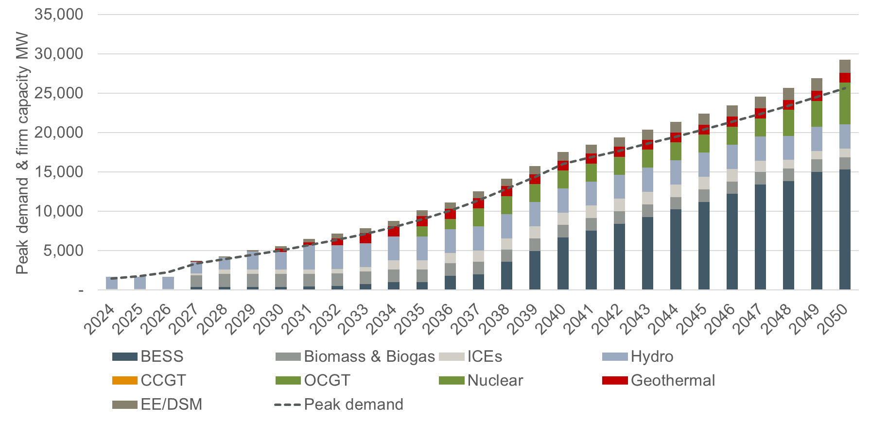
Source: ECA analysis

Total NPV of costs across scenarios
Table 15 summarises the NPV of all costs for each scenario. Summed together this represents the total costs of each least cost plan subject to the time value of money.
The Unconstrained scenario results in the lowest average cost per unit of served energy for Uganda. This outcome is expected, as the unconstrained scenario does not impose any policy-driven limitations, allowing the model to select the most economical supply options regardless of their origin or technology.
The Base case scenario, which incorporates national policy targets for emissions results in total costs that are 6.9% higher than the unconstrained case. This provides a useful benchmark for the additional system cost associated with meeting policy-driven objectives. Costs increase by $7/MWh in average NPV terms to implement the net-zero policy target.
The Ten-fold growth and Policy targets scenarios are substantially more expensive, even on a per unit cost basis. To meet the rapidly increasing demand in these scenarios less economic options must be selected including wind and floating solar PV, resulting in higher average costs of production. Costs increase by 17% (or by $11/MWh in average NPV terms) in the Ten-fold growth scenario and by 34% (or by $24/MWh in average NPV terms) in the Policy targets scenario in comparison to the Base case.
The Forced gas and Forced gas and nuclear scenarios explore the impact from a policy decision to develop the gas pipeline and enable gas-fired generators to the mix despite not being selected in the Base case least cost plan. Costs in these two scenarios increase by 9% (or by $1/MWh in average NPV terms) and by 10% (or by $3/MWh in average NPV terms) respectively in comparison to the Base case. The impact on costs from such a policy decision loos minor compared to the benefits of diversifying the energy resources mix.
The Regional integration scenario results in reduced costs relative to the base case as now previously expensive generation can be offset by imports. However, the cost difference is small, only 0.5% less than the base case, mainly due to the relatively high import tariffs and limited proposed new cross-border transmission infrastructure across the time horizon.
The Dry hydro scenario results in additional 9.5% of costs due to the need to meet a shortfall in supply from hydropower assets. The Delayed nuclear and Nuclear pathway scenarios both result in slightly increased costs relative to the Base case. In the Delayed nuclear scenario nuclear is developed slightly later than optimal while in the Nuclear pathway scenario nuclear is commissioned two years earlier than the Base scenario resulting in approximately 5% higher costs.
Table 15 Uganda NPV of least cost plan costs by scenario
Scenario | Capital costs  (m$) | Variable costs  (m$) | Fixed O&M costs  (m$) | Tx lines costs  (m$) | Import costs (m$) | Total costs  (m$) | Average costs*  ($/MWh) | +/- **  (%) | CO2  (Mt)
Unconstrained | 31,168 | 6,138 | 3,034 | 303 | 0 | 40,643 | 92 |  | 184
Base | 34,820 | 4,529 | 3,793 | 317 | 0 | 43,459 | 99 | 7% | 34
Delayed growth | 10,721 | 1,067 | 1,140 | 121 | 0 | 13,049 | 69 | -25% | 18
Ten-fold growth | 47,097 | 9,492 | 5,296 | 543 | 0 | 62,427 | 108 | 17% | 39
Policy targets | 90,874 | 21,893 | 10,423 | 824 | 0 | 124,013 | 123 | 34% | 106
Dry hydro | 36,875 | 4,508 | 4,016 | 471 | 0 | 45,869 | 105 | 14% | 36
Nuclear pathway | 34,805 | 4,851 | 3,839 | 392 | 0 | 43,888 | 100 | 8% | 33
Forced gas | 33,695 | 7,087 | 3,002 | 335 | 0 | 44,119 | 100 | 9% | 195
Forced gas and nuclear | 33,809 | 7,535 | 3,154 | 371 | 0 | 44,868 | 102 | 10% | 171
Delayed nuclear | 36,004 | 3,351 | 3,865 | 391 | 0 | 43,611 | 99 | 7% | 33
Regional integration | 33,872 | 3,343 | 3,865 | 307 | 1,413 | 42,799 | 97 | 5% | 34
Rapid technology cost reduction | 33,141 | 2,459 | 4,039 | 283 | 0 | 39,922 | 91 | -2% | 32
Discount rate +3% | 23,837 | 5,711 | 1,996 | 227 | 0 | 31,771 | 105 | 14% | 233
Discount rate -3% | 51,786 | 3,484 | 6,234 | 303 | 0 | 61,807 | 92 | 0% | 31
Source: Source: ECA analysis. Note: * NPV total costs / NPV Served energy, ** Relative to Unconstrained scenario.

Transmission system least cost plan
The transmission development plan for the main scenarios is presented in the sections below. The results include the least-cost regional interconnectors optimised as part of the plan.

General approach
Several key transmission corridors will see transfer levels in excess of 1,000 MW, even reaching several thousand MWs. This calls for the use of 400 kV voltage on the key transmission corridors and would also result in lower costs of investments, losses and operation and maintenance costs than 220 kV. Although single circuit lines may be an option in some areas, the transfer levels expected along the main transmission corridors would require two or more circuits and to save space, building double-circuit lines are seen as viable solutions – in line with recent approach on the 220 kV system as well.
It may be an option to build new major transmission lines at 400 kV and operate such lines at a lower voltage initially, thereby potentially postponing investing in costly substations. However, should the growth in demand be as rapid as in the base case demand forecast, savings are likely minor and the emphasis would likely be on implementing the numerous projects as efficiently as possible – noting that staged development would increase overall costs of investments somewhat, and therefore postponing substations investments by temporarily operating new lines at a lower voltage level than the design voltage may not provide any (significant) economic benefits.
As discussed in Section 6.3, further expansion of the 220 kV system should also be considered carefully in view of the need to develop a 400 kV system to integrate large power plants (including large PV plant projects as well as nuclear plants in most scenarios). A system mainly built on a 400 kV transmission grid supported by a 132 kV sub-transmission system that feeds into a distribution system (at 33 kV or below) is foreseen to be the optimal long-term development approach – avoiding large and costly substations with all three voltage levels, i.e. 400 kV, 220 kV and 132 kV. The optimal approach is naturally highly dependent on the actual growth in demand, but the high growth foreseen in the IRP will require significant investment on a 400 kV grid and expanding a parallel 220 kV system is therefore not required nor seen to provide significant benefits in view of possible postponement of the development of a 400 kV grid.
A key planning assumption underlying the transmission system development plan is that all new 400 kV interconnectors are developed as double-circuit transmission lines.

Transmission system least cost plan by scenario

Base case scenario
In the Base case scenario, the transmission system development is supporting power evacuation from several large solar plants as well as nuclear power generation to supply high demand centres. The transmission development plan also includes significant investment in new 400 kV transmission lines to provide stronger integration of the different regions within Uganda, thereby supporting regional power exchange.
Table 17 presents the transmission system least cost plan and investment costs for the Base case scenario as outlined in the generation expansion plan in Section 7. The transmission lines least cost plan, shown in Table 16, show an optimisation favouring high levels of solar and nuclear generation, particularly in the Eastern Region. To facilitate this, the selected least cost option is reinforcements between the Eastern Region and GKM, specifically between Opuyo and GKM, enabling effective power evacuation from the east to the main load centres in GKM. Similarly, reinforcements between the Northern Region and GKM are included in the least-cost expansion plan, between Karuma and GKM.
These reinforcements collectively establish a robust high-voltage transmission corridor spanning the country from north to south and from east to the central areas. Together with other new 400 kV transmission lines between key bulk supply points throughout each region in Uganda, this forms a reliable 400 kV backbone with high capacity for varying dispatch on a system with a high penetration level of renewables.
Table 16 Transmission lines least cost plan – Base case scenario
Candidate interconnection | Implementation year
Kafu - Hoima | 2029
Olwiyo upgrade | 2031
Karuma - Kafu | 2031
Hoima - Kiboga - Bussunju | 2031
Opuyo - Buyende - Jinja - Mukono | 2035
Masaka - Mbarara | 2037
Karuma - Ayago | 2034
Opuyo - Namulonge | 2039
Karuma - Kawanda | 2040
Opuyo - Namulonge | 2049
Source: Norconsult analysis
Table 17 400 kV backbone grid development – Base case transmission investment plan
Description | Implementation year | Capital costs  (mUSD)
Olwiyo: Substation 400/132 | 2029 | 35.50
Kafu - Hoima: 75 km 400 kV double circuit line; 400/220 kV substation in Hoima, 400 kV bay extension Kafu | 2029 | 117.00
Kinyara: Substation 400/132 | 2029 | 35.50
Ayago switching station: 10 line bays | 2031 | 45.00
Karuma - Kafu: 87 km 400 kV doble circuit line; 400 kV bay extension in Karuma and Kafu | 2031 | 61.50
Hoima - Kiboga - Bussunju : 148 km 400 kV line, 400/132 kV substation in GKM (north-west); 400 kV bay extension in Hoima | 2031 | 115.50
Gulu - Olwiyo: 60 km 400 kV line; 400/132 kV substation in Gulu; 400 kV extension in Olwiyo | 2034 | 74.50
Opuyo - Buyende - Jinja - Mukono: 205 km 400 kV line; 400/132 kV substation in Olwiyo; 400/220 kV substation in Bujjagali; 400/220 kV substation in Mukono | 2035 | 219.00
Tororo - Opuyo: 140 km 400 kV line; 400 kV bay extension in Tororo and Opuyo | 2035 | 88.00
Karuma - Lira: 73 km 400 kV double circuit; 400/132 kV substation in Lira; 400 kV bay extension in Karuma | 2036 | 73.00
Masaka - Mbarara: 130 km 400 kV double circuit line; 400/132 kV substation in Mbarara; 400 kV bay extension in Masaka | 2037 | 109.50
Wobulenzi - Bussunju - Masaka: 155 km 400 kV double circuit: 400/132 kV substation in Wobulenzi; 400 kV bay extension in Masaka and GKM | 2037 | 131.00
Mukono - Namulonge - Wobulenzi: 50 km 400 kV double circuit; 400/132 kV substation in Namulonge; 400 kV bay extension in Masaka and Wobulenzi | 2037 | 78.50
Opuyo - Namulonge 180 km 400 kV double circuit line; 400 kV bay extension in Opuyo; 400/132 kV substation in Namulonge | 2039 | 134.50
Moroto - Opuyo: 145 km 400 kV double circuit; 400/132 kV substation in Moroto; 400 kV bay extension in Opuyo | 2039 | 117.00
Mbarara - Ishaka - Kasese/Nkenda: 140 km 400 kV line; 400/132 kV substation in Kasese; 400 kV bay extension in Mbarara | 2039 | 114.50
Karuma - Ayago: 35 km 400 kV double circuit; 400 kV bay extension in Karuma: 400 kV bay extension in Ayago | 2040 | 35.50
Buloba: 400/132 kV substation in GKM, connected to along Wobulenzi - Masaka | 2045 | 35.50
Opuyo - Namulonge: 180 km 400 kV double circuit line; 400 kV bay extension in Opuyo; 400 kV bay extension in Namulonge | 2049 | 108.00
Total |  | 1,728.5
Excluding investments reported in the generation least cost plan
Total |  | 801
Source: Norconsult analysis
Although a high-capacity grid will be developed throughout the study period, the least cost plan results indicate that development of local generation resources to support local demand in many areas is part of the least cost solution. The 400 kV backbone will therefore not be necessary in all regions early on, but rather ensure that the full potential of power plants in high-resource generation areas is utilised, therefore prioritising build-up of transmission corridors that enable efficient power evacuation.
Further reinforcement within regions have been assessed to provide support for local generation and local demand points. This includes investments on all voltage levels (400 kV, 220 kV, and 132 kV) based on the existing infrastructure in the area. Expansion of the existing 132 kV infrastructure is considered necessary to reinforce the existing grid and to establish new 132/33(11) kV substations to off-load existing substations and medium voltage distribution systems as demand grows and naturally to feed into areas yet to be electrified. A number of commercial projects (agricultural parks, industrial parks, data centres, free trade regions, steel plants, etc.) is also foreseen to connect to relevant bulk supply points – many if not most of which are foreseen to require supply at sub-transmission voltage.
Figure 44 illustrates the final least cost transmission system backbone for the Base case scenario.
Figure 44 Main 400 kV corridors - Base case transmission development plan
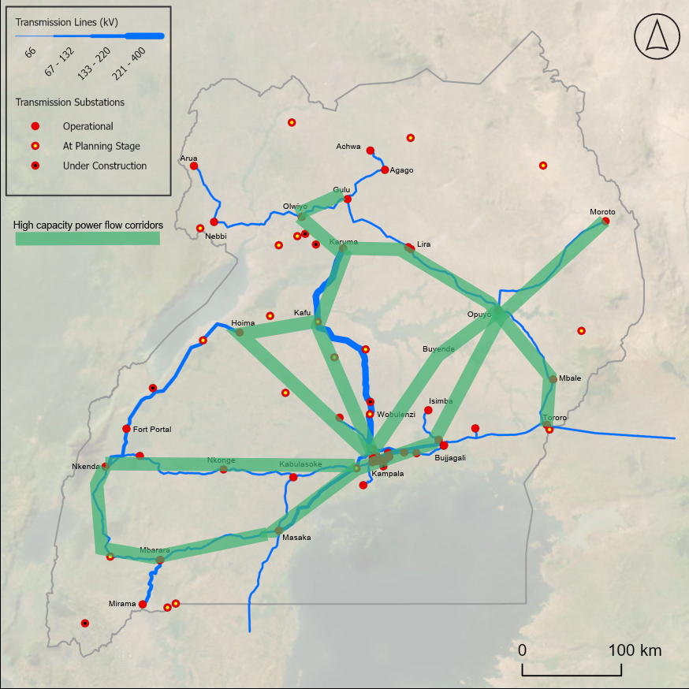
Source: Norconsult analysis
Investments at the 132 kV and 220 kV voltage levels are based on information provided from the preparation of UETCL’s Grid Development Plan, supplemented by generic investment costs, as presented in the table below. The generic investment costs represent additional reinforcements seen as required after accounting for the specific 132 kV and 220 kV investments and cover network measures that are not modelled as individual projects. These investments are defined at a strategic level and is foreseen to be refined as load allocation to specific projects is further defined as part of pre-feasibility and feasibility studies of the different sub-systems throughout the country.
The transmission development plan primarily foresees expansion and reinforcement of the 132 kV network. However, some reinforcement of the existing 220 kV infrastructure is also expected to be required.
Table 18 132 kV and 220 kV backbone grid development – Base case investment plan
Description | Implementation year | Capital costs  (mUSD)
Arua - Oraba: 70 km 132 kV double circuit; 132/33 kV substation in Oraba | 2030 | 35.50
Arua - Adjumanji: 150 km 132 kV double circuit; 132/33 kV substation in Adjumanji | 2030 | 120.75
Mbale - Bulambuli - kween: 76 km 132 kV double circuit line: associated substations | 2030 | 35.50
Moroto - Bulambuli: 150 km 132 kV double circuit | 2030 | 59.25
Moroto - Kaboong: 150 km 132 kV double circuit; 132/33 kV substation in Kaboong | 2030 | 85.75
Bibia - Adjumanji: 50 km 132 kV double circuit | 2030 | 58.25
Agago/Achwa - Kitgum - Bibia East: 160 km 132 kV double circuit line and associated substations | 2030 | 160.50
Kabale - Ishaka: 95 km 132 kV double circuit | 2030 | 44.13
Nkonge - Mubende - Kiboga: 130 km double circuit; 132/33 kV susbstations in Mubende and Kiboga | 2030 | 71.25
Nakangosola - Kasana: 78 km 132 kV double circuit line; 132/33 kV associated substations | 2030 | 65.95
Nakangosola - Kasana: 78 km 132 kV double circuit line; 132/33 kV associated substations | 2030 | 74.95
Nkenda - Fort Portal - Hoima: upgrade of substations to 220kV | 2030 | 100.00
Generic reinforcement in GKM | 2030 | 250.00
Generic reinforcement of the 132 kV and 220 kV networks | 2035 | 920.00
Generic reinforcement of the 132 kV and 220 kV networks | 2040 | 920.00
Generic reinforcement of the 132 kV and 220 kV networks | 2045 | 920.00
Generic reinforcement of the 132 kV and 220 kV networks | 2050 | 920.00
Total |  | 4,841.8
Source: Norconsult analysis
The investments in generic reinforcement of the 132 kV and 220 kV networks represents aggregated reinforcement investments at the 132 kV and 220 kV levels, included at a strategic level and phased in five-year stages.

Unconstrained scenario
As the Unconstrained scenario includes no nuclear build-out, the transmission system no longer requires the same level of transfer capacity between the Eastern Region – where the main nuclear candidate sites are located – and the GKM region. Instead, the transmission development plan under the Unconstrained scenario reflects a shift in generation siting, with increased solar generation selected as least cost. The main difference in the transmission development plan under the unconstrained scenario is that greater reinforcement between the Northern Region and the GKM region is selected, rather than between the Eastern Region and the GKM region as in the Base case.
Table 19 Transmission lines least cost plan – Unconstrained scenario
Candidate interconnection | Implementation year
Kafu - Hoima | 2029
Olwiyo upgrade | 2031
Karuma - Kafu | 2032
Hoima - Kiboga - Bussunju | 2032
Karuma - Ayago | 2034
Opuyo - Buyende - Jinja - Mukono | 2035
Masaka - Mbarara | 2038
Opuyo - Namulonge | 2040
Karuma - Kawanda | 2049
Source: Norconsult analysis

Delayed transition scenario
In the Delayed transition scenario, the key difference compared to the Base case is that power evacuation from nuclear generation is no longer required. As a result, fewer interconnectors between the regions in Uganda are selected in the transmission development plan. In addition, the lower rate of demand growth leads to a postponement of transmission reinforcement investments, with implementation shifted to later years.
The main transmission developments in this scenario relate to power evacuation from the Northern Region to the GKM Region, as well as from the Eastern Region to the GKM Region. PLEXOS does not select reinforcements between several other regions due to the significantly reduced load levels.
Table 20 Transmission lines least cost plan – Delayed transition scenario
Candidate interconnection | Implementation year
Kafu - Hoima | 2034
Olwiyo upgrade | 2035
Karuma - Kafu | 2037
Hoima - Kiboga - Bussunju | 2037
Opuyo - Buyende - Jinja - Mukono | 2048
Karuma - Ayago | 2050
Source: Norconsult analysis

Ten-Fold growth scenario
The Ten-fold growth scenario results in a substantial increase in generating capacity, particularly nuclear development in both the Eastern and Central Regions. Consequently, the transmission development plan is broadly similar to the base case, but with significant additional reinforcements between the Central Region and the Western Region. Overall, higher transmission capacity is required, and a larger number of transmission candidates is selected as least cost compared to the Base case.
Table 21 Transmission lines least cost plan – Ten-fold growth scenario
Candidate interconnection | Implementation year
Kafu - Hoima | 2029
Masaka - Mbarara | 2029
Olwiyo upgrade | 2031
Karuma - Kawanda | 2031
Opuyo - Buyende - Jinja - Mukono | 2033
Karuma - Kawanda | 2036
Nkonge - Kasese | 2037
Hoima - Kiboga - Bussunju | 2031
Masaka - Mbarara | 2037
Opuyo - Namulonge | 2038
Jinja - Mukono | 2043
Kawanda - Masaka | 2050
Opuyo - Namulonge | 2050
Source: Norconsult analysis

Policy targets scenario
The Policy target scenario imposes aggressive renewable electricity requirements, combined with a higher load forecast. As a result, this scenario leads to extensive transmission development and represents the case with the largest overall build-out of the transmission system as shown in the table below.
Table 22 Transmission lines least cost plan – Policy targets scenario
Candidate interconnection | Implementation year
Kafu - Hoima | 2029
Opuyo - Buyende - Jinja - Mukono | 2029
Opuyo - Namulonge | 2029
Opuyo - Lira | 2029
Olwiyo upgrade | 2031
Karuma - Kawanda | 2032
Tororo - Jinja | 2034
Karuma - Ayago | 2034
Masaka - Mbarara | 2035
Nkonge - Kasese | 2036
Opuyo - Namulonge | 2036
Hoima - Kiboga - Bussunju | 2036
Opuyo - Namulonge | 2037
Opuyo - Namulonge | 2037
Masaka - Mbarara | 2038
Kawanda - Masaka | 2038
Masaka - Mbarara | 2039
Kawanda - Masaka | 2039
Jinja - Mukono | 2040
Karuma - Ayago | 2040
Kawanda - Masaka | 2041
Kawanda - Masaka | 2044
Source: Norconsult analysis

Distribution system least cost plan and electrification
The National Electrification Strategy for Uganda prepared by iED in 2021 (study funded by the World Bank) has been used as the basis for the preparation of estimates of investments required on the distribution system to meet growth in demand and to increase access to electricity in both urban and rural areas.
The iED study identified costs in the period 2021-2030 to provide electricity to an estimated 10.4 million households, ensuring universal Tier 1 connectivity by 2030. However, with 53 % of these households being supported by standalone solar system (SHS) with a 3 W solar system per household. The number and type of connections under the National electrification strategy is illustrated in Figure 45.
Figure 45 National electrification strategy – Number and type of connections
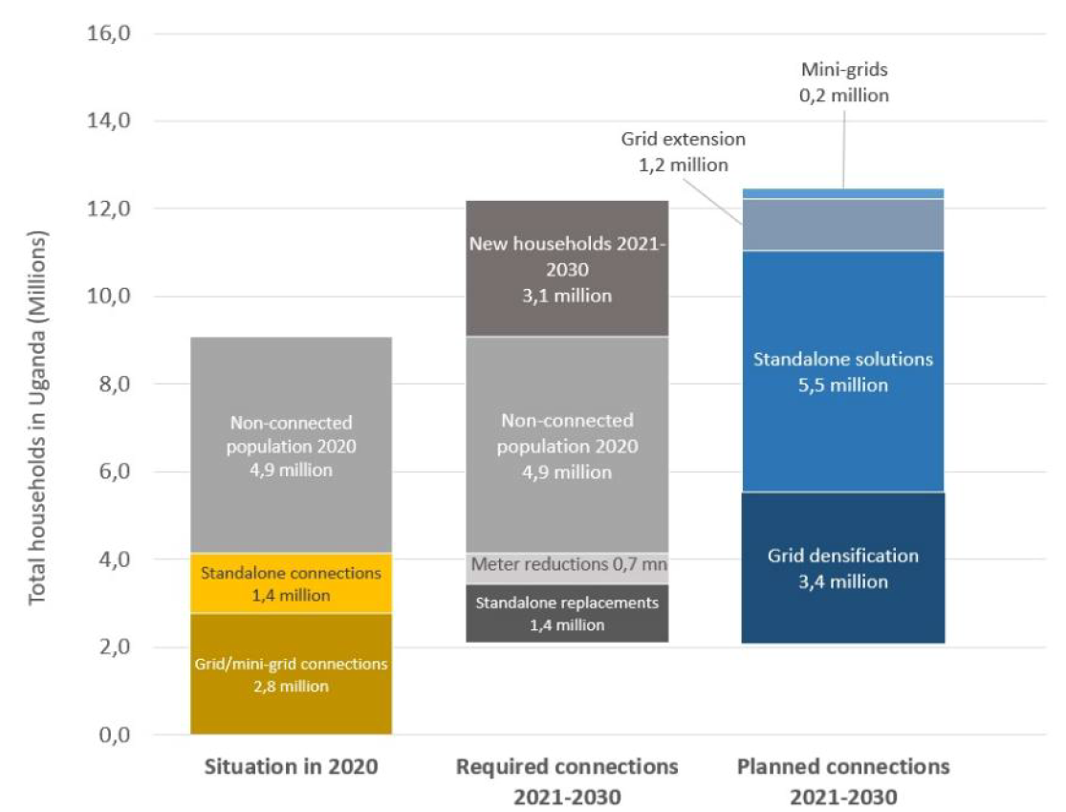
Source: National Electrification Strategy for Uganda

General approach
The IERMP builds on the approach used in the National Electrification Strategy, drawing on an update of the estimated population, number of households and electrification rates in the different scenarios as covered by the Demand forecast report for the IERMP.
The costs for densification, grid extension, solar home system (and/or multi-light systems), and mini grids have been estimated throughout the study period up to 2050. Furthermore, reinvestment in solar home systems have been accounted for in line with the iED study (the lifespan of simple solar systems estimated at just six years).
However, it is also foreseen that over the period up to 2050, a number of households initially provided a solar home system will be climbing the ladder to become part of solar mini-grids and/or be provided a grid connection. The rate at which such conversion will happen is highly uncertain, and it is underlined that the estimates provided are uncertain. Figure 46 from the Uganda Energy Transition Plan (IEA, December 2023) provides insights on how such a transition may take place.
The IEA study assumed grid access would increase to well above 40 % by 2030, about 70 % by 2040 and more than 80 % by 2050. Mini-grids would provide supply to about 10 % of the population by 2030, and solar home systems and transitional multi-light systems (MLS) would provide access to the rest of the population. Over the period up to 2050, most of the households with MLS and solar home systems would switch over to mini-grids and grid connections, and some mini-grids would become connected to the grid. A similar transition is assumed in this IRP study, reflecting the number of households and access rates as provided in the Demand Forecast presented previously.
Figure 46 Share of population with electricity access by technology in the ETP
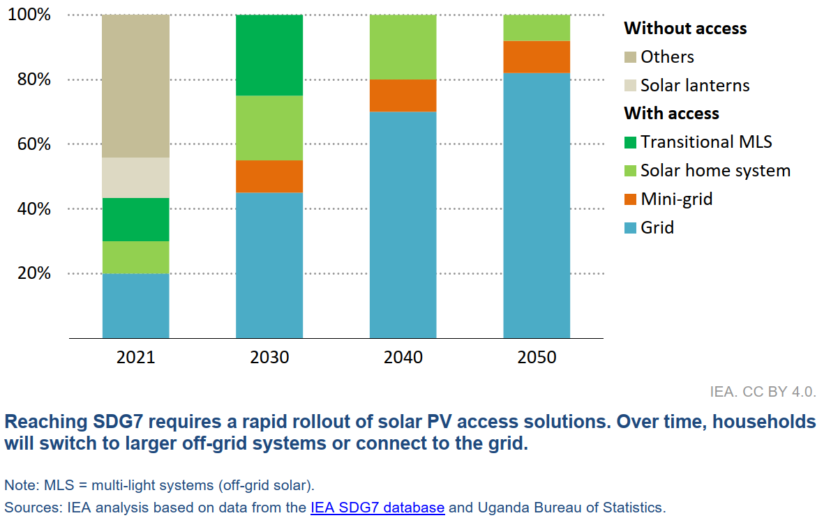
Source: Energy Transition Plan, IEA

Costs estimates per new connection
The investment costs on the distribution system were assessed using the following allocation for household connections:
- Grid connected households, as part of densification projects of grid extension projects
  - Number of grid connections reflect the figures presented previously as part of the Demand Forecast report – starting at about 2.5 million households in 2025 and growing to about:
    - 17.4 million households by 2050 in the Base transition scenario
    - 13.5 million households by 2050 in the Delayed transition scenario
- Households connected to solar mini-grids
  - In line with the IEA study referred to above, the Base transition scenario assumes that 10 % of the households are connected to mini-grids at the end of the study period (2050) – growing steadily from an estimated 2.5 % early on. For the Delayed transition, the number of households is assumed to pick up at a lower rate, reaching 5.0 % by 2050.
- Households provided supply by solar home systems and multi-light systems, i.e. off-grid solar systems
  - Households not on grid connection or mini-grids
- Households without access
  - Starting at about 70 % in 2025 and dropping in line with assumptions in the Demand Forecast Report
    - 10 % without access in the Base transition scenario by 2050
    - 30 % without access in the Delayed transition scenario by 2050

Solar home systems and multi-light systems
To provide a basic Tier 1 service level, the iED study on the Electrification Strategy for Uganda assumed that more than 5.5 million households would rely on standalone 3 W solar home system by 2030 at a cost of USD 76 per connection. Such simple systems are foreseen to have a limited life-time of six years, and the cost of replacing such systems must therefore be accounted for.
Furthermore, we expect that some customers would opt for a higher capacity at a relatively small additional cost. This may certainly be a fair assumption at the time of replacing the initially installed low-capacity standalone system. Cost per kW of such installations may also be expected to drop in future. The estimated investment costs for solar home systems have therefore been based on a unit cost of USD 100 per household – representing an estimated average cost of systems ranging from a minimum of 3 W to about 6-10 W (with the larger units allowing for more lights and/or for use for more hours per day).

Solar mini-grids
The National Electrification Strategy Study by iED estimated cost of solar-diesel mini-grids serving clusters of at least 500 inhabitants to an average of just above USD 1 500 per connection. Cost of solar panels have dropped considerably in recent years and combined with lower costs of battery storage; solar-battery mini-grids are likely better alternatives than solar-diesel systems in the future. This is certainly the case if cost of battery storage drop further (partly driven by technology developments, partly volumes). Globally, solar-battery mini-grids make up more than half of mini-grids implemented in recent years.
Cost of solar-battery mini-grids vary widely depending on size of systems and maturity of supply chains in different countries and regions. For clusters with more than 200 customers, we would expect costs ranging from below USD 1 000 per customer to more than USD 2 000 per customer. Historically, costs of projects in Africa have been in the higher range, partly due to projects including fewer customers than in many other parts of the world (projects in Asia falling into the lower range). The cost estimates presented in the following are based on an average cost per connection (household) of USD 1 500, and that this cost level represents the average cost both at present and in the future (although cost of batteries is expected to drop in future, cost of other components required for the mini-grids have increased in some areas and may also increase further).
It is noted that there is potential for a few hydropower mini-grids, however, going by the results in presented by iED in 2021, this is limited to about 40 000 people and would have no significant impact on the overall cost estimate of providing access to about seven million households without access at present and a further 12 million or so new households to be built by 2050. The impact of such mini-grids has therefore been ignored in the cost estimate provided. The potential projects may still be part of least-cost development plans for the relevant areas though.

Grid connections
The cost of providing grid supply varies significantly between urban and rural areas, available capacity on the existing grid in case of densification, and distance from existing supply points for grid extension projects etc. The study by iED estimated average cost per connection as follows:
- Densification projects: USD 730 per connection
- Grid extension: USD 1,088 per connection
We foresee that cost of grid extensions may increase throughout the study period as households in more remote areas will likely be making up a higher share of new connections towards the end of the study period than for projects implemented early on. The average cost as estimated by iED may therefore represent a reasonable estimate for projects initiated at the time being, but it seems reasonable to increase the cost of grid extension projects towards 2040 and beyond. Also adjusting the costs to price level of 2025, the cost estimates presented in the following have been prepared assuming the following average costs per household or connection:
- Densification projects: USD 800 per connection
- Grid extension: USD 1,200 per connection in 2026 increasing to
USD 1,400 per connection by 2040
The number of households is also foreseen to more than double in the study period, and clearly, grid extension projects will likely dominate the picture once households in areas suited for densification have been provided a grid connection. Initially, an estimated 75 % of new grid connections are foreseen to be part of densification projects, dropping steadily to just 10 % of new grid connections by 2040 and beyond.
Some of the mini-grid systems are also assumed to be provided a grid connection at some stage. The cost of upgrading such systems have been estimated at USD 500 per household early on, increasing to USD 700 per household by 2040 and beyond.

Total distribution system costs
Total estimated investment costs r the distribution system are presented in the following table. Further detail and breakdown per year in the study period are provided in Annex A8.
The total investment cost of providing more than 14.5 million connections in the Base transition scenario is estimated at more than USD 13 billion. There is clearly a significant potential saving on postponing grid connections for households on mini-grid systems. With further reduction in cost of solar panels and battery storage, upgrading such mini-grid systems may in future provide lower-cost solutions than grid connections (lower-cost projects completed prior to remote, more costly projects).
Table 23 Distribution plan – Investment costs (million USD)
 | Base transition scenario  (million USD) | Delayed transition  (million USD)
Solar home systems, including reinvestment costs | 578 | 457
Mini-grids | 1,746 | 1,340
Grid connection, previous mini-grid households | 2,938 | 2,557
Grid connection, other households | 7,872 | 5,829
Total | 13,314 | 10,182
Source: Norconsult analysis
Total investment costs for the Delayed transition scenario are about USD 10 billion. Notably, the costs in the first few years are much lower than in the Base case scenario – only about 40% up to 2030. In the last few years, annual investment costs in the delayed scenario will however slightly exceed costs in the Base case scenario with the assumptions made.

Policy considerations
The least-cost power development plan for Uganda identifies a combination of EE and DSM measures, hydropower, biomass/biogas, nuclear and solar PV supported by batteries and ICEs to meet growing power demand. Additionally significant transmission investments will be necessary to transfer power from new generation centres to demand centres and to strengthen the grid for the deployment of new large scale solar PV projects.
To align with the target of a zero-emission power network by 2050, the plan prioritises the deployment of renewable energy technologies in their economic order: grid-scale solar PV, hydropower, biomass, nuclear, geothermal and onshore wind. These technologies are to be developed progressively each year up to their feasible capacity limits and depending on lead times and availability. Development in nuclear and/or gas generation is also required to provide baseload power. The least cost option is gas fired power plants without net zero targets and nuclear with net zero targets. The impact on costs from including both options to the capacity mix is minor. To enhance diversification of resource a policy that promotes both options could be considered.
The current IERMP of Uganda should be regularly reviewed (typically every 3-5 years) to reflect technological developments and evolving system needs.
The following boxes respond and comment on key policy questions for the Uganda IRP.

In which technologies to invest?
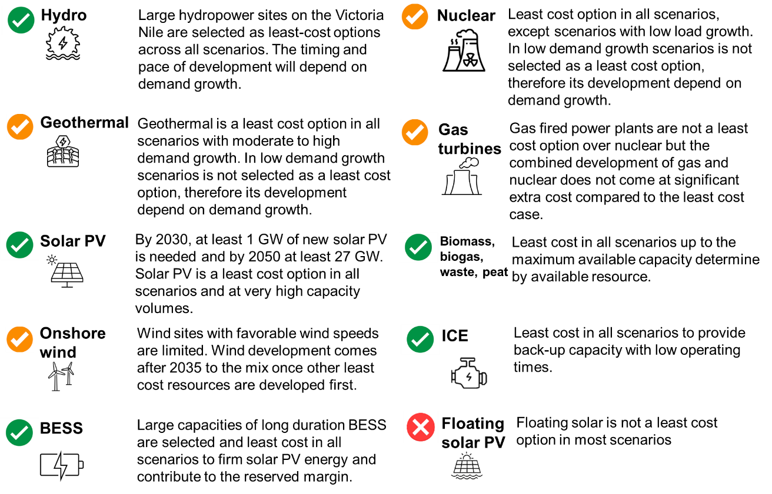

What are the necessary investment costs over the next 10 years?
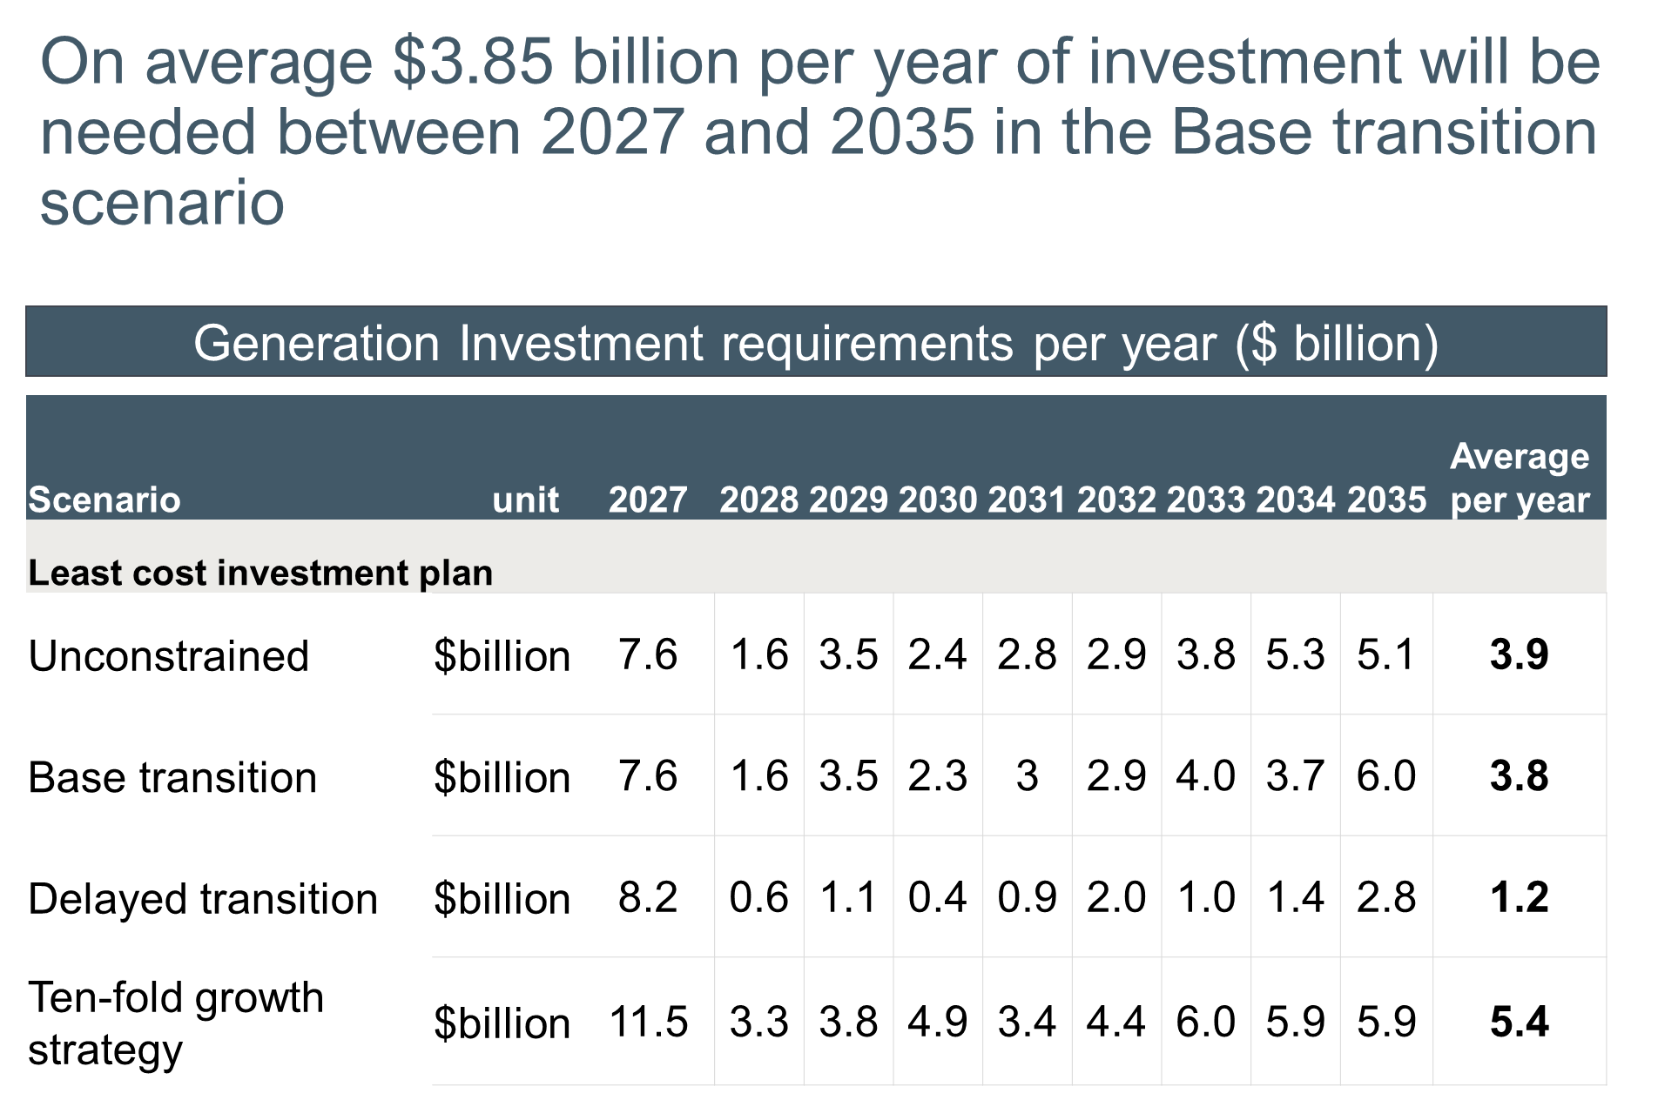

What it takes to deliver a zero-emission power system by 2050?
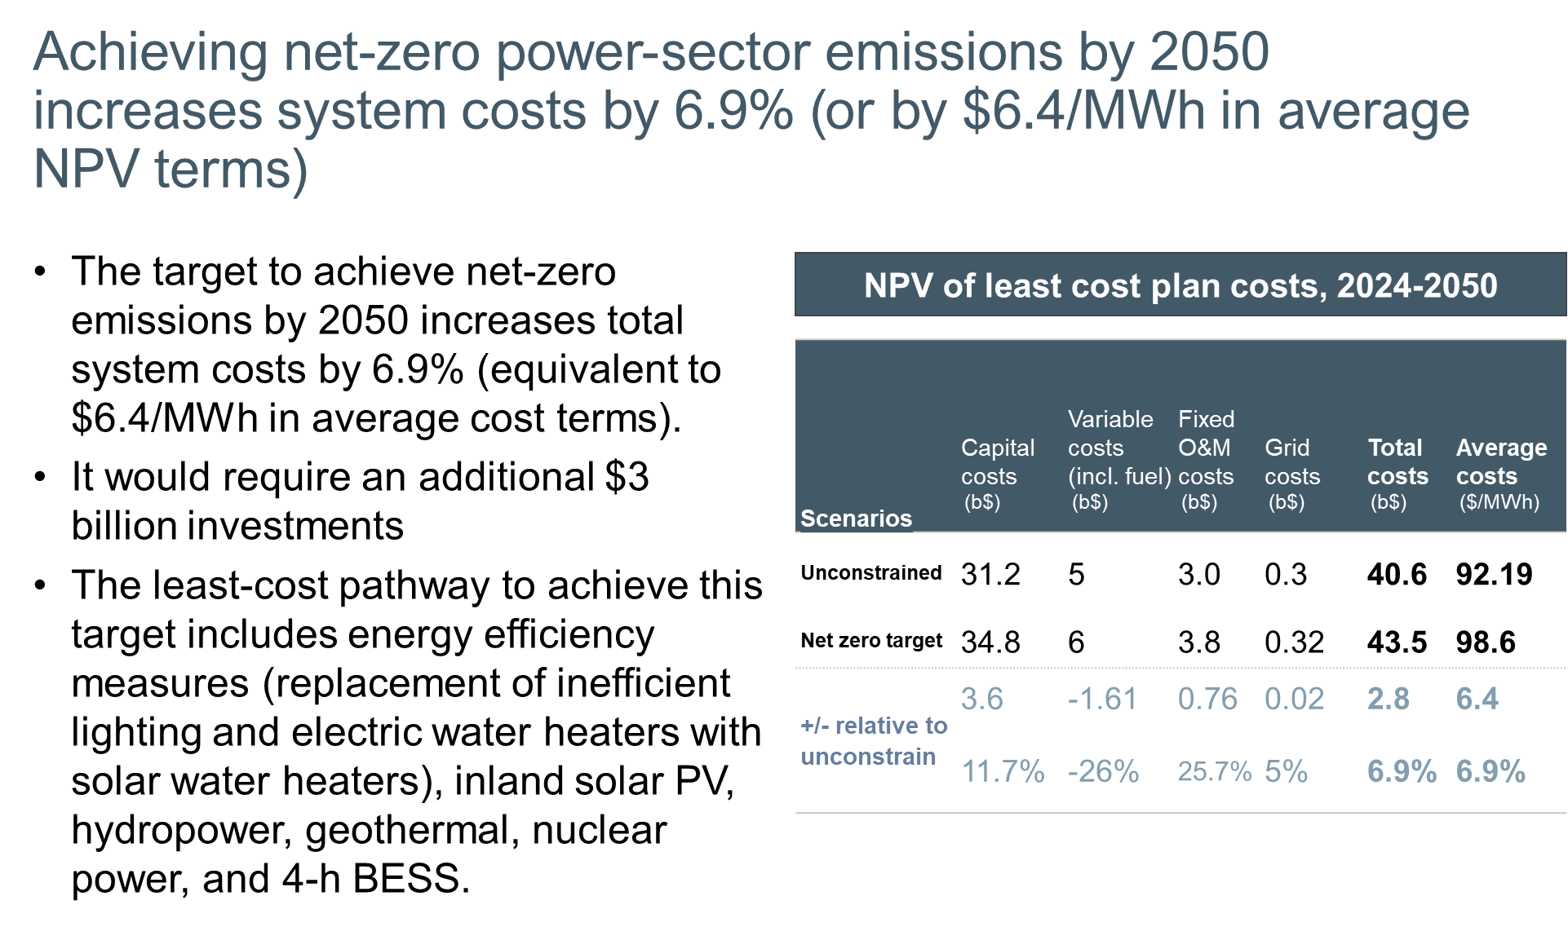

Is nuclear an economic option for Uganda?
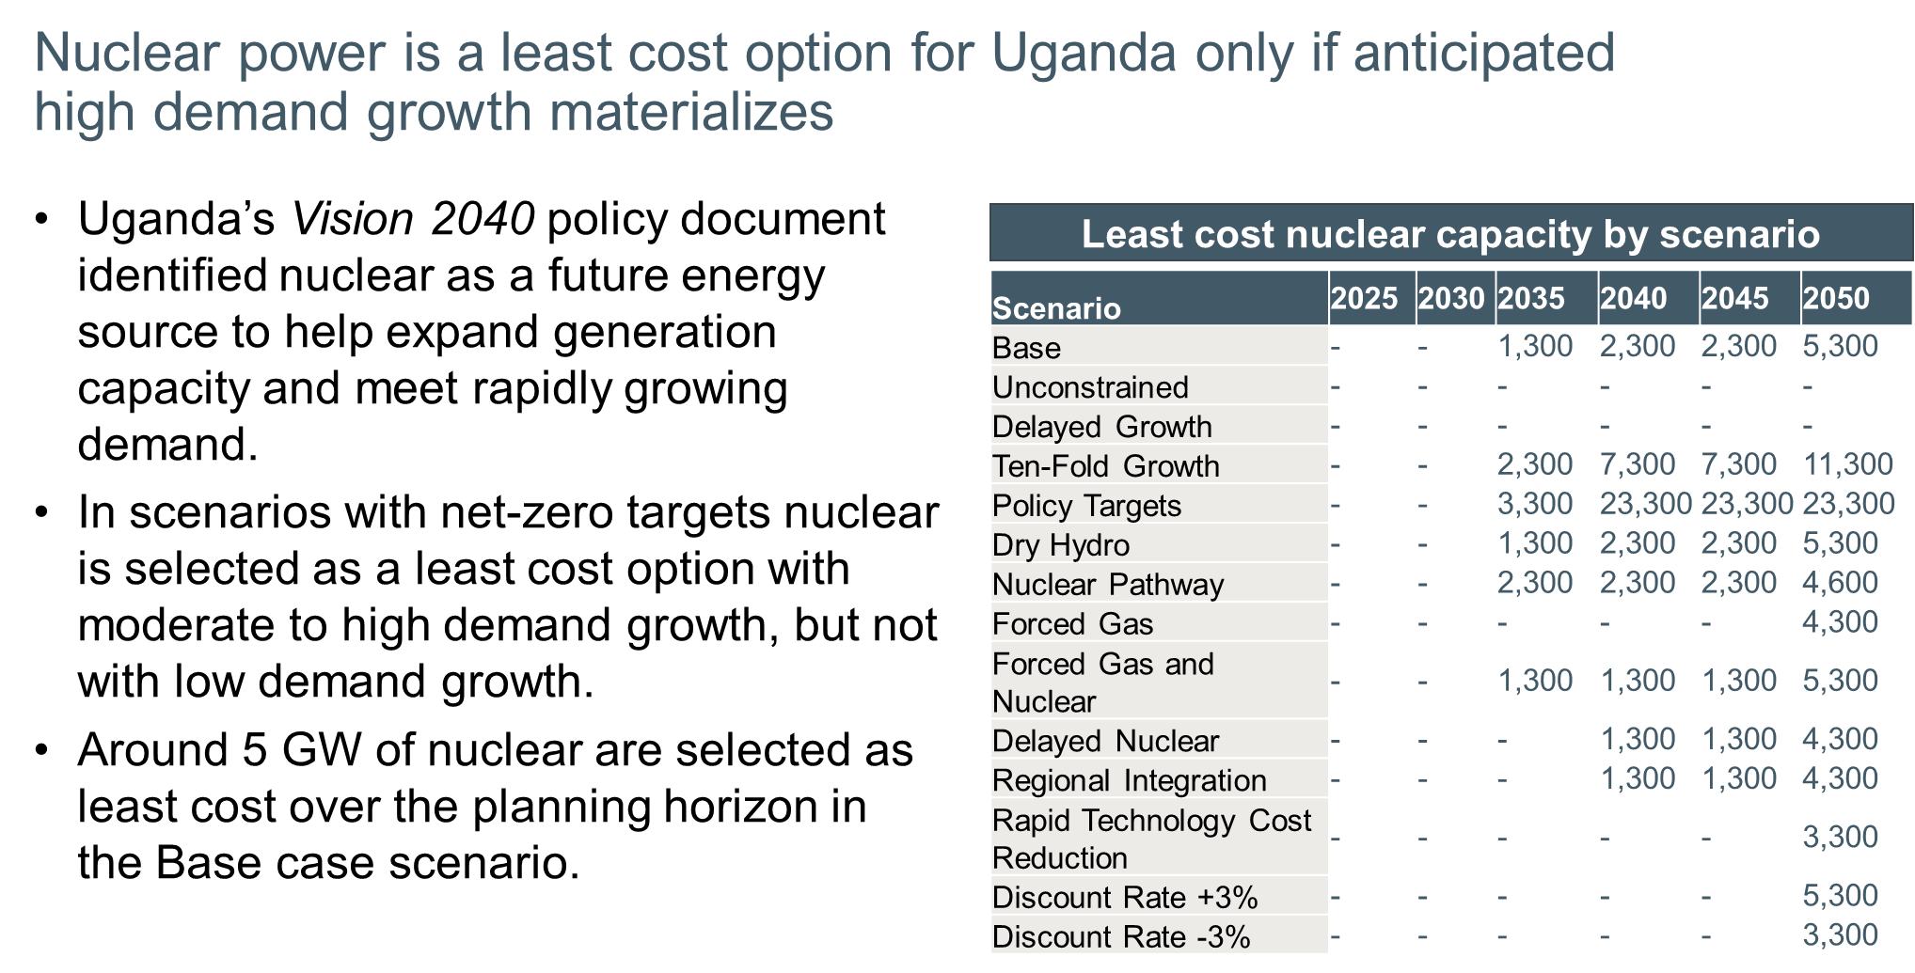

Is natural gas an economic option for Uganda?
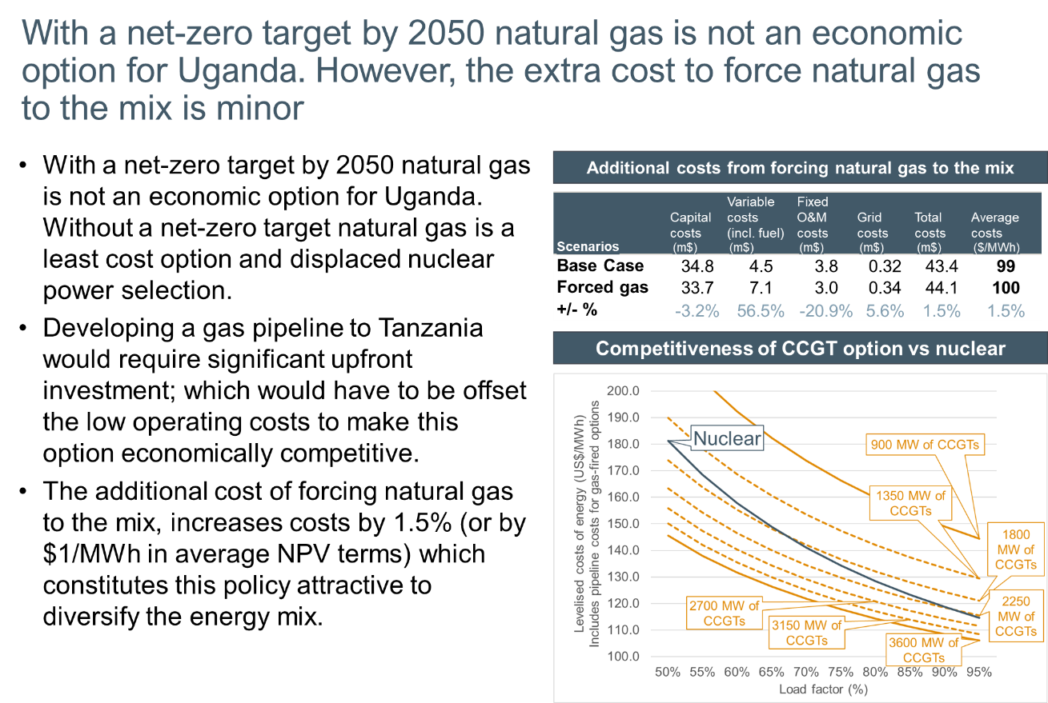

What role will hydropower play in Uganda’s future electricity mix, and what risks does this entail?
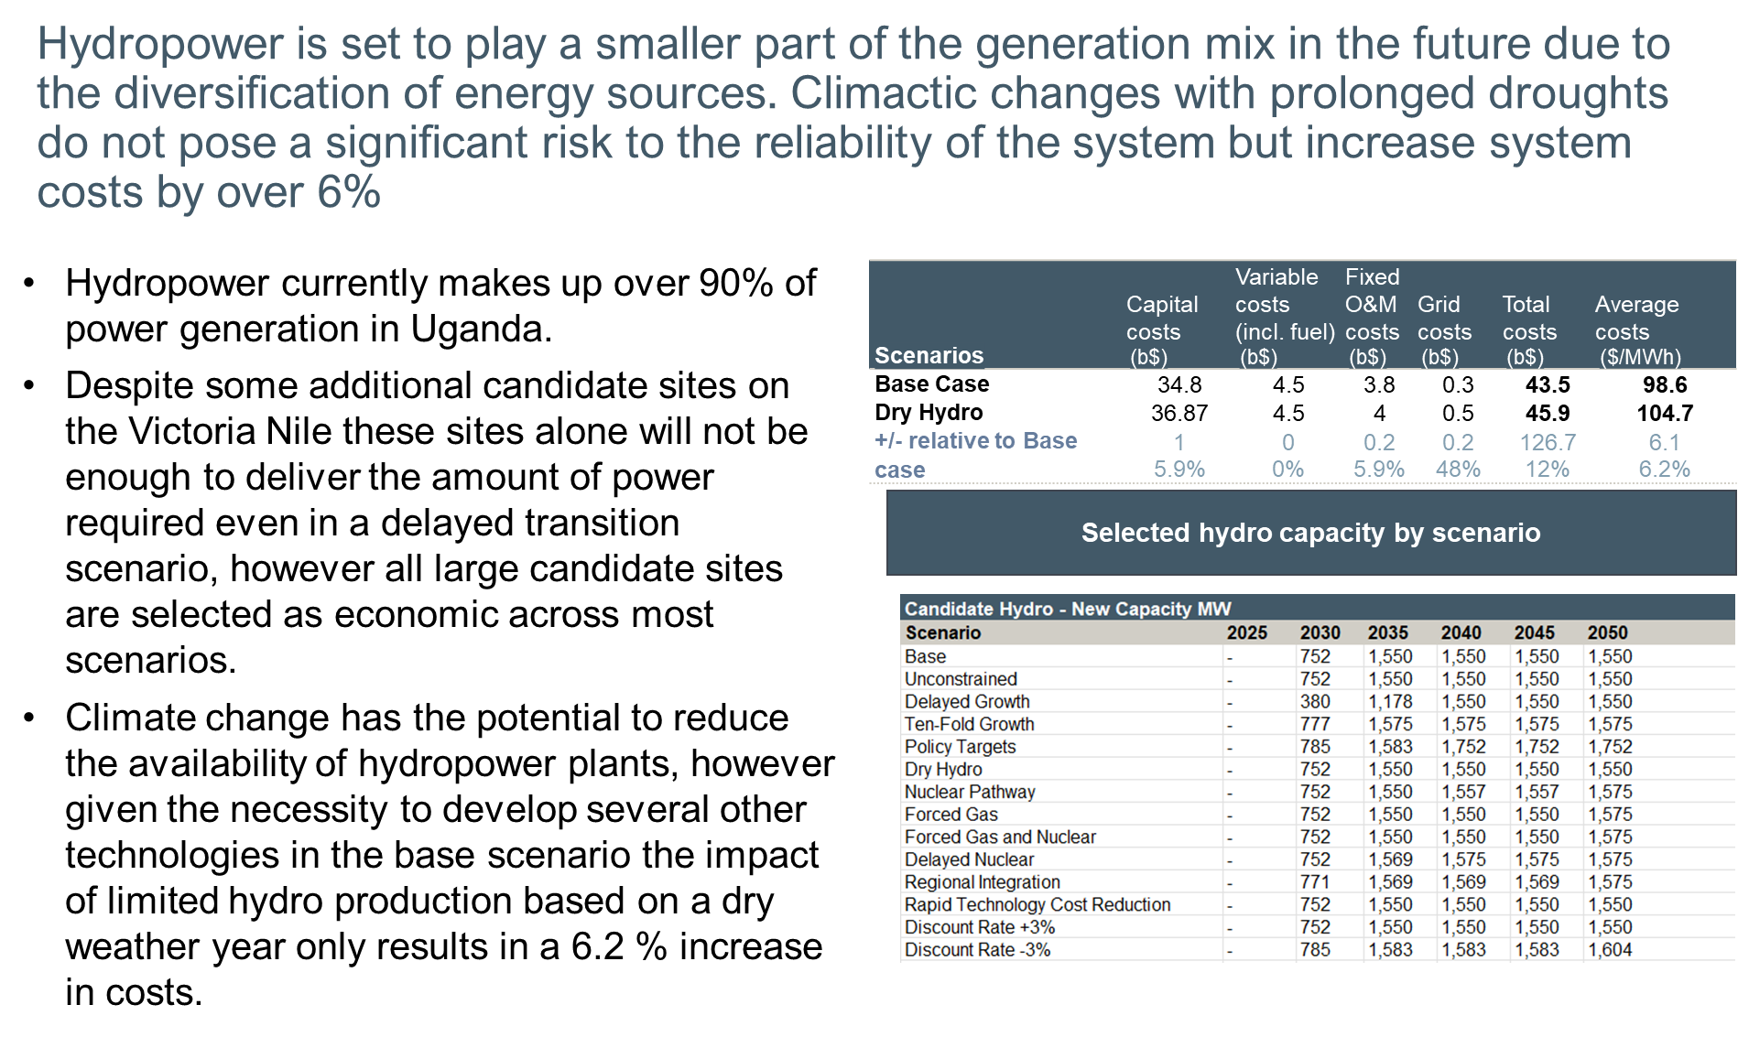

What EE and DSM measures should Uganda pursue and what are the investment requirements?
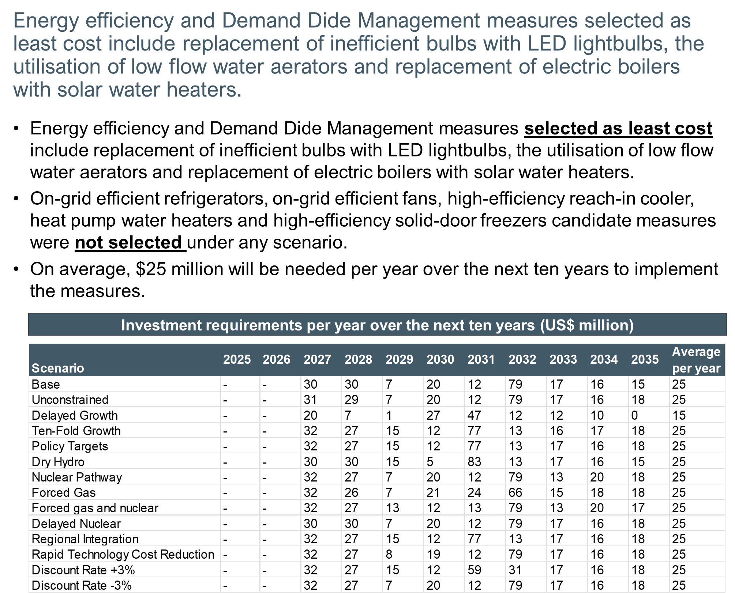
What is the impact on emissions from the least cost plan?
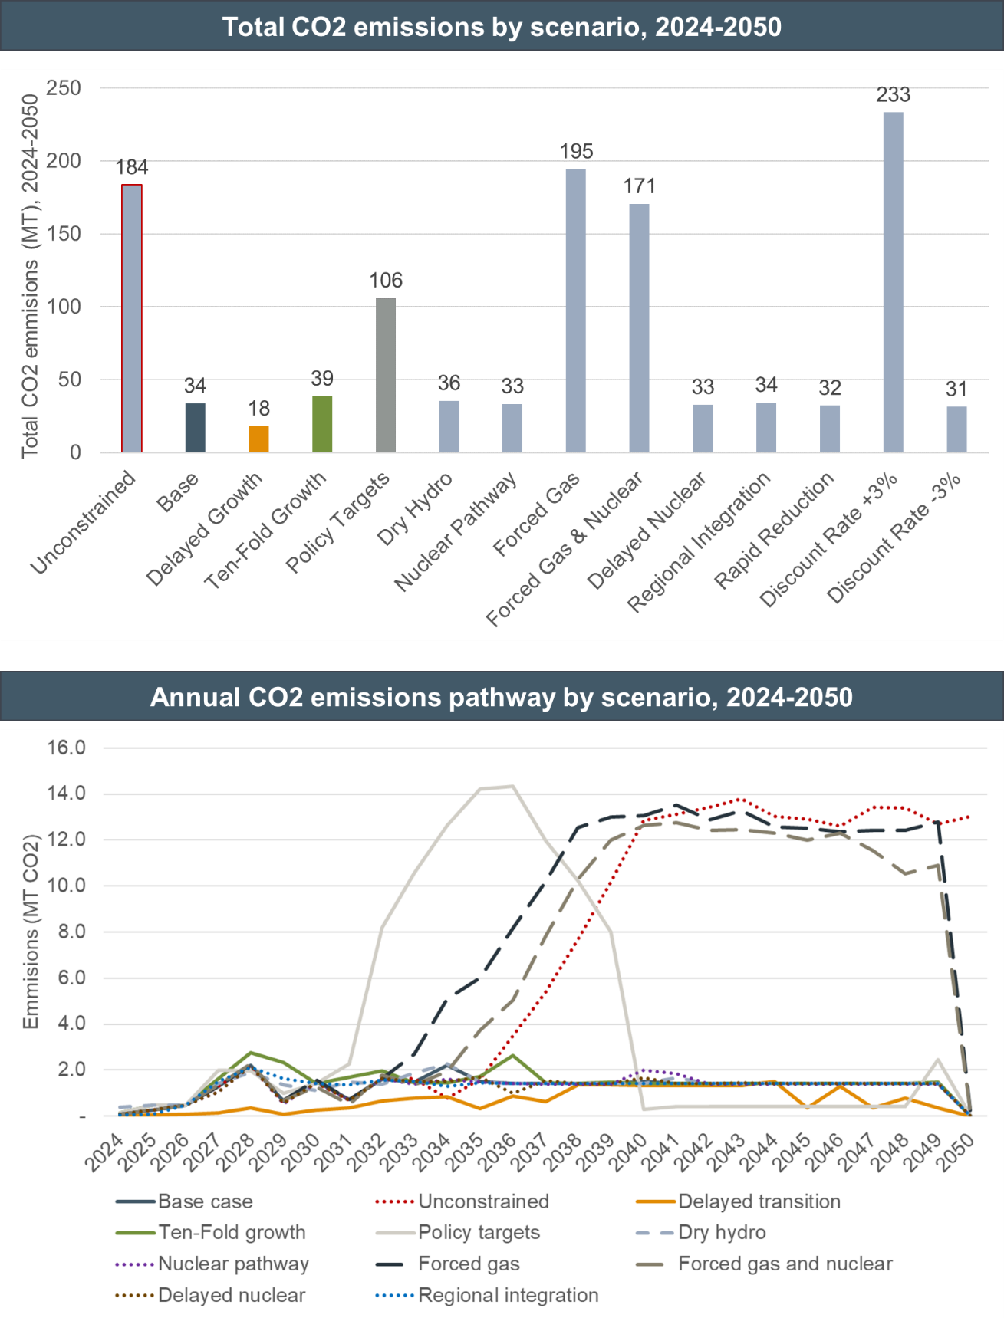

5-year focus
Short term focus for the selected scenario by the Ministry and stakeholders. It will be the scenario selected to draft the Roadmap for the next five years. The scenario should be chosen by the Ministry and stakeholders and can be discussed during the upcoming Workshop.

Annexes
- Step-loads considered in the demand forecast
Step loads are assumed to connect to the transmission system and categorised as either large industrial or extra-large industrial customers. In the case of data centres, where a capacity of 770 MW has already been committed through PPA, their associated demand is included with a 100% certainty in all scenarios with the exception of the DT scenario, where a low probability is maintained. All other step-loads follow the probabilities assigned for each scenario. The step-loads assumed in the demand forecast are provided in Table 24
Table 24 Probability-adjusted step-loads by scenario (capacity requirement in MW)
 | 2024 | 2030 | 2040 | 2050
Base transition (50% probability of occurrence)
Data centres | 13 MW | 859 MW | 907 MW | 907 MW
Iron and steel plants | 8 MW | 27 MW | 1,305 MW | 1,305 MW
Industrial parks | 56 MW | 717 MW | 3,730 MW | 3,730 MW
Phosphates | - | 13 MW | 75 MW | 75 MW
SGR | - | 28 MW | 268 MW | 268 MW
Tenfold growth strategy (100% probability of occurrence)
Data centres | 15 MW | 988 MW | 1,044 MW | 1,044 MW
Iron and steel plants | 15 MW | 54 MW | 2,611 MW | 2,611 MW
Industrial parks | 112 MW | 1,435 MW | 7,460 MW | 7,460 MW
Phosphates | - | 26 MW | 149 MW | 149 MW
SGR | - | 56 MW | 535 MW | 535 MW
Delayed transition (10% probability of occurrence)
Data centres | 2 MW | 99 MW | 104 MW | 104 MW
Iron and steel plants | 2 MW | 5 MW | 261 MW | 261 MW
Industrial parks | 11 MW | 14 MW | 746 MW | 746 MW
Phosphates | - | 3 MW | 15 MW | 15 MW
SGR | - | 6 MW | 54 MW | 54 MW
Policy targets (100% probability of occurrence)
Data centres | 15 MW | 988 MW | 1,044 MW | 1,044 MW
Iron and steel plants | 15 MW | 54 MW | 2,611 MW | 2,611 MW
Industrial parks | 112 MW | 1,435 MW | 7,460 MW | 7,460 MW
Phosphates | - | 26 MW | 149 MW | 149 MW
SGR | - | 56 MW | 535 MW | 535 MW
Source: Data provided by MEMD, ECA assumptions
- Exports considered in the demand forecast
According to ERA’s transmission statistics, Uganda exported 485 GWh of electricity to neighbouring countries (mainly Kenya, Rwanda, and Tanzania) in 2023. According to UETCL grid development plan 2023-2040, Uganda is expected to increase its exporting capacity to Tanzania, Rwanda, DRC, and South Sudan over the 2024-2040 period from the current capacity. The maximum capacity shown below has been added to all scenarios assuming the same load factor as the historical exports reported to each country.
Existing export contracts were considered with a 100% probability of occurrence throughout the planning horizon in all scenarios. New potential contracts were included in the demand forecast with varying degrees of probability to occur to reflect the uncertainty to materialise.
Table 25 Electricity exports considered in the demand forecast by scenario
 | Base transition | Tenfold growth strategy | Delayed transition | Policy targets
Export capacity of existing contracts (firm commitments)
Total export capacity | 170 MW | 170 MW | 170 MW | 170 MW
Kenya | 100 MW | 100 MW | 100 MW | 100 MW
Tanzania | 30 MW | 30 MW | 30 MW | 30 MW
Rwanda | 40 MW | 40 MW | 40 MW | 40 MW
Load factor (%) – Kenya | 32% | 32% | 32% | 32%
Load factor (%) – Tanzania | 54% | 54% | 54% | 54%
Load factor (%) – Rwanda | 18% | 18% | 18% | 18%
Probability of occurrence | 100% | 100% | 100% | 100%
Potential additional exporting capacity from new contracts (Non-firm commitments)
Total capacity | 480 MW | 480 MW | 480 MW | 480 MW
Tanzania | 150 MW | 150 MW | 150 MW | 150 MW
Rwanda | 20 MW | 20 MW | 20 MW | 20 MW
DRC | 50 MW | 50 MW | 50 MW | 50 MW
South Sudan | 260 MW | 260 MW | 260 MW | 260 MW
Load factor (%) – Tanzania | 54% | 54% | 54% | 54%
Load factor (%) – Rwanda | 18% | 18% | 18% | 18%
Load factor (%) – DRC | 57% | 57% | 57% | 57%
Load factor (%) – South Sudan | 40%* | 40%* | 40%* | 40%*
Probability of occurrence | 50% | 100% | 0% | 100%
Source: UETCL Grid Development Plan 2023-2040, ECA assumptions. * Weighted average of all other countries.

- Regional disaggregation of the demand forecast
The national demand forecast of each scenario was disaggregated by area to inform the transmission and the distribution least cost plans. UETCL uses 7 transmission zones for planning purposes: Central, Eastern, GKM, Jinja Metro, Northern, West Nile and Western. The same definition of zones was adopted to disaggregate the national demand forecast by zone. For the distribution development plan, the national demand forecast was disaggregated by subregion following the definition of subregions shown in the 2024 Census. The subregions include Kampala city, Buganda, Busoga, Bukedi, Bugisu, Sebei, Teso, Karamoja, Lango, Acholi, West Nile, Madi, Bunyoro, Tooro, Rwenzori, Ankole and Kigezi.
To disaggregate the demand by zone and subregion the following methodology was applied:
- Residential demand – the forecast number of urban and rural households was initially assessed by subregion and zone using information from the 2024 Census. The forecast number of rural and urban households of each subregion (or zone) was multiplied with the forecast electrification rate and the forecast average consumption per rural and urban household to derive the residential demand by subregion or zone.
- Commercial and medium industrial demand – it was disaggregated by zone and subregion using the percentage split of the residential demand (out of the total residential demand) by zone or subregion.
- Large and Extra-large industrial demand – existing industrial demand was allocated to zones and subregions using UETCL demand data. New industrial demand was allocated to the subregion or zone it is expected to connect.
- Other step loads - The demand of step loads was assigned to the sub-regions and transmission zones each step load is expected to connect:
  - Data centres – expected location is near hydro power plants (Isimba, Karuma, and Kiba)
  - Industrial parks – the locations described in the National Industrial Parks Development Strategy.
  - Iron and steel plants – allocated based on the share of total iron ore reserves by sub-region and transmission zones according to the Mineral Potential of Uganda 2024 provided by MEMD.
The forecasts for representative years in each subregion and transmission zone are presented below.

Table 26 Load forecast by sub-region
Sub-region | Energy demand (GWh) |  |  | Peak demand (MW)
 | 2025 | 2035 | 2050 | 2025 | 2035 | 2050
Base transition
Kampala city | 3,269 | 8,646 | 27,260 | 602 | 1,465 | 4,613
Buganda | 2,679 | 11,622 | 33,588 | 484 | 1,834 | 5,419
Busoga | 720 | 3,891 | 11,032 | 129 | 625 | 1,834
Bukedi | 220 | 1,891 | 6,838 | 39 | 298 | 1,065
Bugisu | 211 | 1,451 | 4,810 | 38 | 239 | 788
Sebei | 90 | 480 | 1,447 | 16 | 76 | 234
Teso | 162 | 1,382 | 4,416 | 29 | 229 | 737
Karamoja | 109 | 822 | 2,637 | 20 | 136 | 440
Lango | 170 | 1,622 | 5,107 | 31 | 268 | 852
Acholi | 205 | 1,950 | 4,722 | 34 | 296 | 764
West Nile | 146 | 2,176 | 6,383 | 25 | 343 | 1,029
Madi | 15 | 179 | 599 | 3 | 31 | 103
Bunyoro | 934 | 13,604 | 23,655 | 126 | 1,704 | 3,092
Tooro | 285 | 3,193 | 8,148 | 47 | 448 | 1,197
Rwenzori | 156 | 763 | 2,492 | 29 | 129 | 421
Ankole | 396 | 2,869 | 8,321 | 70 | 446 | 1,329
Kigezi | 205 | 2,216 | 10,428 | 35 | 324 | 1,483
Tenfold growth strategy
Kampala city | 3,544 | 9,920 | 30,840 | 677 | 1,698 | 5,305
Buganda | 3,052 | 15,638 | 43,519 | 564 | 2,402 | 6,938
Busoga | 792 | 4,508 | 12,806 | 146 | 731 | 2,166
Bukedi | 261 | 2,613 | 9,893 | 47 | 402 | 1,508
Bugisu | 238 | 1,818 | 6,163 | 44 | 297 | 1,005
Sebei | 102 | 643 | 1,841 | 19 | 98 | 294
Teso | 183 | 1,696 | 5,336 | 34 | 279 | 897
Karamoja | 122 | 1,004 | 3,164 | 23 | 166 | 533
Lango | 194 | 1,995 | 6,193 | 36 | 328 | 1,040
Acholi | 231 | 2,299 | 5,596 | 40 | 352 | 917
West Nile | 185 | 2,946 | 8,325 | 31 | 452 | 1,327
Madi | 16 | 199 | 685 | 3 | 35 | 121
Bunyoro | 1,312 | 20,879 | 37,850 | 173 | 2,583 | 4,836
Tooro | 388 | 5,150 | 12,398 | 61 | 693 | 1,754
Rwenzori | 171 | 892 | 2,910 | 33 | 152 | 500
Ankole | 470 | 3,970 | 11,033 | 84 | 598 | 1,733
Kigezi | 269 | 3,617 | 18,222 | 45 | 514 | 2,538
Delayed transition
Kampala city | 2,810 | 5,748 | 16,069 | 496 | 971 | 2,688
Buganda | 2,106 | 5,262 | 14,746 | 370 | 860 | 2,412
Busoga | 558 | 1,830 | 5,277 | 98 | 357 | 933
Bukedi | 168 | 828 | 2,642 | 29 | 135 | 424
Bugisu | 169 | 711 | 2,137 | 30 | 119 | 352
Sebei | 74 | 248 | 713 | 13 | 41 | 117
Teso | 131 | 692 | 2,071 | 23 | 116 | 344
Karamoja | 90 | 431 | 1,281 | 16 | 72 | 213
Lango | 136 | 797 | 2,359 | 24 | 133 | 392
Acholi | 128 | 724 | 1,994 | 22 | 166 | 379
West Nile | 101 | 927 | 2,666 | 17 | 151 | 436
Madi | 12 | 92 | 282 | 2 | 16 | 47
Bunyoro | 258 | 2,764 | 5,805 | 41 | 768 | 1,231
Tooro | 183 | 1,104 | 2,933 | 31 | 168 | 455
Rwenzori | 129 | 414 | 1,236 | 23 | 70 | 206
Ankole | 299 | 1,230 | 3,506 | 52 | 199 | 570
Kigezi | 140 | 763 | 2,989 | 24 | 119 | 445
Policy targets
Kampala city | 3,984 | 22,871 | 60,026 | 747 | 3,810 | 10,058
Buganda | 3,513 | 34,017 | 86,703 | 641 | 5,428 | 14,047
Busoga | 895 | 10,507 | 27,479 | 163 | 1,717 | 4,578
Bukedi | 294 | 5,440 | 16,819 | 52 | 867 | 2,648
Bugisu | 272 | 4,436 | 12,466 | 50 | 728 | 2,043
Sebei | 113 | 1,278 | 3,404 | 20 | 202 | 550
Teso | 208 | 4,275 | 11,722 | 38 | 704 | 1,949
Karamoja | 137 | 2,480 | 6,812 | 25 | 408 | 1,133
Lango | 221 | 5,067 | 13,690 | 40 | 834 | 2,275
Acholi | 256 | 4,791 | 11,631 | 44 | 762 | 1,910
West Nile | 209 | 6,564 | 17,073 | 35 | 1,048 | 2,770
Madi | 19 | 608 | 1,692 | 4 | 103 | 287
Bunyoro | 1,351 | 24,427 | 46,506 | 179 | 3,167 | 6,262
Tooro | 422 | 8,120 | 19,567 | 67 | 1,182 | 2,935
Rwenzori | 196 | 2,363 | 6,519 | 37 | 394 | 1,094
Ankole | 534 | 8,349 | 21,602 | 95 | 1,319 | 3,474
Kigezi | 294 | 5,516 | 22,849 | 49 | 826 | 3,299
Source: ECA analysis
Table 27 Load forecast by sub-region
Sub-region | Energy demand (GWh) |  |  | Peak demand (MW)
 | 2025 | 2035 | 2050 | 2025 | 2035 | 2050
Base transition
Central | 408 | 2,614 | 6,554 | 70 | 363 | 953
Eastern | 883 | 6,739 | 22,055 | 158 | 1,090 | 3,578
GKM | 5,213 | 16,419 | 50,586 | 957 | 2,738 | 8,473
Jinja Metro | 955 | 4,412 | 12,834 | 172 | 711 | 2,128
Northern | 594 | 6,173 | 16,058 | 100 | 940 | 2,569
West Nile | 194 | 2,769 | 7,948 | 33 | 436 | 1,287
Western | 1,725 | 19,630 | 45,848 | 266 | 2,613 | 6,413
Tenfold growth strategy
Central | 509 | 4,269 | 10,087 | 87 | 568 | 1,409
Eastern | 1,010 | 8,616 | 28,663 | 185 | 1,376 | 4,615
GKM | 5,721 | 19,692 | 59,647 | 1,086 | 3,281 | 10,081
Jinja Metro | 1,054 | 5,263 | 15,165 | 196 | 850 | 2,541
Northern | 701 | 7,906 | 20,276 | 119 | 1,189 | 3,231
West Nile | 240 | 3,635 | 10,167 | 41 | 561 | 1,636
Western | 2,297 | 30,405 | 72,767 | 346 | 3,957 | 9,900
Delayed transition
Central | 294 | 931 | 2,425 | 51 | 141 | 375
Eastern | 695 | 3,192 | 9,650 | 122 | 541 | 1,596
GKM | 4,355 | 9,445 | 26,590 | 767 | 1,586 | 4,428
Jinja Metro | 762 | 2,183 | 6,271 | 134 | 404 | 1,084
Northern | 384 | 2,370 | 6,637 | 67 | 472 | 1,178
West Nile | 130 | 1,159 | 3,330 | 23 | 200 | 557
Western | 872 | 5,286 | 13,802 | 148 | 1,116 | 2,426
Policy targets
Central | 564 | 6,373 | 15,066 | 96 | 914 | 2,227
Eastern | 1,142 | 19,886 | 56,259 | 206 | 3,231 | 9,157
GKM | 6,517 | 47,022 | 122,542 | 1,216 | 7,761 | 20,387
Jinja Metro | 1,192 | 12,022 | 31,564 | 219 | 1,960 | 5,233
Northern | 779 | 16,277 | 40,661 | 132 | 2,568 | 6,590
West Nile | 270 | 8,189 | 21,194 | 46 | 1,312 | 3,455
Western | 2,452 | 41,339 | 99,275 | 371 | 5,756 | 14,263
Source: ECA analysis

- Policy targets considered in the IERMP
A summary of the policy targets incorporated into the set of scenarios modelled in the IERMP is shown in Table 28.
Table 28 Policy targets incorporated IERMP scenarios and sensitivities
Indicator | Target | Deadline | Source
Solar PV installed capacity | 5,000 MW | 2040 | Vision 2040
Geothermal capacity | 1,500 MW | 2040 | Vision 2040
Nuclear capacity | 24,000 MW | 2040 | Vision 2040
Installed generation capacity | 52,481 MW | 2040 | NEP 2023
Energy consumption from renewables | >95% | 2040 | NEP 2023
Energy resources in the energy mix | 8 | 2040 | NEP 2023
Length of transmission lines | 4,354 km | 2025 | NDP III
GHG reduction (unconditional vs. BaU) | 5.90% | 2030 | Nationally Defined Contribution
GHG reduction (conditional vs. BaU) | 18.80% | 2030 | Nationally Defined Contribution
Geothermal capacity | 1500 MW | 450 MW by 2030, 1500 MW by 2040 | Green Growth Dev. Strategy
Solar capacity | 5000 MW | 2030 | Green Growth Dev. Strategy
Net-zero emissions (energy sector) | Net-zero | 2065 (possibly 2062) | ETP / Ministry
Source: Vision 2040, The Third National Development Plan (NDP III), The National Energy Policy (NEP) for Uganda 2023 and the Energy Transition Plan 2023 (ETP).

- Gas pipeline assumptions for the IERMP
Investment in a gas pipeline linking Uganda and Tanzania would be substantial, encompassing both the capital costs of the pipeline itself and the compressor stations required to transport gas over a long distance.
Given the high capital costs of pipeline infrastructure, the choice of pipeline capacity is a critical decision, as it directly determines the volume of gas-fired generation that can be supported downstream. When pipeline and generation investments are considered jointly, the costs exhibit significant economies of scale, enabling substantial reductions in per-unit costs through investment in higher-capacity gas pipelines.
Therefore, the choice of the capacity of the gas pipeline (and the respective costs to be accounted for gas fired generation) was optimised relative to the least cost gas fired capacity selected in the least cost plans. The choise was based on the following assumptions for the gas pipeline costs.
Table 29 Gas pipeline xcost assumptions assumptions
Parameter | Value | Source
Gas fired power plant load factor | 100% | The pipeline needs to be sized to be able to support the full operation of the power plant
Gas fired power plant heat rate (GJ/MWh) | 7.234 | Resource assessment report
Conversion factor (mmscf/GJ) | 0.000947817 | https://www.ogsrlibrary.com/conversion_chart_oil_gas_ontario
Kampala-Tanaga Distance (km) | 1,500 | Measured with google maps
Pipeline Capital costs per distance per pipeline diameter ($/km/inch) | 115,000 | The Palgrave Handbook of International Energy Economics by M Hafner, 2022
Compressor station capex (m$/MW power of compressor station) | 3 | The Palgrave Handbook of International Energy Economics by M Hafner, 2022
One compressor station every … km | 150 | The Palgrave Handbook of International Energy Economics by M Hafner, 2022
Horsepower per compressor station (hp) | 12,676 | Natural gas compressors and processors, NETL 2017
Conversion factor (MW/Hp) | 0.0007457 | https://www.ogsrlibrary.com/conversion_chart_oil_gas_ontario
Pipeline Opex (% of Capex) | 3% | The Palgrave Handbook of International Energy Economics by M Hafner, 2022
Compressor Opex (%of Capex) | 5% | The Palgrave Handbook of International Energy Economics by M Hafner, 2022
Source: ECA analysis
As shown in the figure below at a capacity factor of 85%, investment in CCGTs, together with the associated pipeline infrastructure, becomes competitive with nuclear generation when gas fired capacity exceeds approximately 2,250 MW. Lower gas fired capacities would be uneconomic in comparison to nuclear power generation. This highlights the importance of adequately sizing pipeline infrastructure to unlock cost competitiveness for large-scale gas-fired power generation.
Figure 47 LCOE of CCGTs against Nuclear incorporating gas pipeline costs
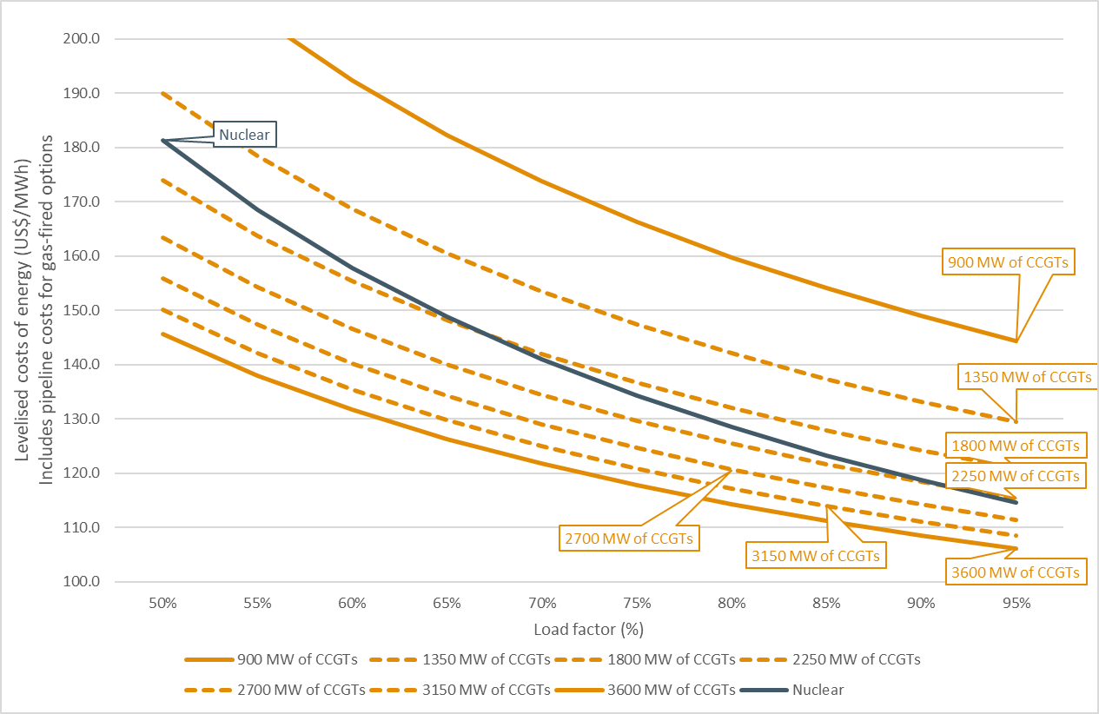
Source: ECA analysis

- Capital costs of EE and DSM measures
Table 30 Capital costs for the implementation of EE and DSM measure
Equipment | Price  (Ush) | Price  (USD) | Capacity (kW) | No per user | Total cost per user (USD) | Source
Residential
On-grid urban LED lighting | 2,300 | 0.62 | 0.007 | 4.8 | 3 | https://tronic.ug/products/7w-tronic-led-bulb-b22-le-0722-dl
On-grid rural LED lighting | 2,300 | 0.62 | 0.007 | 3.9 | 2 | https://tronic.ug/products/7w-tronic-led-bulb-b22-le-0722-dl
On-grid urban heat pump hot water heater | 12,741,282 | 3,440.15 | 2.500 | 1.0 | 3,440 | https://paylaterug.com/shop/davis-and-shirtliff/solar-solutions/solar-water-heaters/dayliff-hpw150-2-5kw-1ph-all-in-one-heat-pump/
On-grid rural heat pump hot water heater | 12,741,282 | 3,440.15 | 2.500 | 1.0 | 3,440 | https://paylaterug.com/shop/davis-and-shirtliff/solar-solutions/solar-water-heaters/dayliff-hpw150-2-5kw-1ph-all-in-one-heat-pump/
On-grid urban solar hot water heater | 1,500,000 | 405.00 | - | 1.0 | 405 | https://www.easypowerug.com/solar-water-heater-prices-in-uganda/
On- grid rural solar hot water heater | 1,500,000 | 405.00 | - | 1.0 | 405 | https://www.easypowerug.com/solar-water-heater-prices-in-uganda/
On-grid urban efficient refrigerator | 1,250,000 | 337.50 | - | 1.0 | 338 | https://www.jumia.ug/lg-187l-top-freezer-refrigerator-smart-inverter-compressor-multi-air-flow-gn-b202sqbb-214239141.html
On-grid rural efficient refrigerator | 1,250,000 | 337.50 | - | 1.0 | 338 | https://www.jumia.ug/lg-187l-top-freezer-refrigerator-smart-inverter-compressor-multi-air-flow-gn-b202sqbb-214239141.html
On-grid urban efficient fan | 1,850,000 | 499.50 | 0.026 | 2.0 | 999 | https://jiji.ug/central-division/home-appliances/lg-ceiling-air-purifier-fan-lcf12p-sleep-mode-thinq-dbKZQFUItkKLBR4S5z9POD2A.html?page=1&pos=2&cur_pos=2&ads_per_page=20&ads_count=287&lid=McLk17Ae_VUlkZqt&indexPosition=1
On-grid rural efficient fan | 1,850,000 | 499.50 | 0.026 | 2.0 | 999 | https://jiji.ug/central-division/home-appliances/lg-ceiling-air-purifier-fan-lcf12p-sleep-mode-thinq-dbKZQFUItkKLBR4S5z9POD2A.html?page=1&pos=2&cur_pos=2&ads_per_page=20&ads_count=287&lid=McLk17Ae_VUlkZqt&indexPosition=1
Commercial
Low-flow faucet aerator | 25,024 | 6.76 | - | 1.0 | 7 | https://www.jumia.ug/generic-202224mm-kitchen-sink-faucet-tap-nozzle-thread-swivel-aerator-filter-sprayer-kitchen-water-saving-faucet-accessories-231723634.html
High-efficiency reach-in cooler | 1,490,000 | 402.30 | - | 1.0 | 402 | https://www.abanista.com/product/spj-300l-beverage-upright-cooler/
LED drop-in lighting | 110,000 | 29.70 | 50.000 | 1.0 | 30 | https://tronic.ug/products/50w-tronic-600x600-led-daylight-panel-fi-elpl-50-dl
Heat pump water heater | 12,741,282 | 3,440.15 | 2.500 | 1.0 | 3,440 | https://paylaterug.com/shop/davis-and-shirtliff/solar-solutions/solar-water-heaters/dayliff-hpw150-2-5kw-1ph-all-in-one-heat-pump/
Variable speed drive on chiller system | 1,089,200 | 294.08 | 4.000 | 1.0 | 294 | https://www.jumia.ug/generic-4kw-380v-3-phase-output-variable-frequency-drive-inverter-vfd-motor-converter-243474636.html
Solar water heater | 3,600,000 | 972.00 | - | 1.0 | 972 | https://www.easypowerug.com/solar-water-heater-prices-in-uganda/
LED fixture lighting | 110,000 | 29.70 | 50.000 | 1.0 | 30 | https://tronic.ug/products/50w-tronic-600x600-led-daylight-panel-fi-elpl-50-dl
High-efficiency solid-door freezer | 2,590,000 | 699.30 | - | 1.0 | 699 | https://kweli.shop/product/hisense-310-liter-upright-freezer/
Source: Indicated in the table

- Least cost plan by scenario
  - Existing and committed power plants and transmission lines
Timelines are the same for all scenarios.
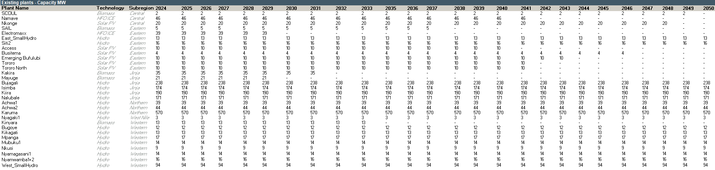
  - Selected candidate generators by scenario
    - Base case
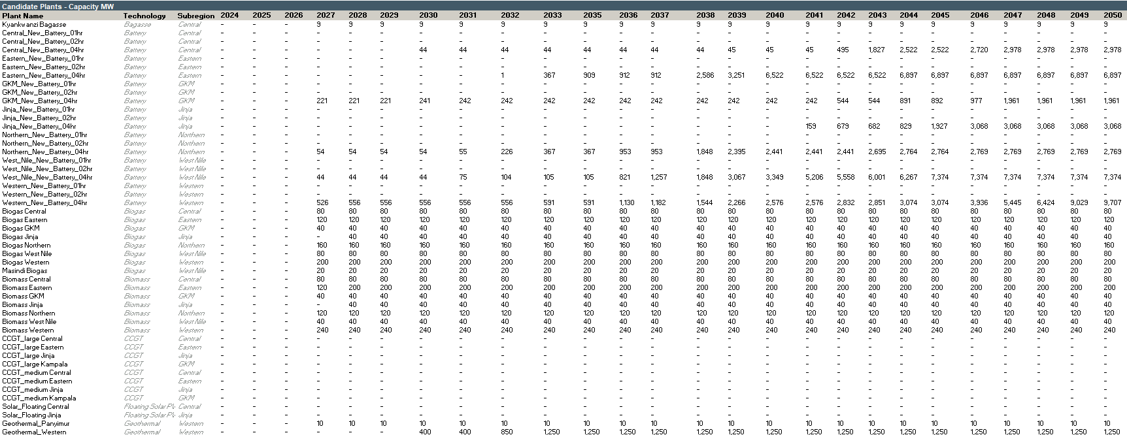
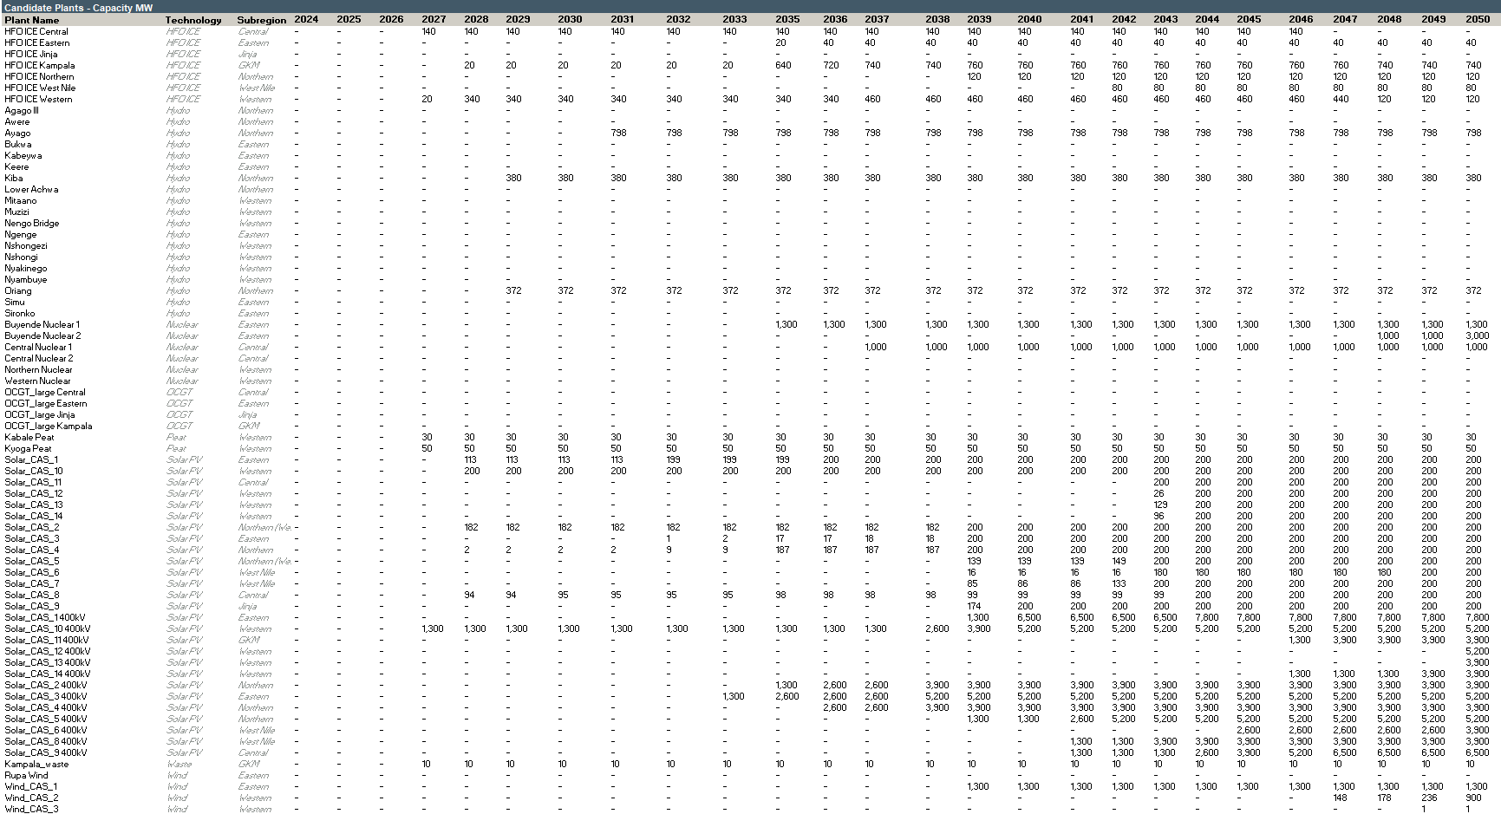

    - Unconstrained
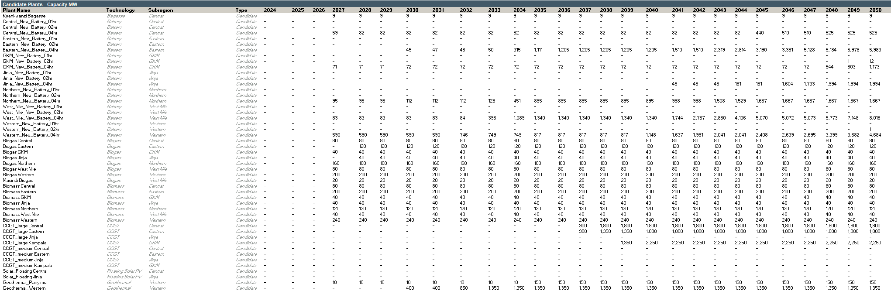
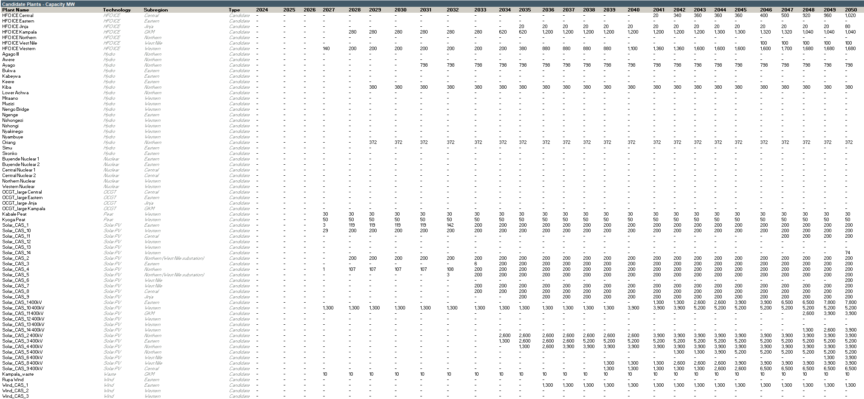
    - Delayed growth
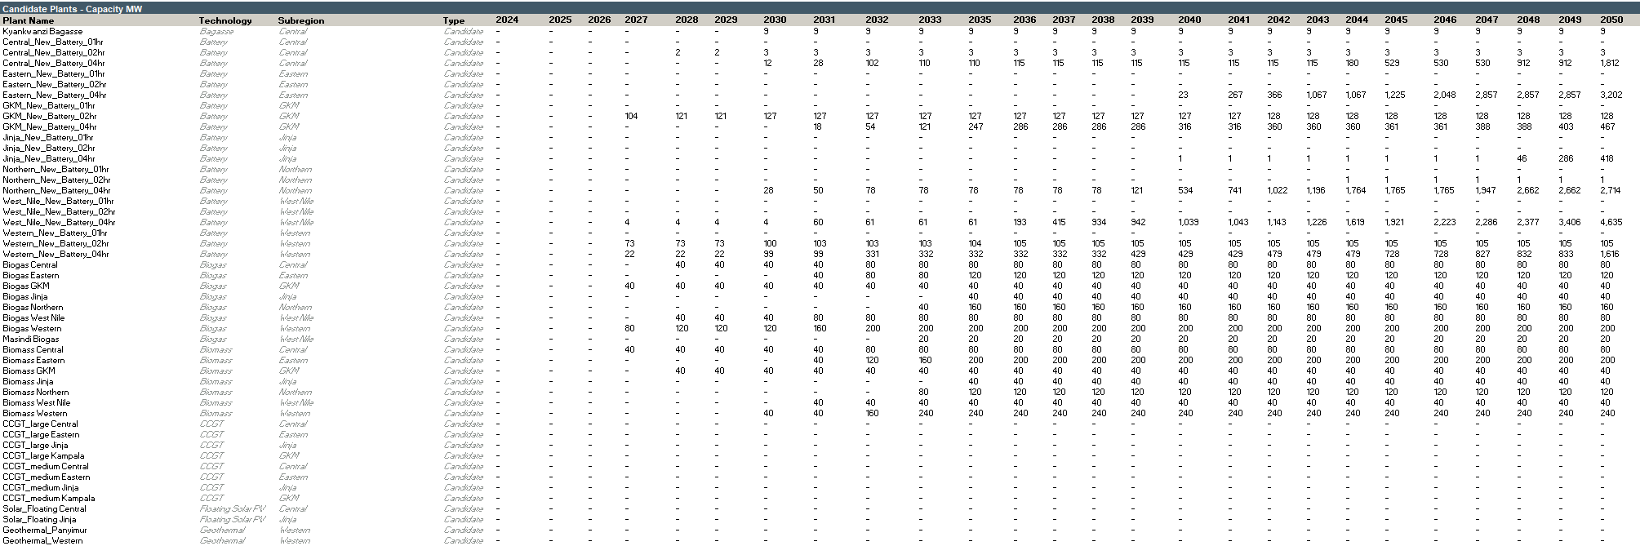
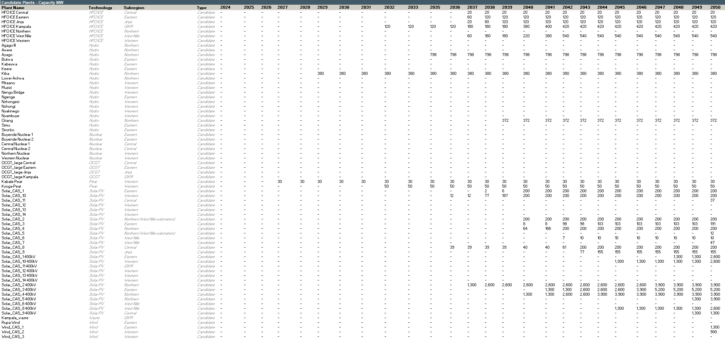
    - Ten-fold growth
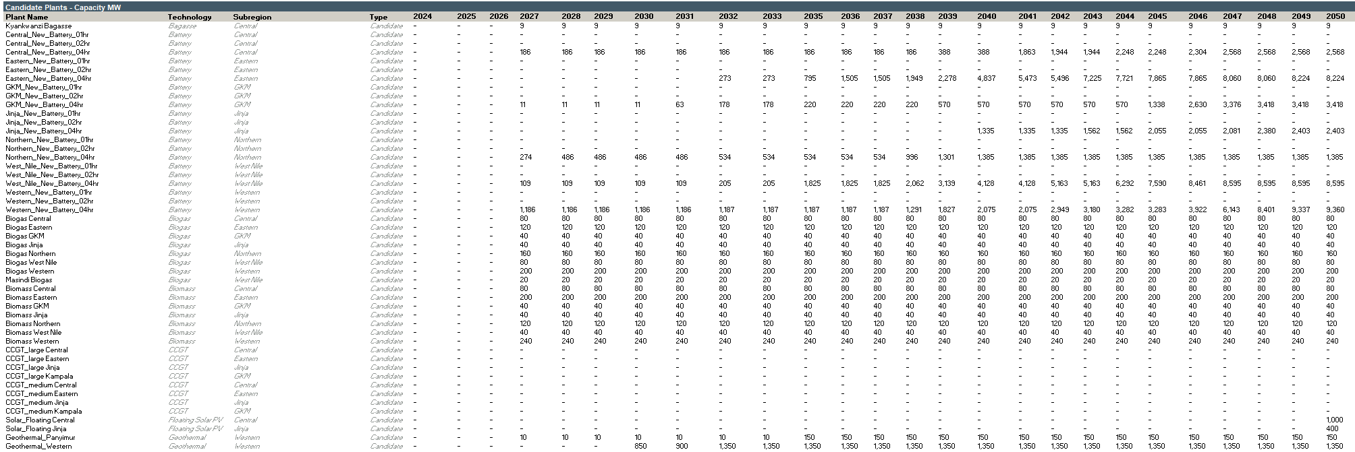
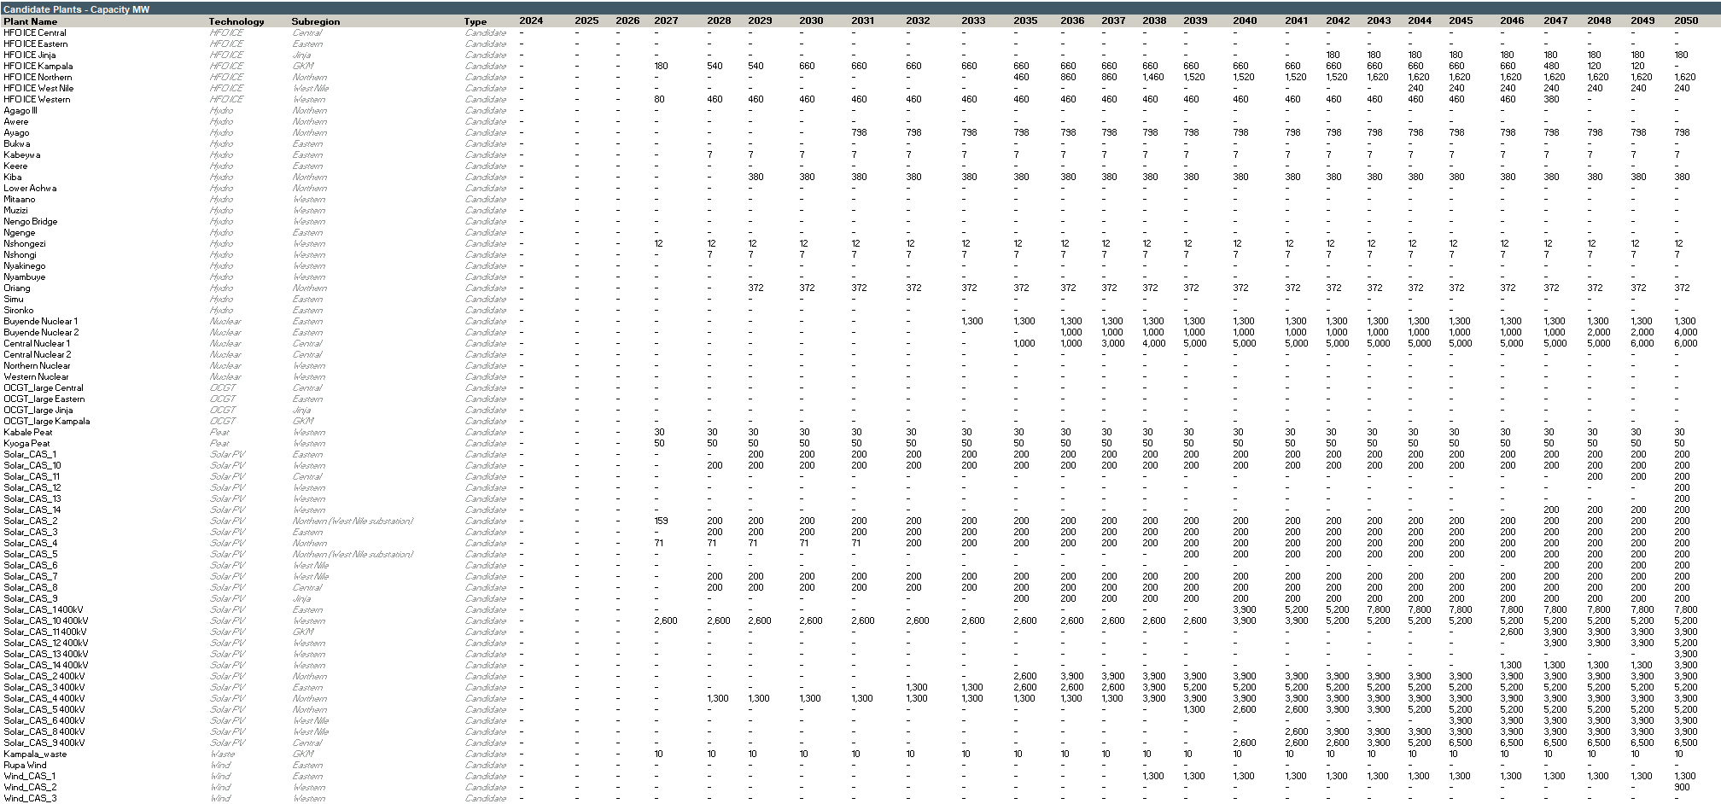

    - Policy targets
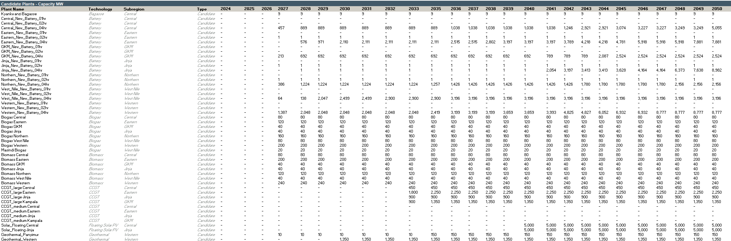
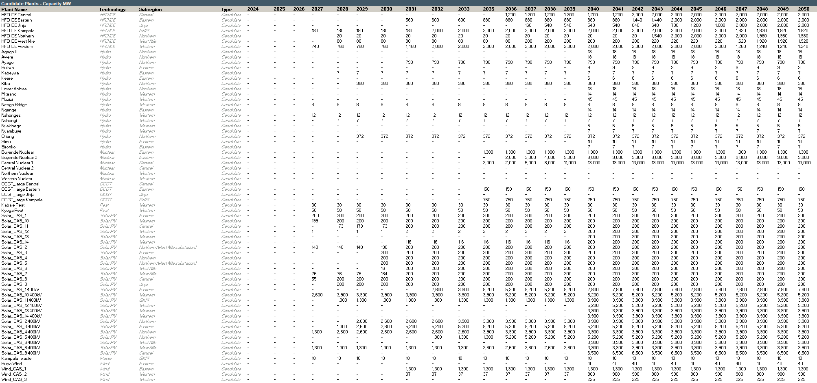
    - Dry hydro
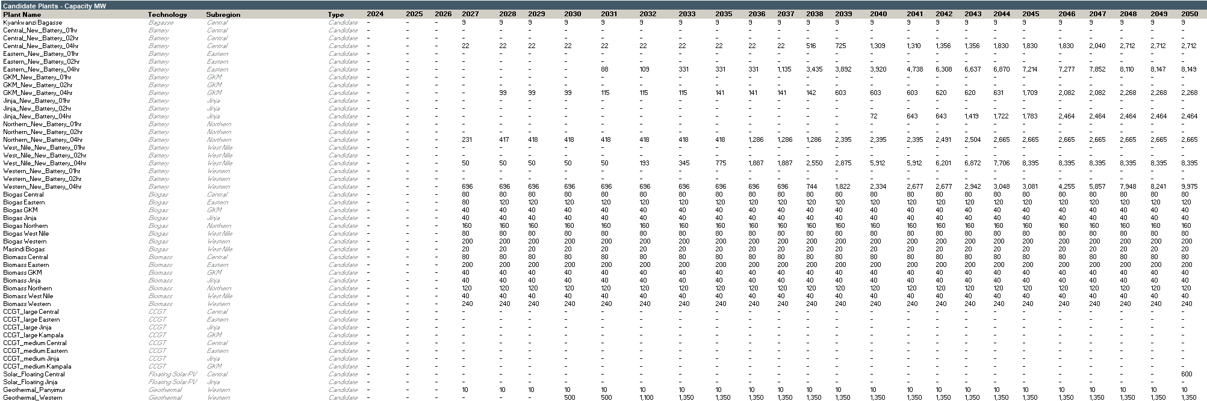
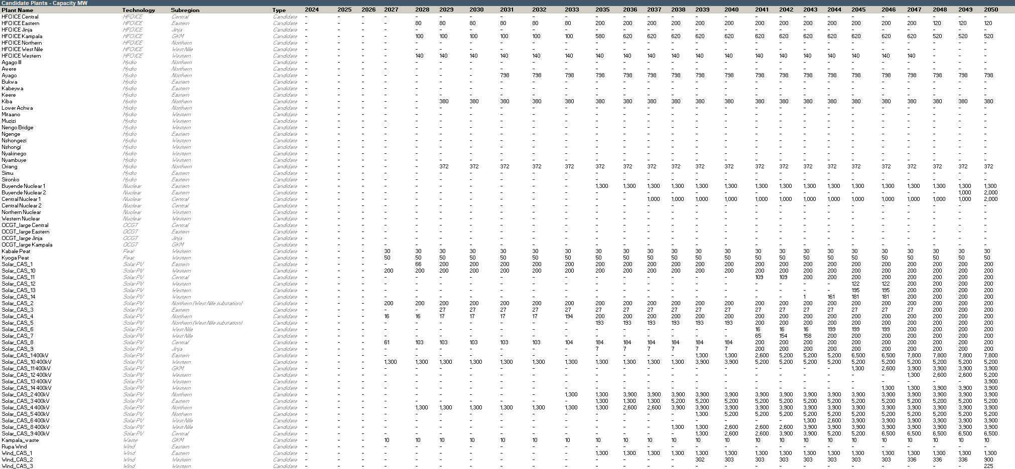
    - Nuclear pathway
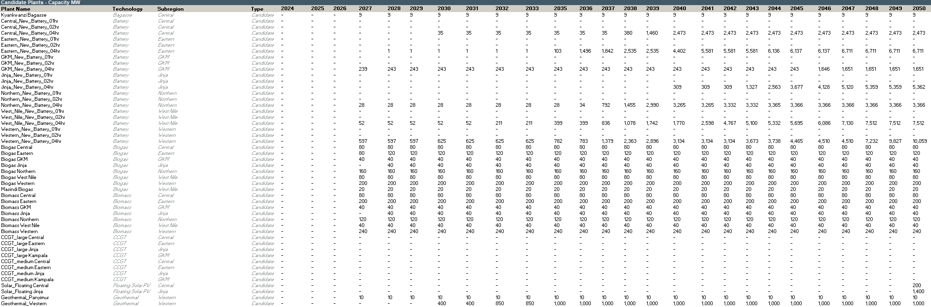
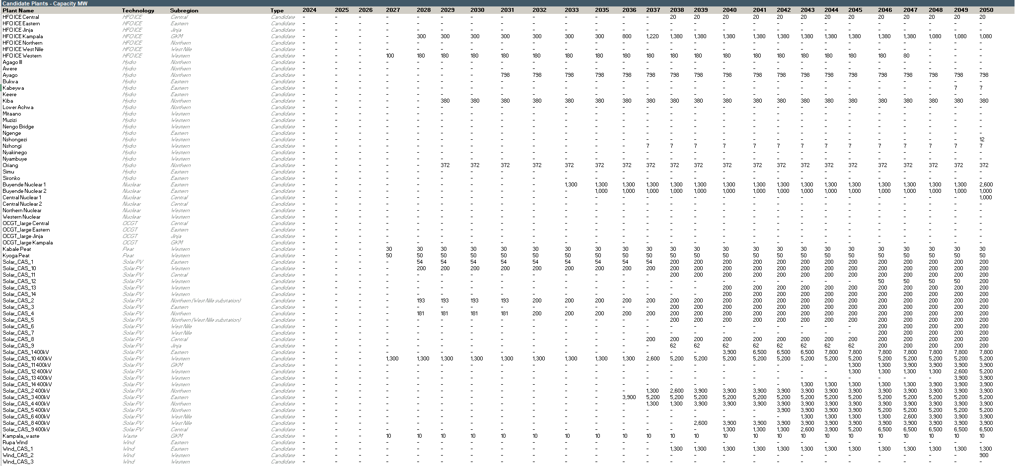
    - Delayed nuclear
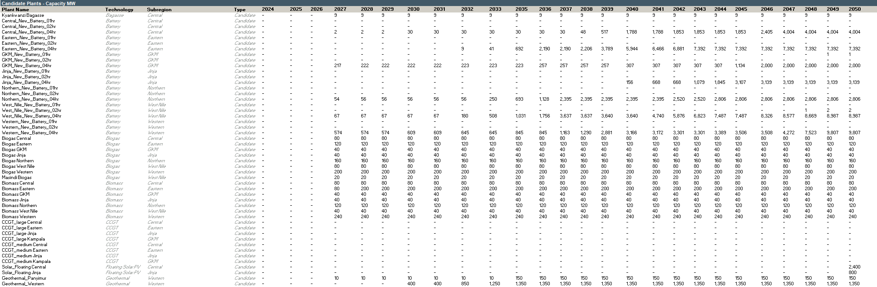
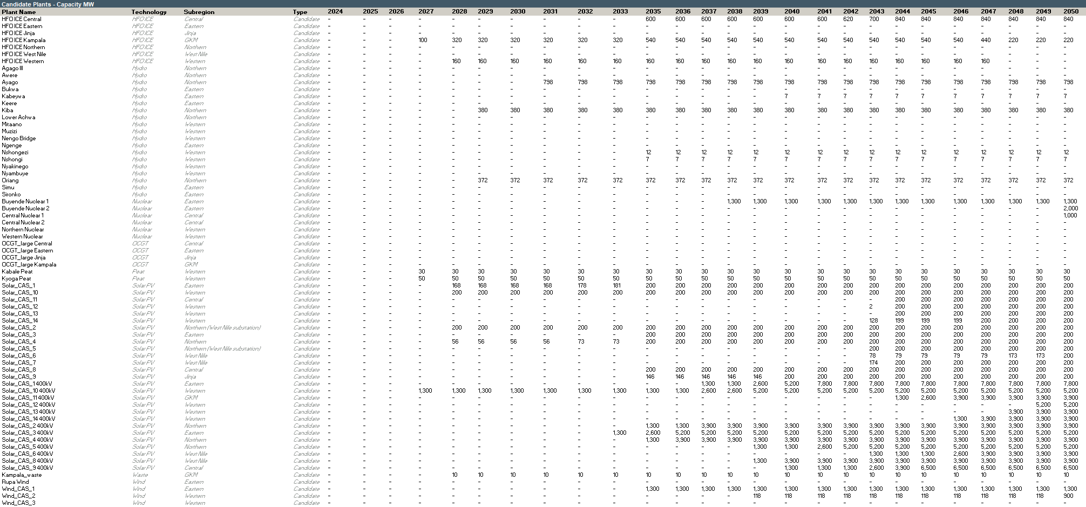
    - Forced gas
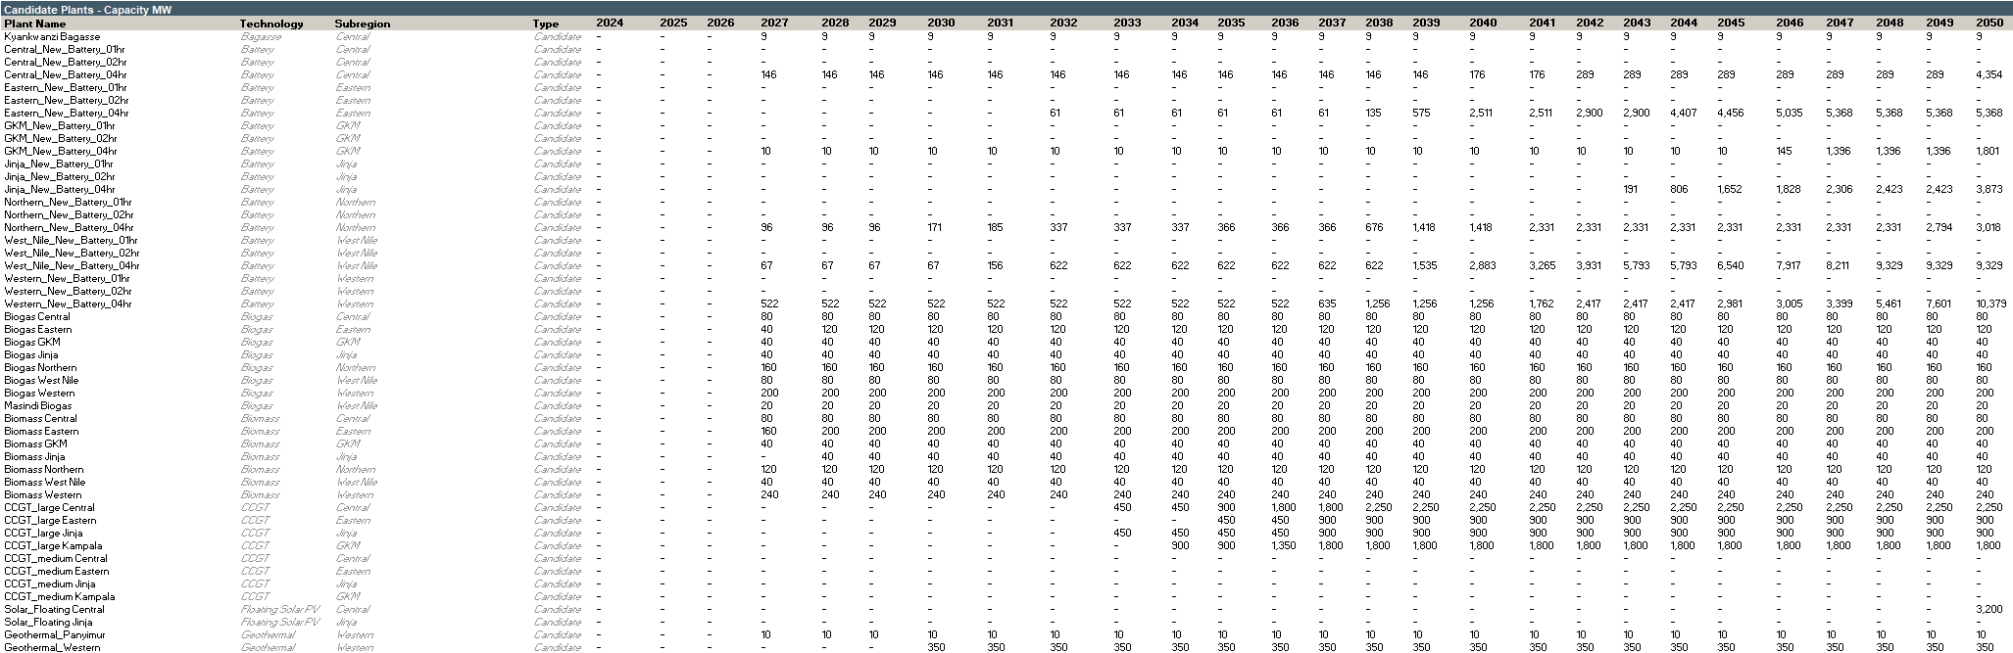
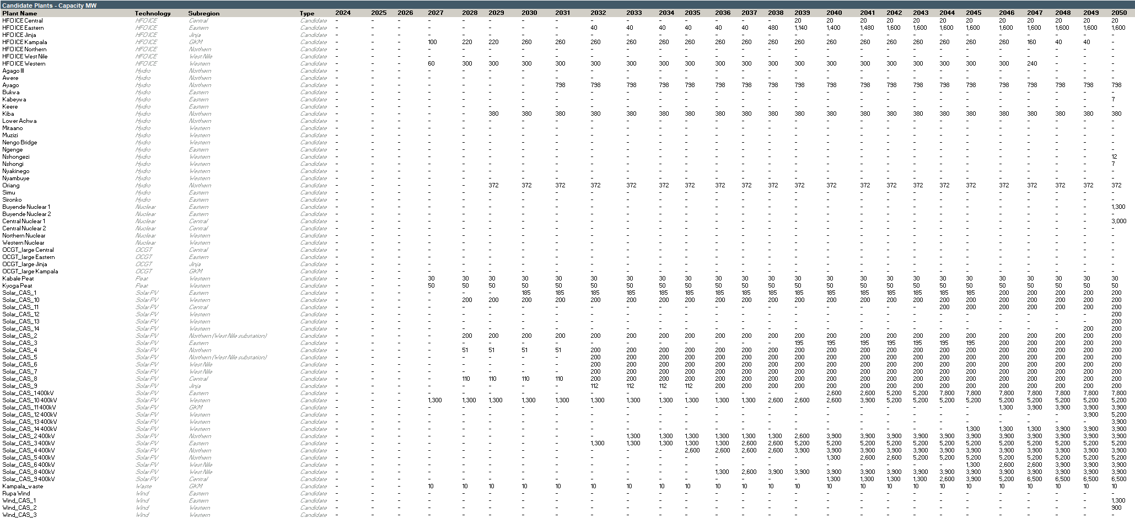
    - Forced gas & nuclear
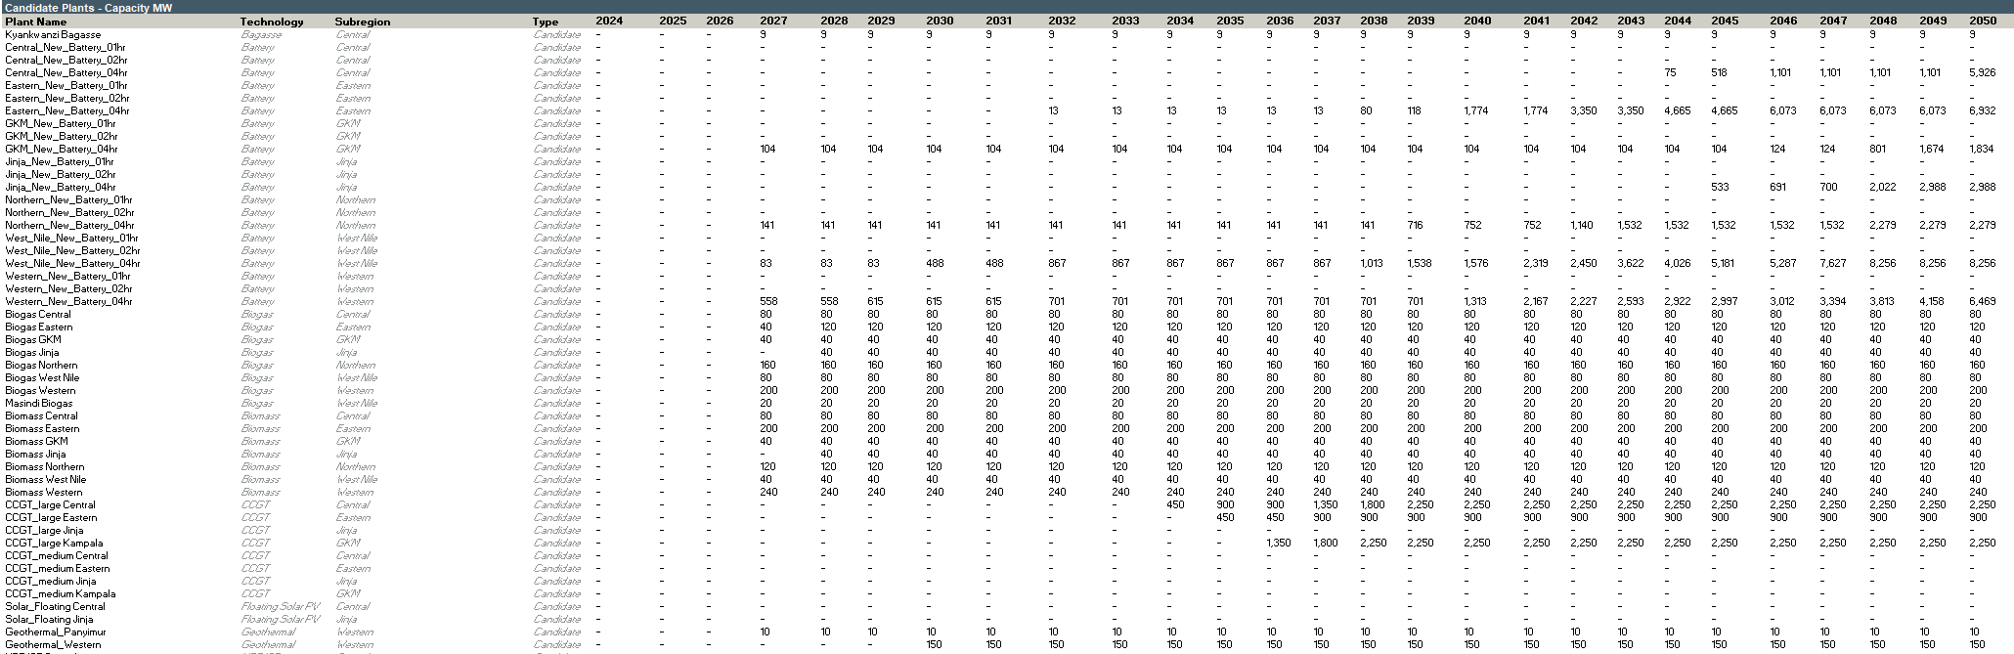
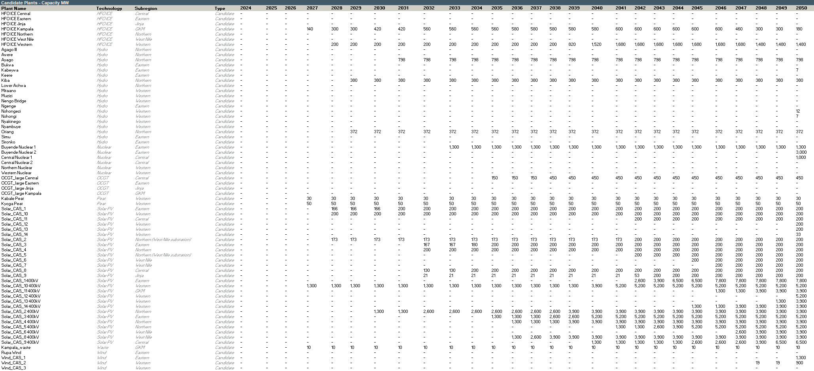
    - Regional integration
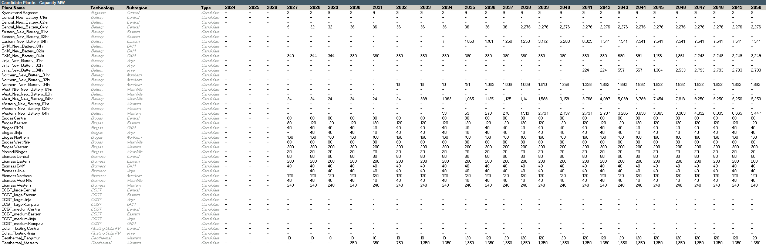
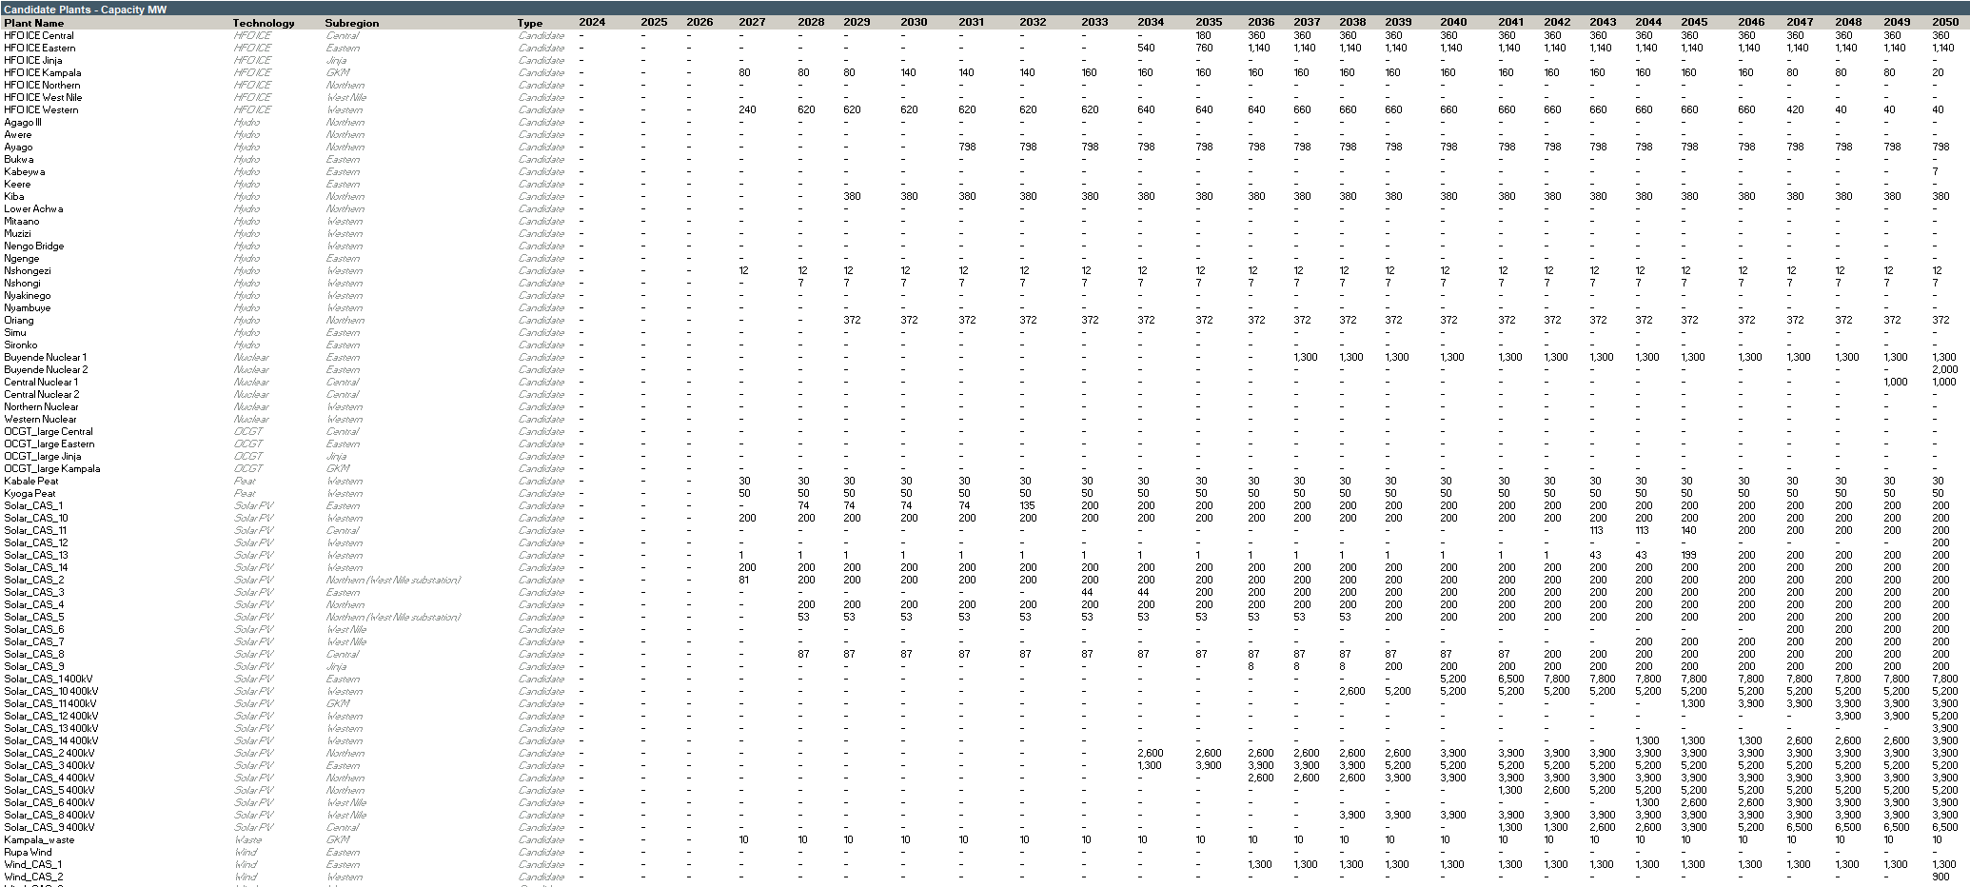
    - Rapid reduction
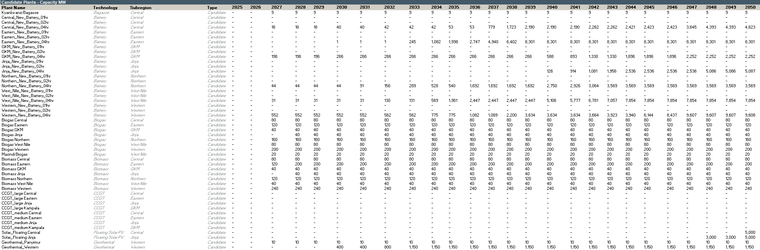
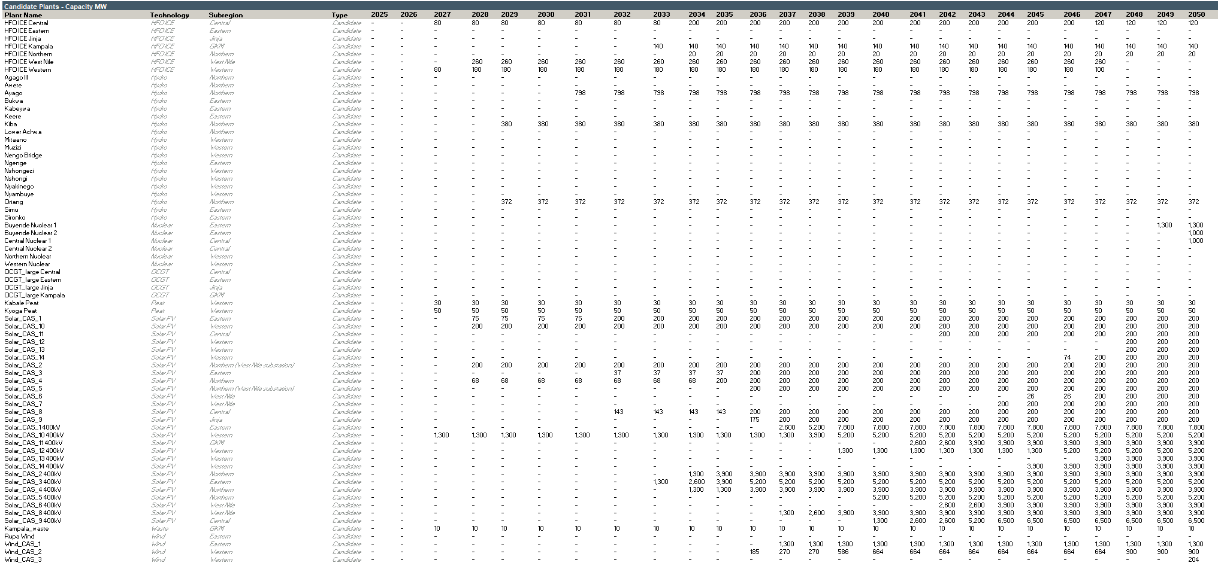
    - Discount rate +3%
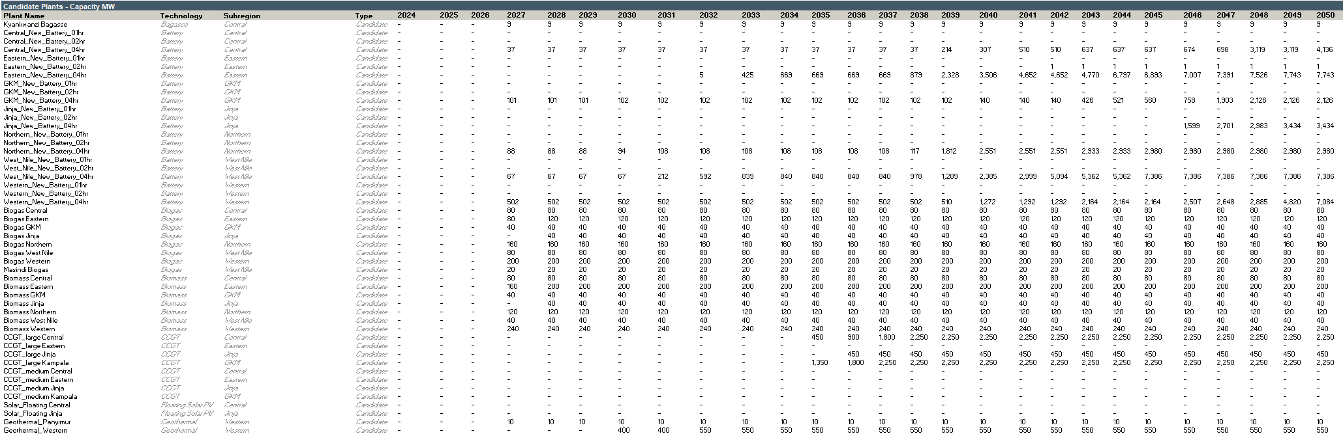
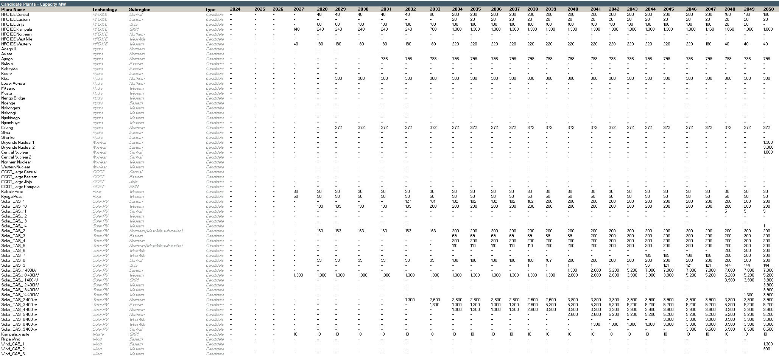

    - Discount rate -3%
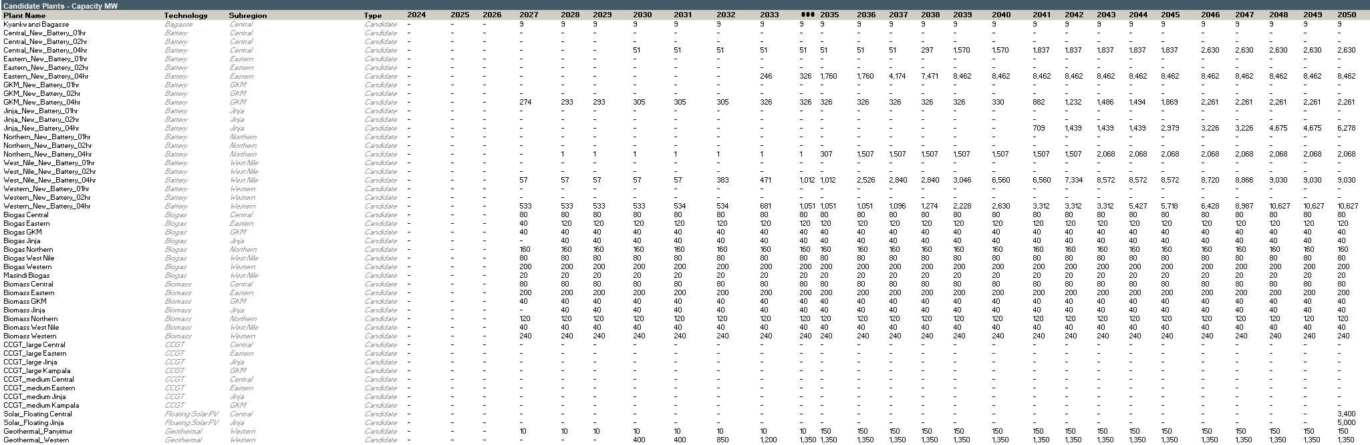

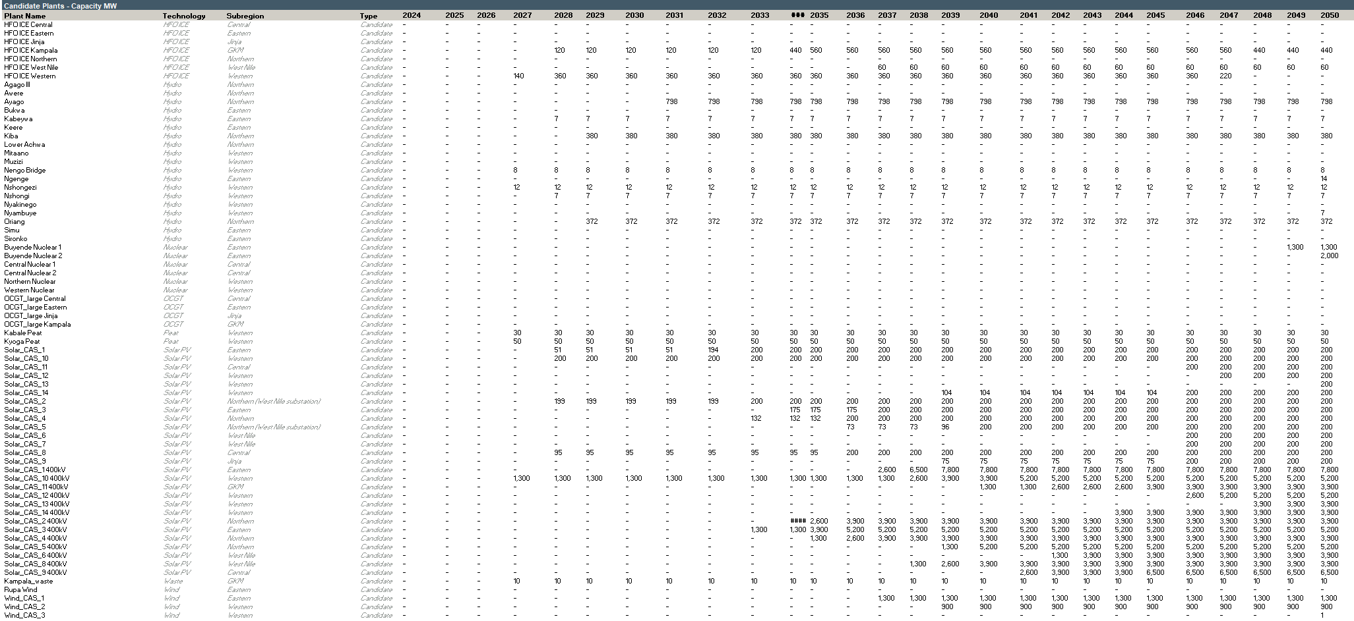

  - Selected candidate EE/DSM measures by scenario
    - Base case
    - Unconstrained
    - Delayed growth

    - Ten-fold growth
    - Policy targets
    - Dry hydro
    - Nuclear pathway
    - Delayed nuclear
    - Forced gas
    - Forced gas & nuclear
    - Regional integration
    - Rapid reduction
    - Discount rate +3%
    - Discount rate -3%

  - Selected subregional transmission candidates by scenario
    - Base case
    - Unconstrained
    - Delayed transition

    - Ten-fold growth
    - Policy targets
    - Dry hydro
    - Nuclear pathway

    - Delayed nuclear
    - Forced gas

    - Forced gas & nuclear
    - Regional integration
    - Rapid reduction
    - Discount rate +3%
    - Discount rate -3%

- Distribution system plan
  - Distribution system costs – Base scenario
  - Distribution system costs – Delayed transition scenario

Following IMF projections up to 2030 and then reflecting the IEA CAGR up to 2040. Between 2040 and 2050 GDP growth slows to 3% to reflect the economy reaching maturity.
Reflecting the historical average growth over the past 10 years until 2030 with a slow-down of the growth until 2050.
Source: Energy Efficiency Roadmap for Uganda, 2017
Source: Energy Efficiency Roadmap for Uganda, 2017
The_Electricity_(Primary_Grid_Code)_Regulations,_2003_SI_24
UETCL Corporate Strategic Plan 2024-2029 (2024)
A detailed analysis of available resources and candidate options (volumes, costs, technologies, etc) was presented in the Resource assessment report and the Energy Efficiency and Demand Side Management Measures report. The candidate options that should be considered for the IERMP of Uganda were discussed and validated during the Resource Assessment Workshop which involved all relevant stakeholders in Uganda.
Excluding the Delayed transition scenario which due to its lower demand has lower costs, the Rapid cost reduction scenario which due to lower capital costs of RES and BESS technologies has lower costs and the Low discount rate scenarios which results in lower values due to the lower discount rate used.
See transmission network planning criteria in Section 4.
Provided the final version of the latest Grid Development Plan is available, the list of projects may be reconsidered in the update to final report of the IRP.
Tier 1: Low capacity (lighting, phone charging) for a few hours each day.

